Conversation design course

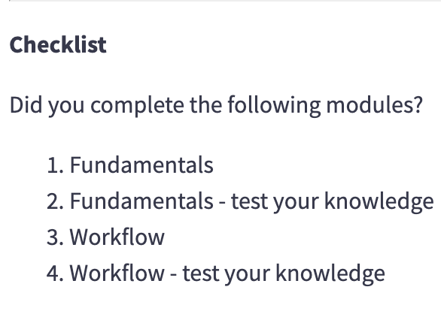

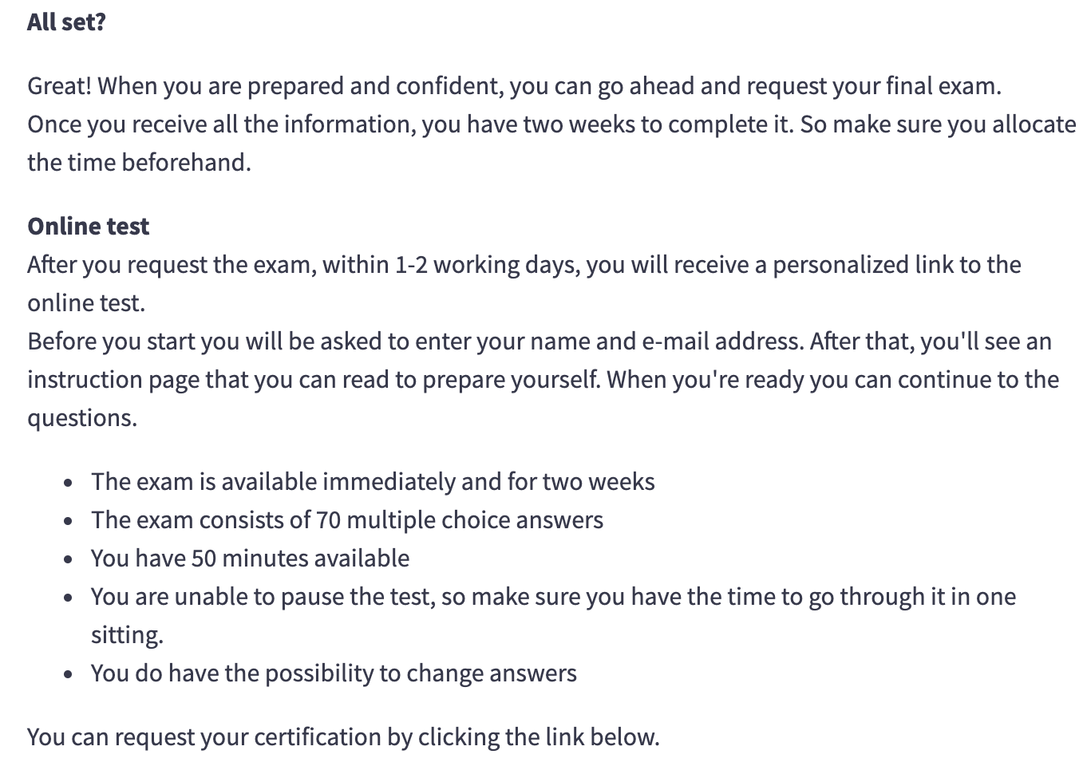

# Section 1 Fundamentals of conversation design

* What is conversation design?

→ make conversation more helpful, natural, and persuasive

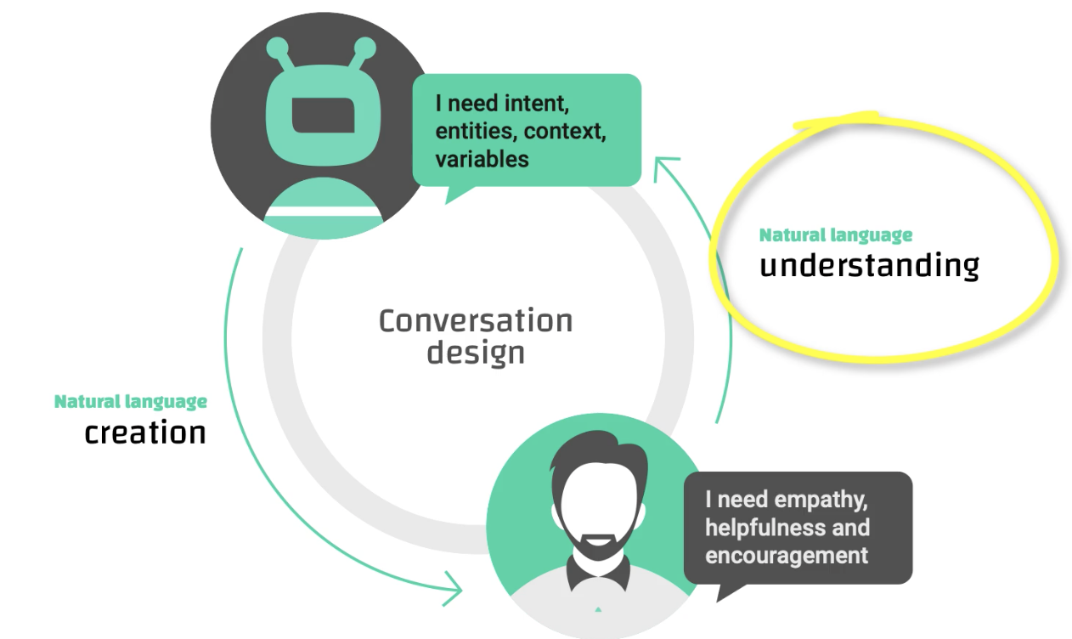

Three important elements:

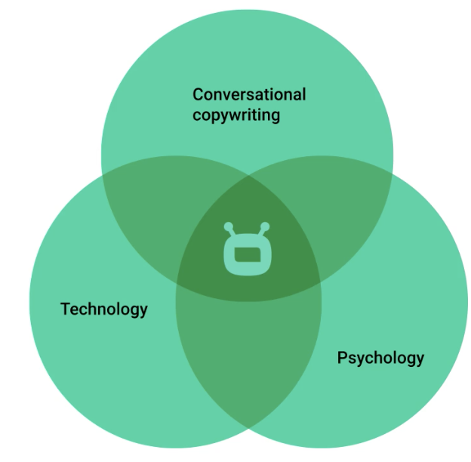

* Where is it needed?

Chatbots (sales, customer service, persuasion), voice assistants, robotics

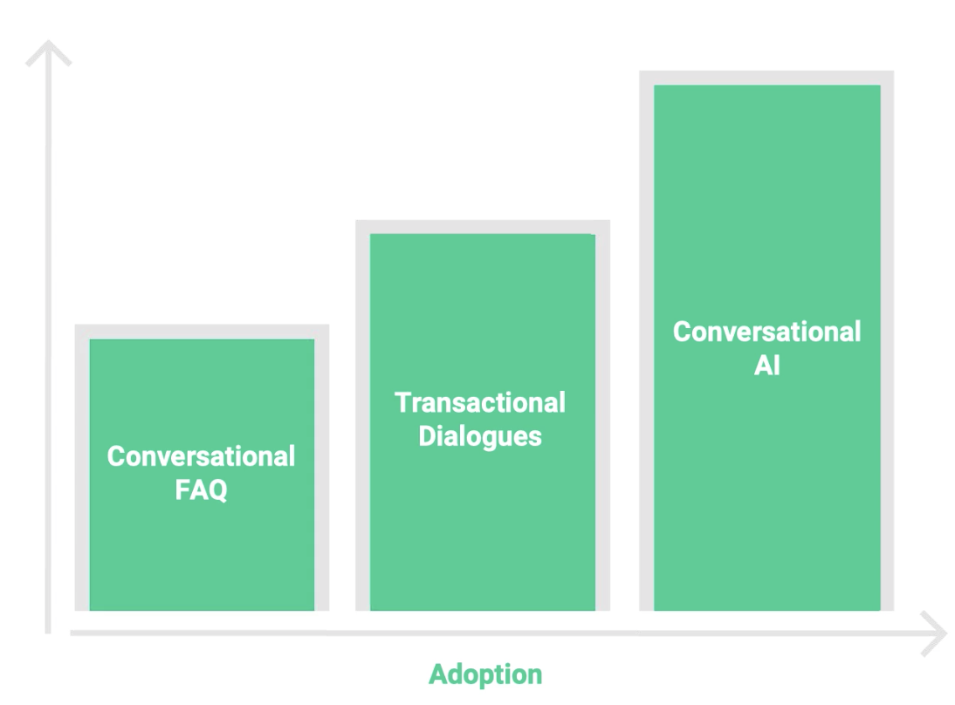

## Maxims: quantity, quality, relevance, and manner

* Don’t expect a yes/no answer to a yes/no question

Relevance

Example: on a train - good morning = show me your ticket

## Scenarios

Aristotle

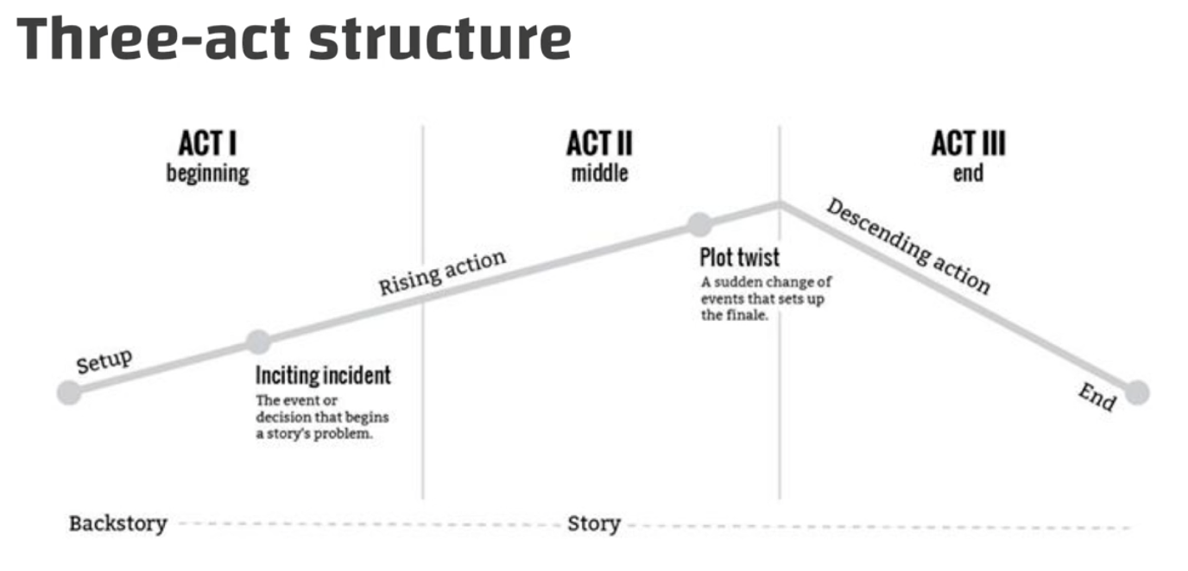

Setup - confrontation - resolution

Two aspects of conversation: rational and emotional conversation

Two types: service conversation (helpful) and sales conversation (persuasive)

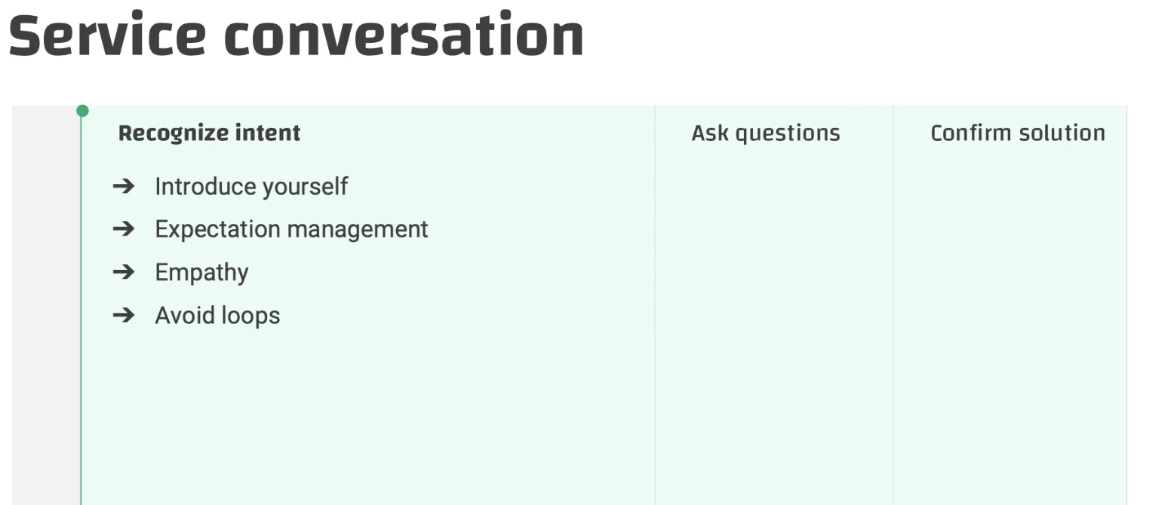

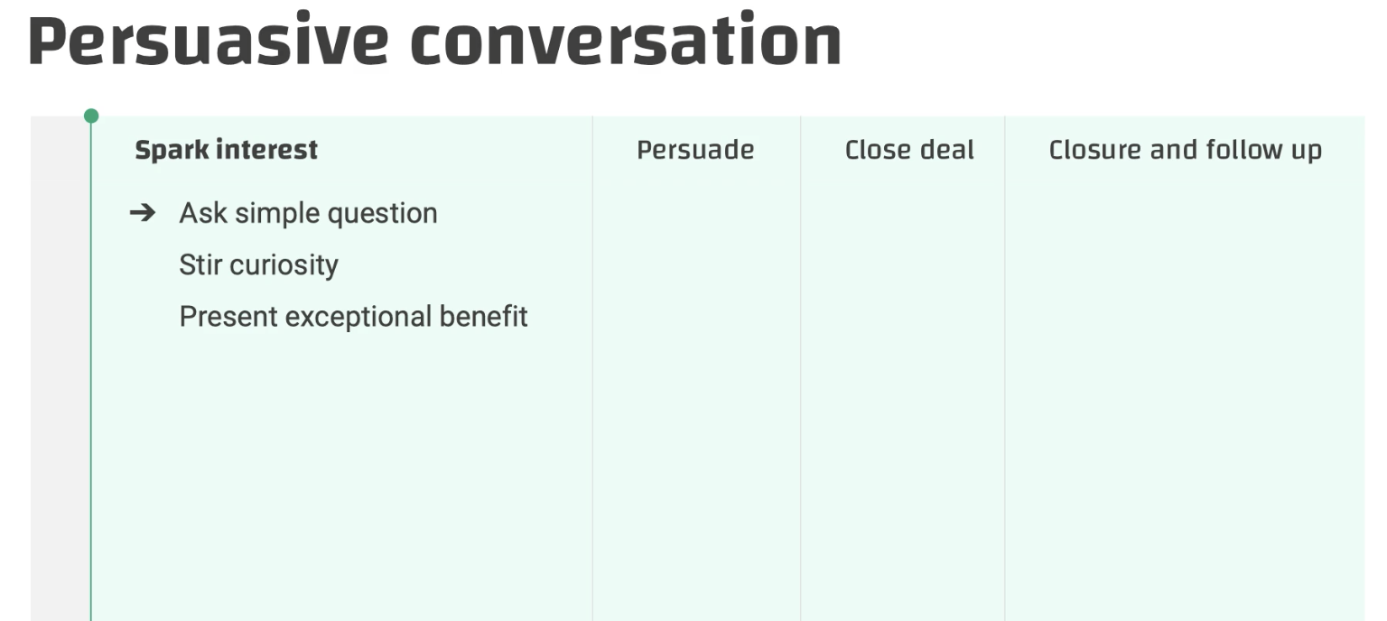

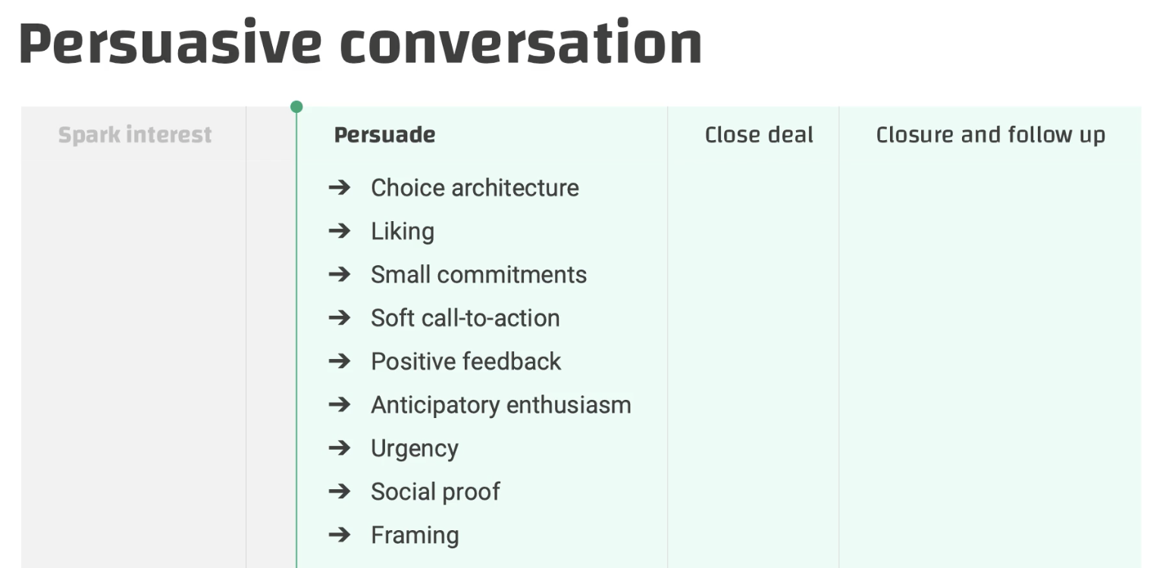

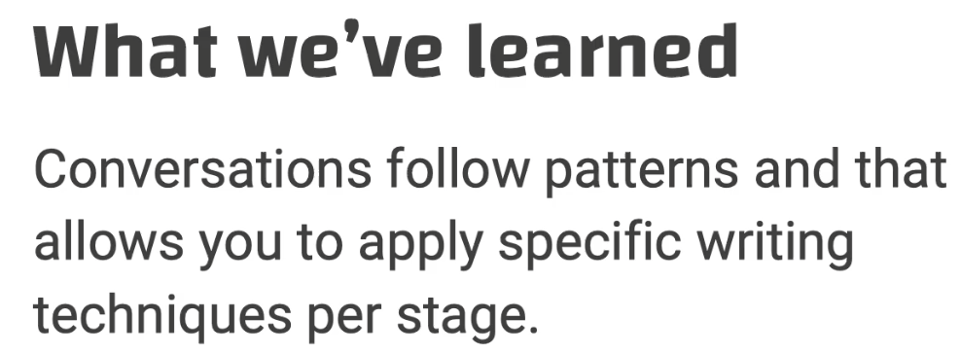

## How to write prompts

* Prompt is something that puts something/someone into action; it is an utterance that invites users to respond or to give us input

## Examples of prompts:

Open - How can I help you?

Closed - Do you want to change your current insurance or get a new one?

Another design: open question + button design

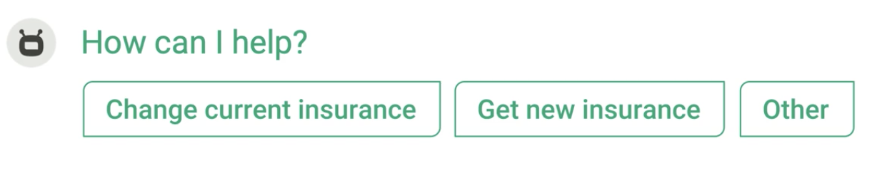

Explicit confirmation -

Three beers and a coconut, is that correct?

Explicit confirmation (sometimes it works)

Three tickets to the banana boat. Say “banana” if that is a yes!

Finish the sentence -- DON’T use unless **quizzes;**

Ok 3 pizza Margherita. And delivery time will be …?

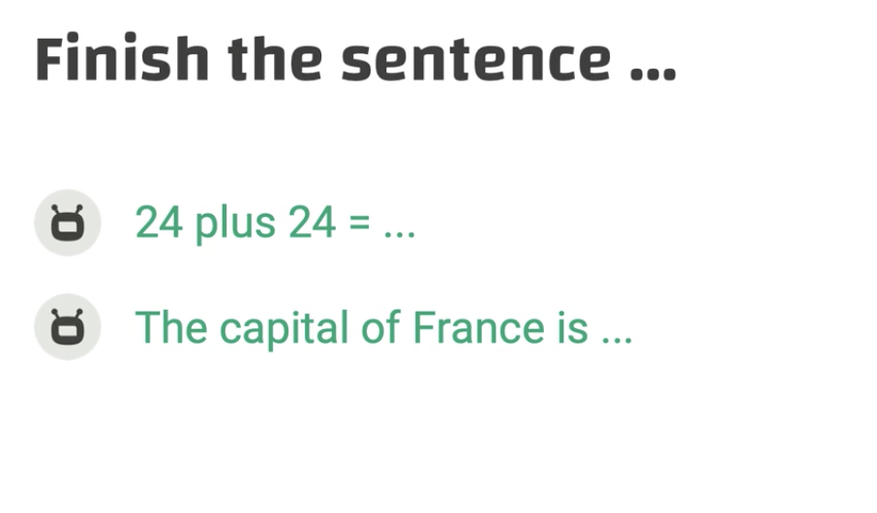

* You need to avoid asking combined questions → simply multiple questions

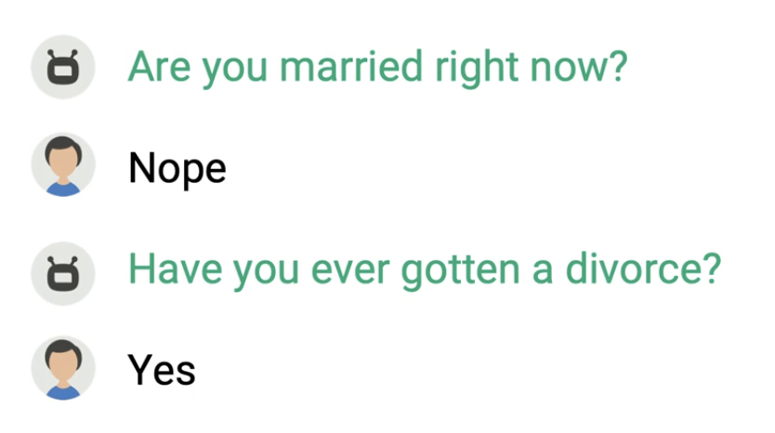

* Write conversational: is it natural?

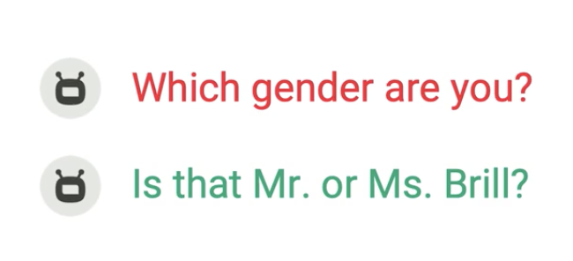

* Limit the number of options
  + Wrong:

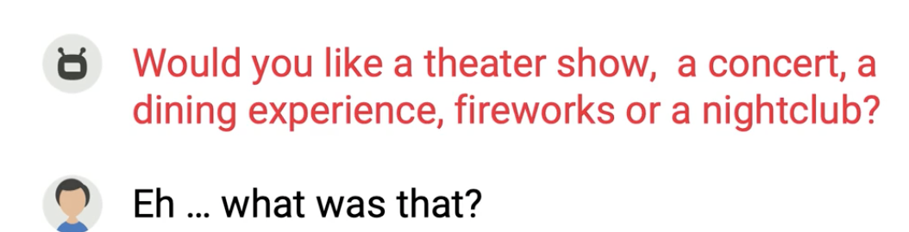

* Right → split it into small questions

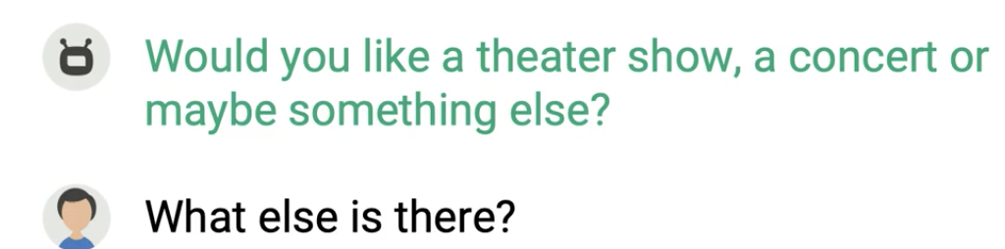

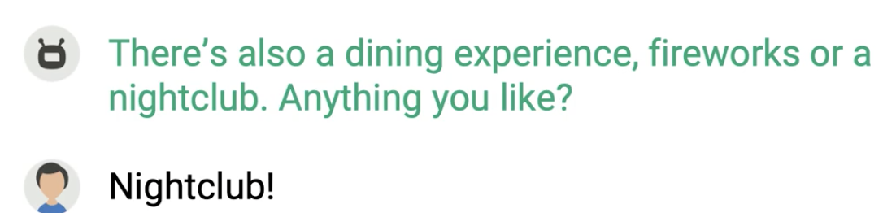

A confusing UX

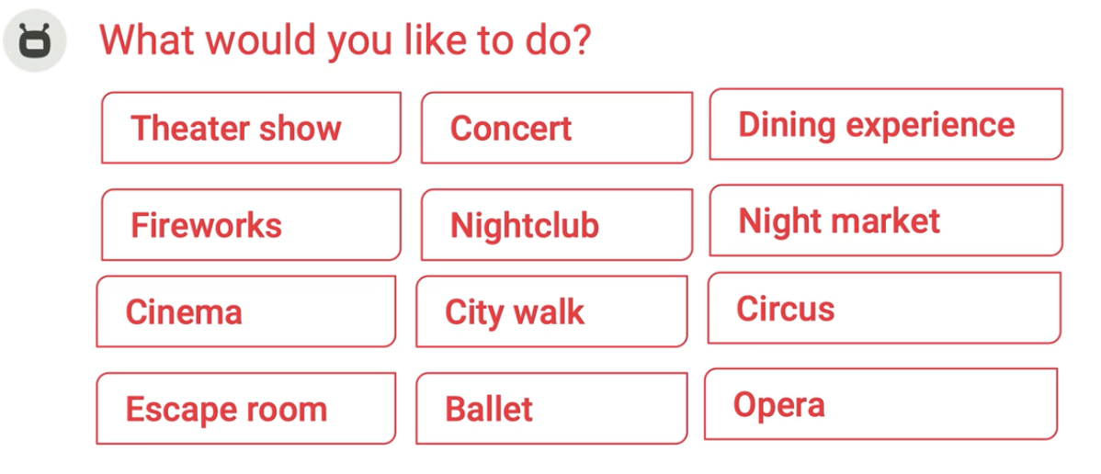

* Turn taking: avoid confusion of whose turn it is

Mixing questions with more statement

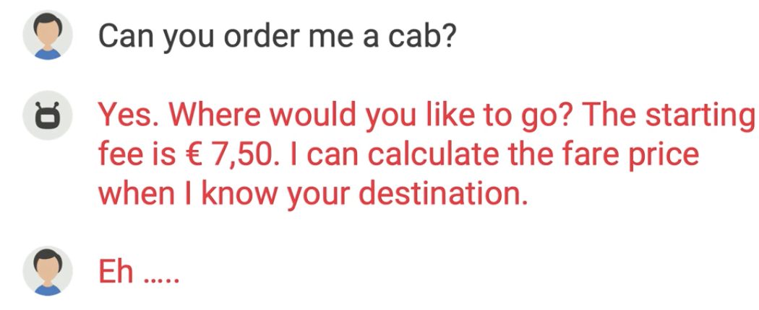

## How to introduce your bot

## Some examples:

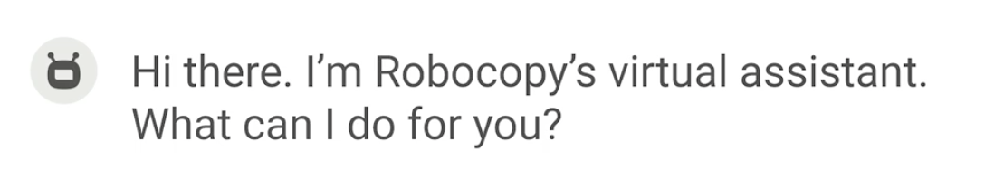

→ lack of functions of the bot

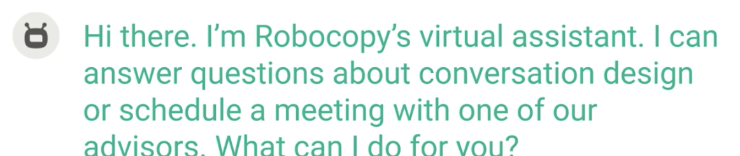

## Design for frequency

Wrong:

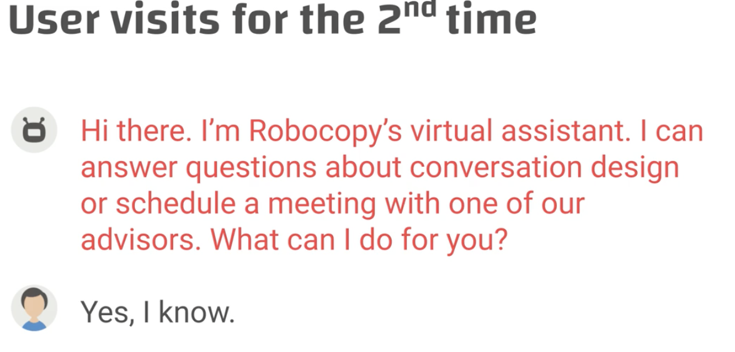

Correct: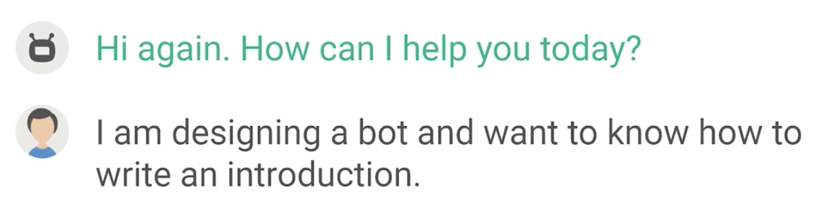

## Common Mistakes

* User-centric

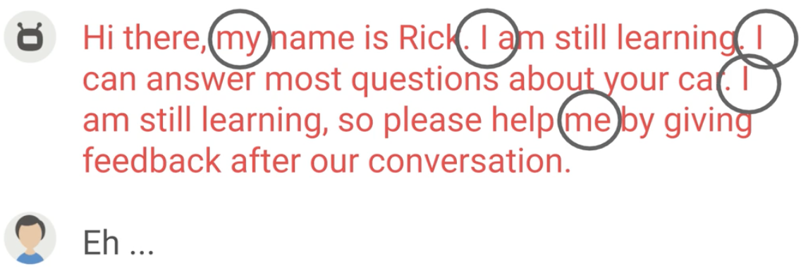

* No need to be arrogant

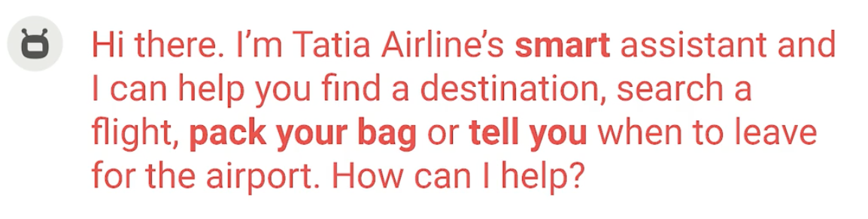

* Don’t pretend to be a real human (that causes confusion)
* Don’t be redundant

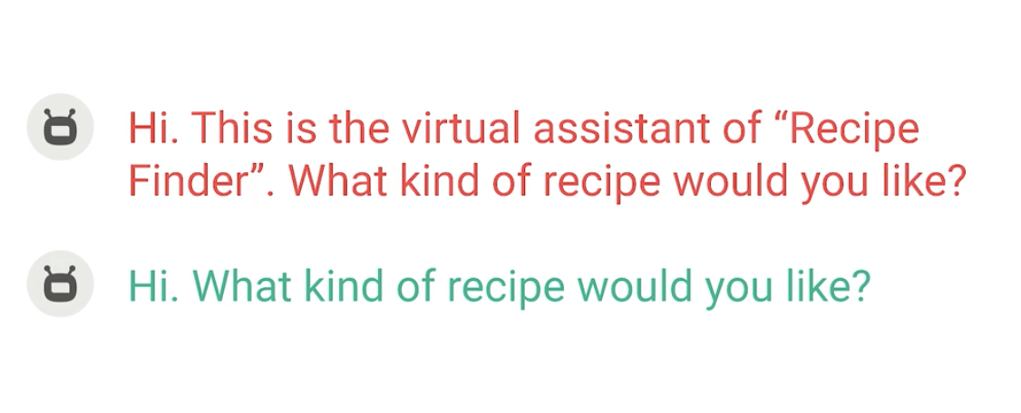

* Start with a greeting

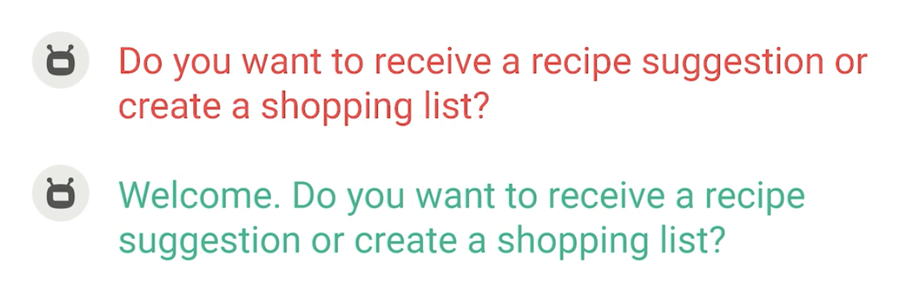

* Don’t explain familiar concepts

No need to explain a quiz

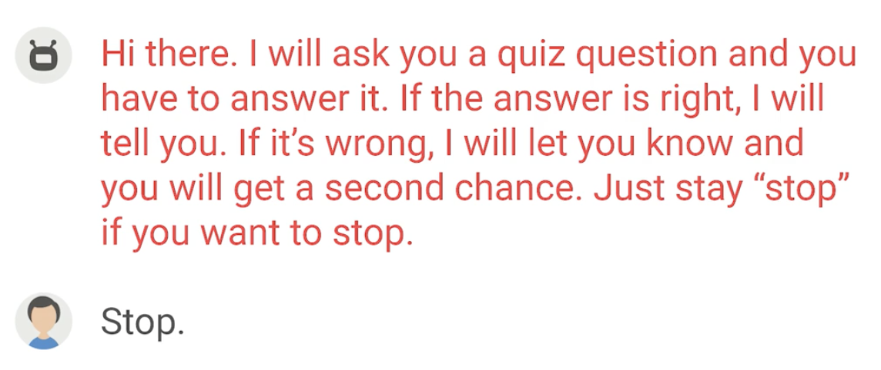

### Summary

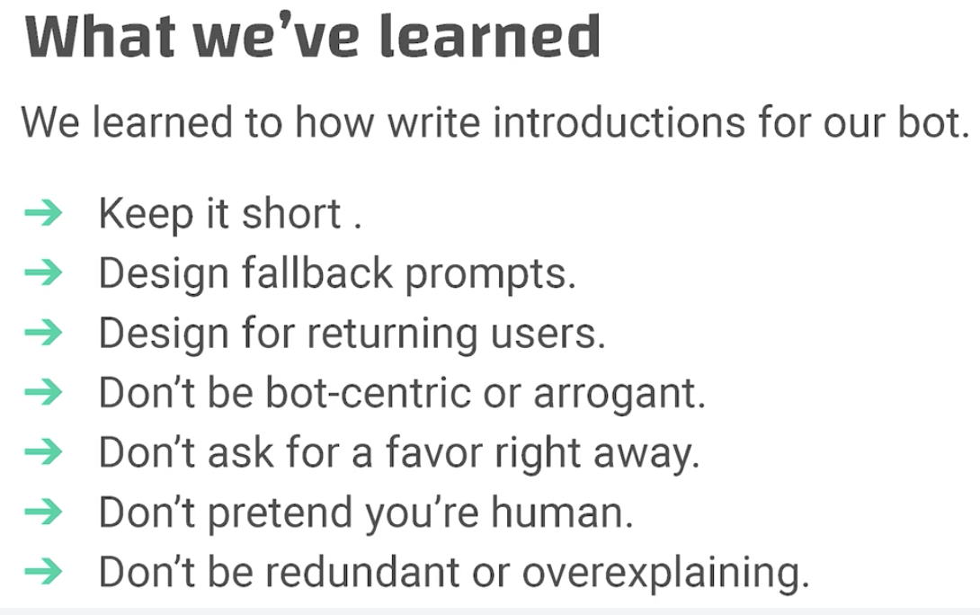

## Turn-taking

Bots cannot use non-verbal clues such as gazing and body language, but we can use prompts to give turns to humans so they know it’s their turn to speak

* End with a question

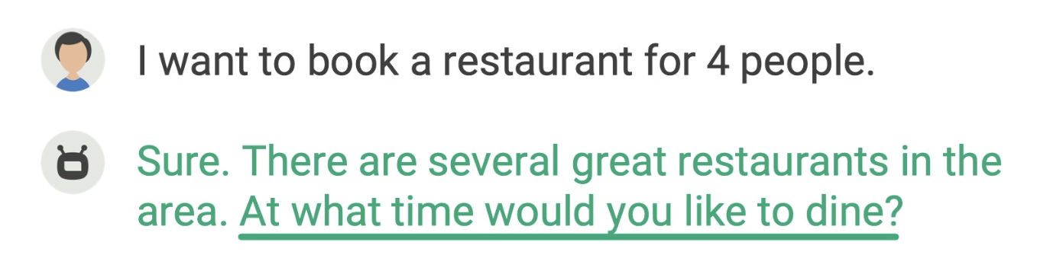

* Give a question after some options to the user

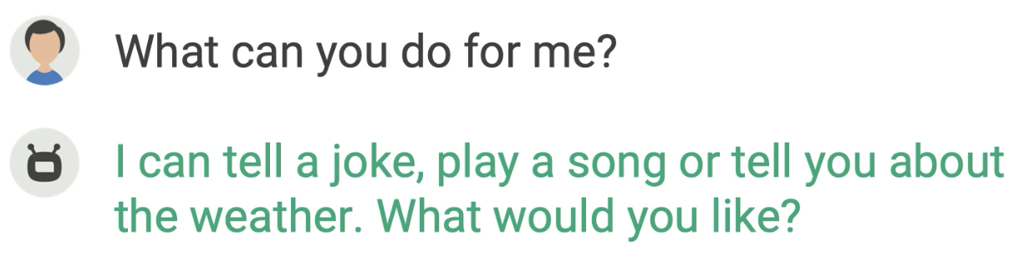

## Explicit & implicit confirmations

Goals: what they are and when to apply

* Explicit confirmation: ask the user to confirm with the action

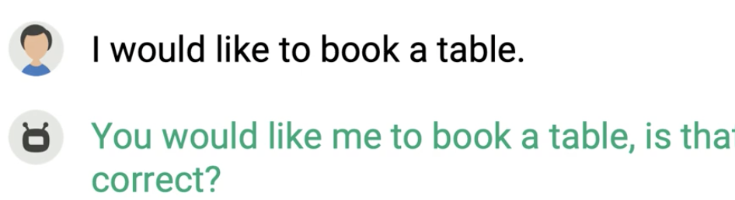

When: (1) we use it when the confidence is low; below 65% → not a usual strategy

(2) sometimes the task has a high stake (e.g., transferring money or sending an email to many people)

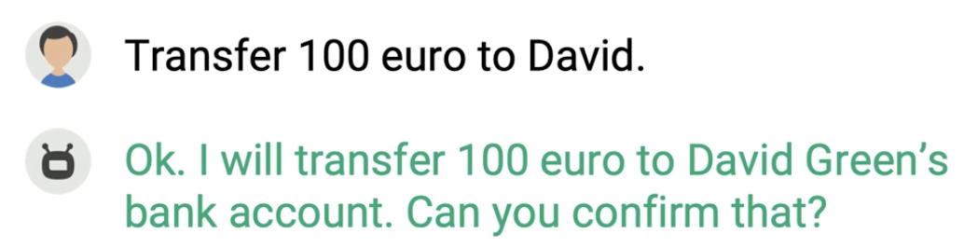

* **Implicit confirmation: it does not require a response from the user, but it requires the user to confirm → our preferred way**

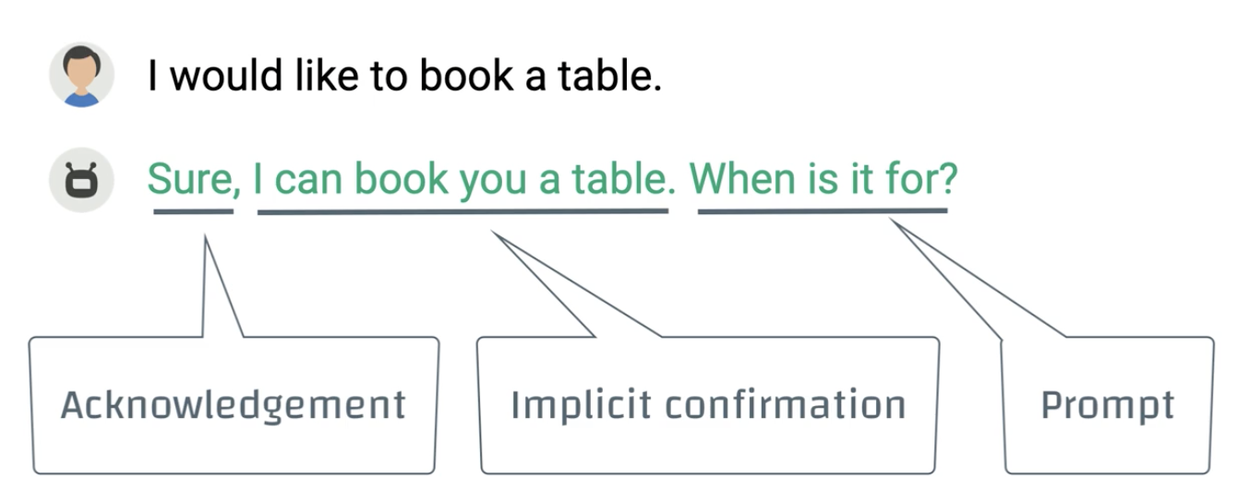

→ the user doesn’t have to confirm **unless necessary**

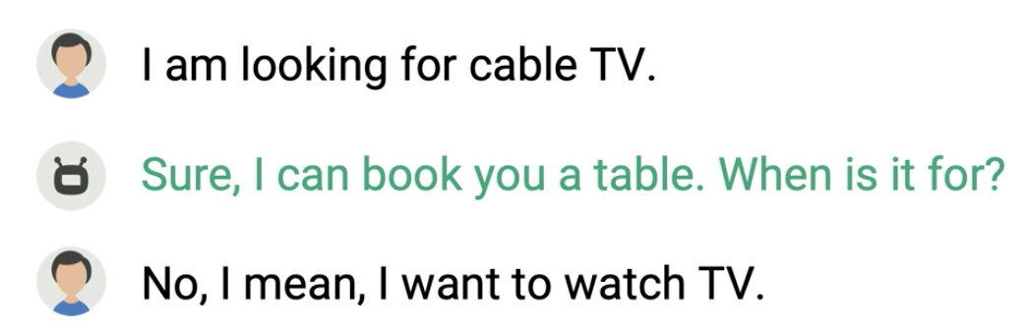

* Acknowledgement is NOT confirmation

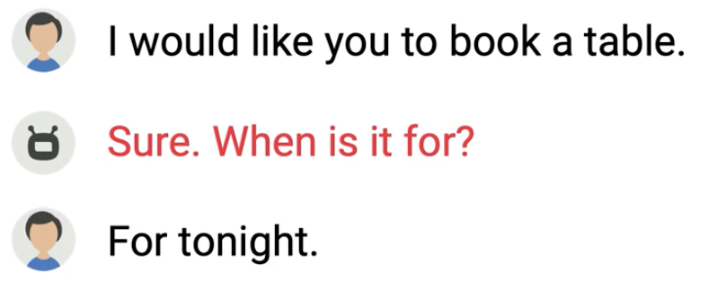

* Implicit confirmation design using **pause (instead of acknowledgement words)**

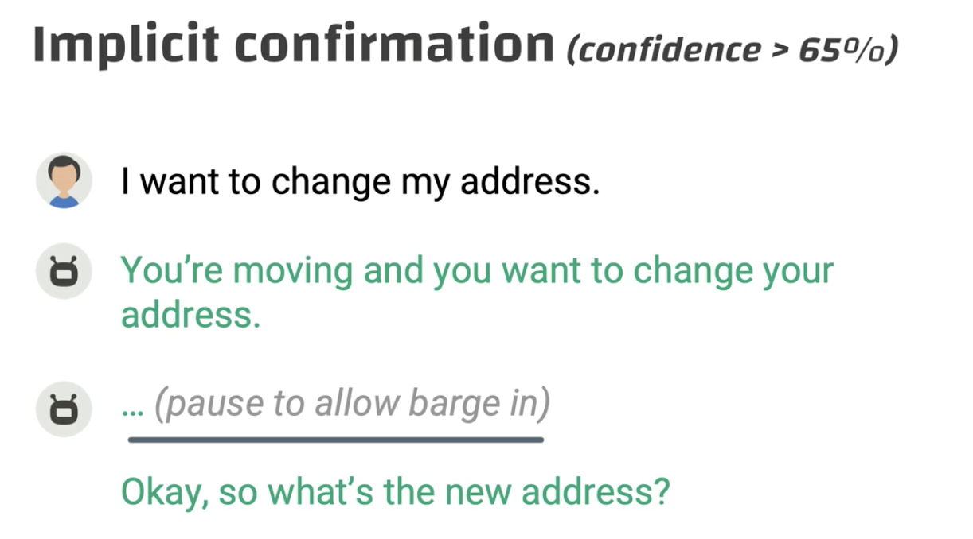

Explicit confirmation (confidence is low)

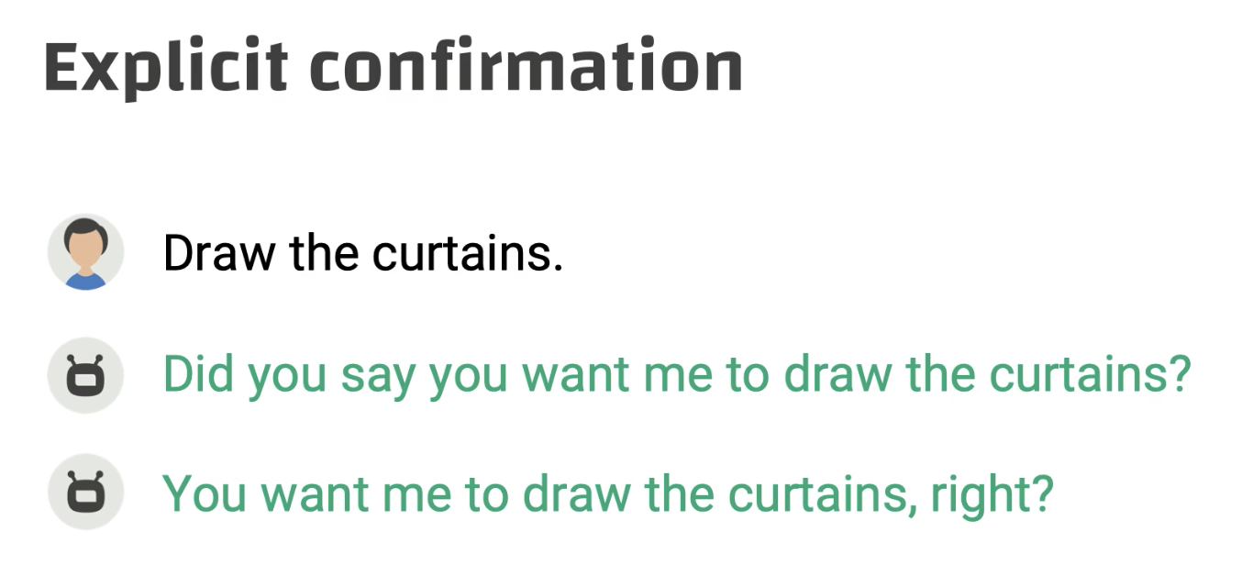

*You can use short versions:*

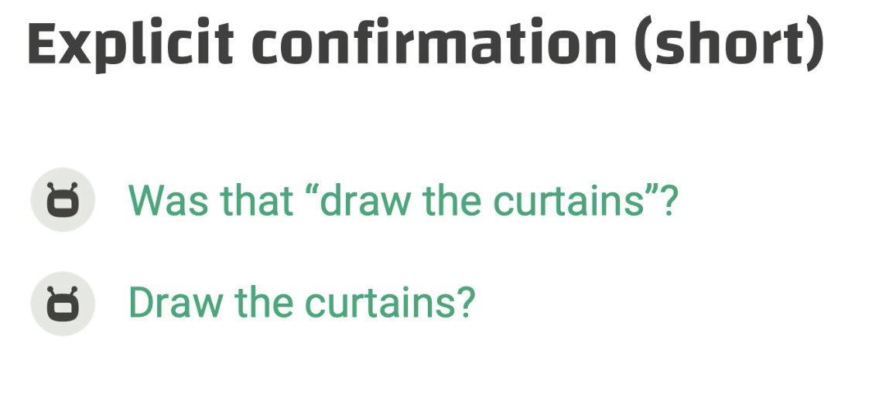

Shortening can be used on implicit confirmation as well

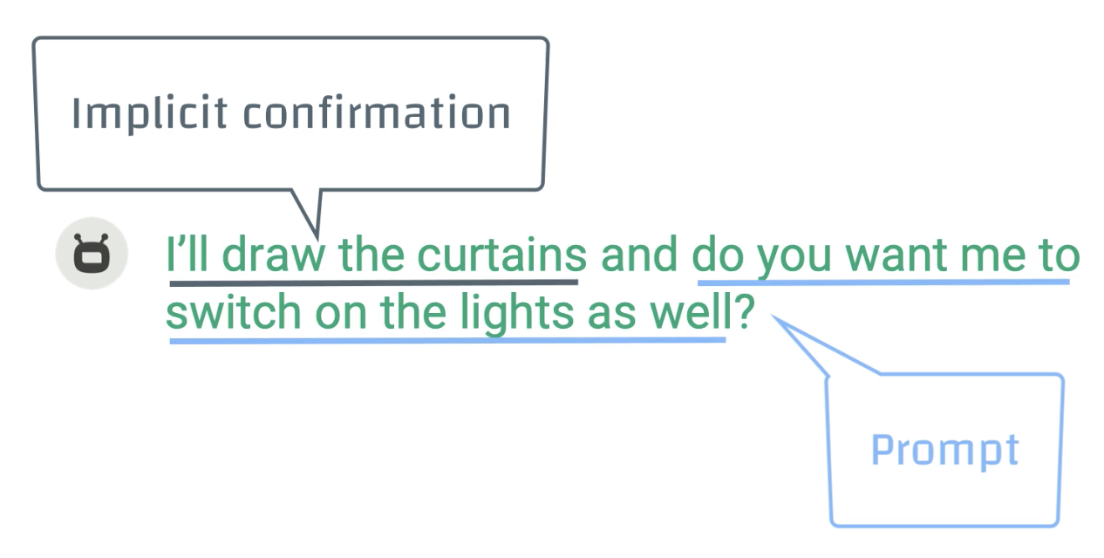

## Acknowledgement

* Definition: confirmation of receiving the user’s input
* Examples: sure, got it, there, alright, ok, …
* Non-verbal: nodding, smiling, facial, and thumbs up
* Sound acknowledgement: ah ha, uh hu, mmm, and mm mm
* Acknowledgement and discourse marker
  + A are different than DM because they can be use independently and do not tell us about the relationship between what has been said and what follows
* Acknowledgement and explicit confirmation
  + A - light green; I can help … - confirmation

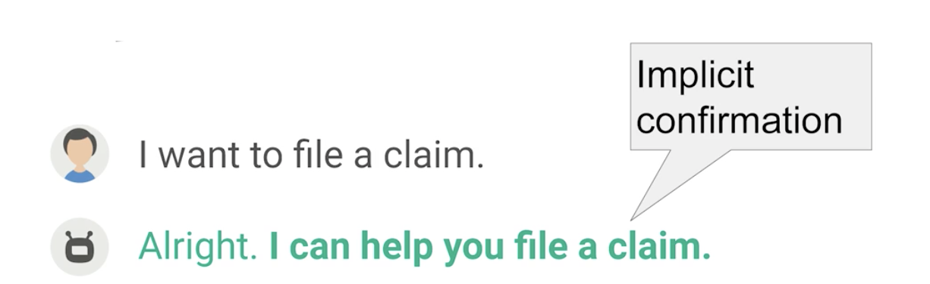

### Vary acknowledgement to show attention

Alright, sure, okay, got it, no problem, …

POS: excellent, wow, super, great, nice, …

**Acknowledgements are very important for voice assistant; for chatbot they give a human and friendly feel to a conversation**

## Prompt verbosity

* Def: **repeating the question with more words** to facilitate the user’s comprehension of the prompt and to create variation
* Some examples:
  + No reply from the user (no input)

You can say ...

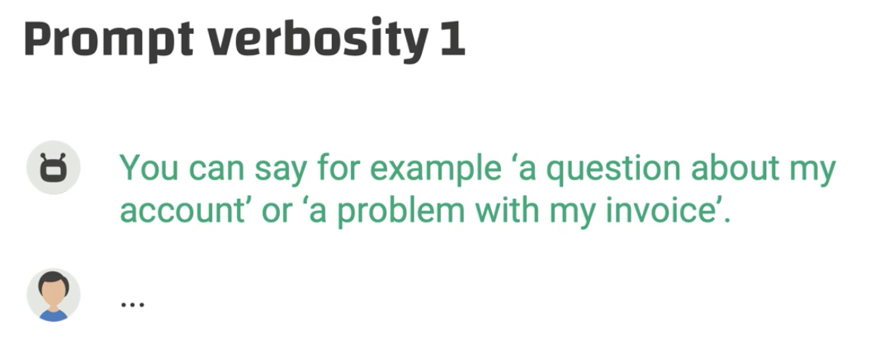

I can help you with questions about ...

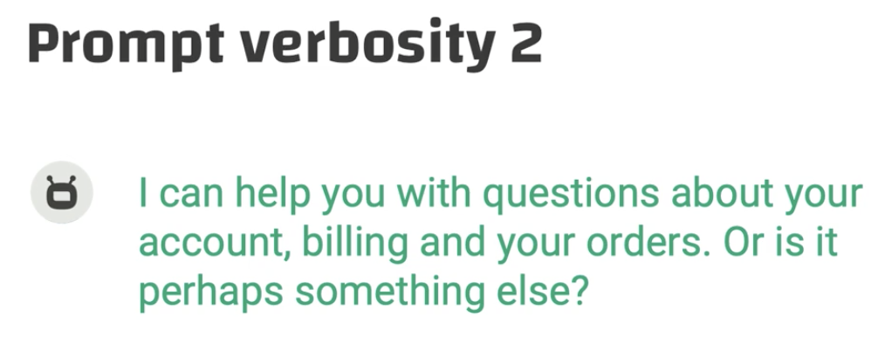

Let’s try it in this way. For …

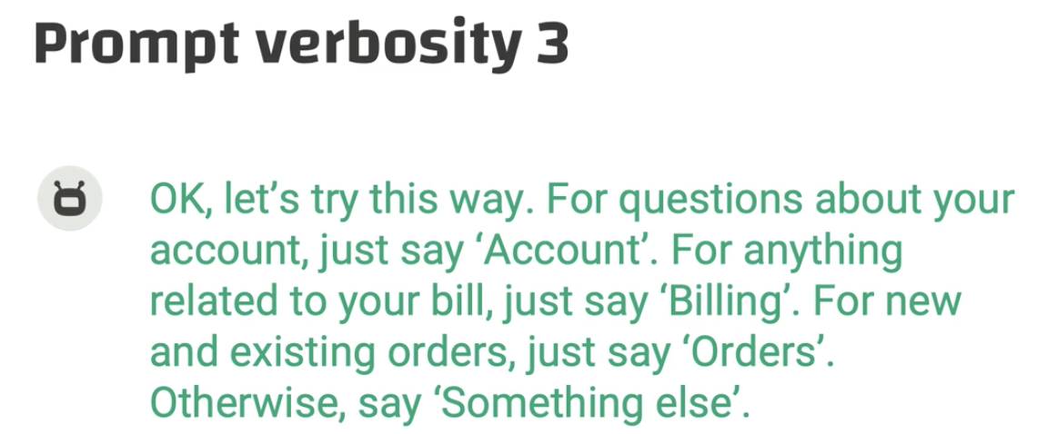

### Don’t repeat exact the same wording

* **Escalating detail is another term for prompt verbosity**

## Barge-in

* A kind of interruption
* Voice-related rather than chatbots

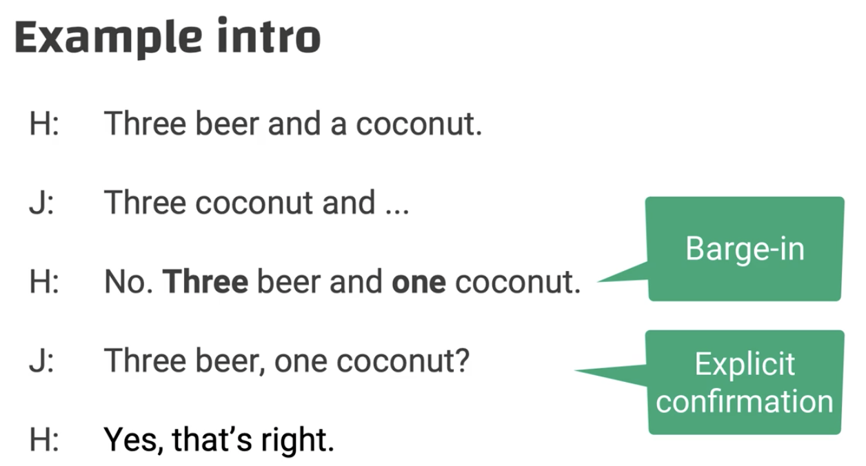

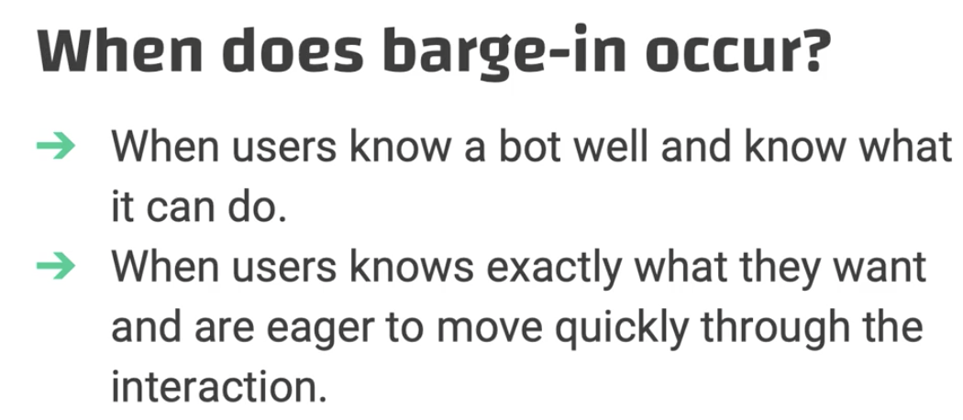

### When the barge-in is appropriate

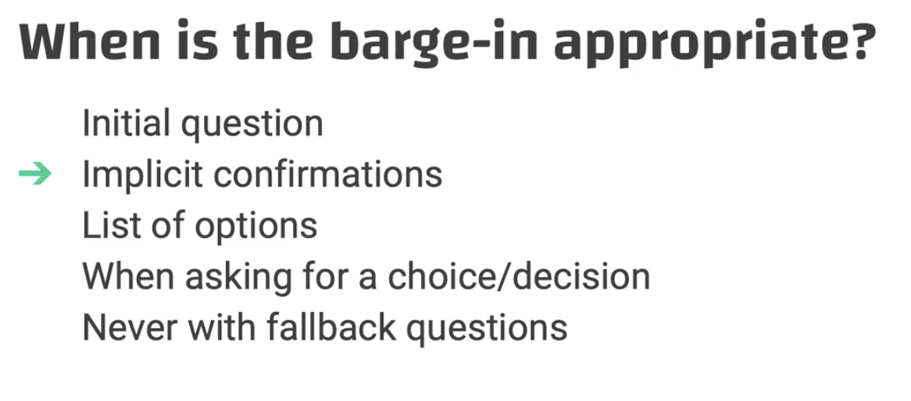

* Initial question

(1)

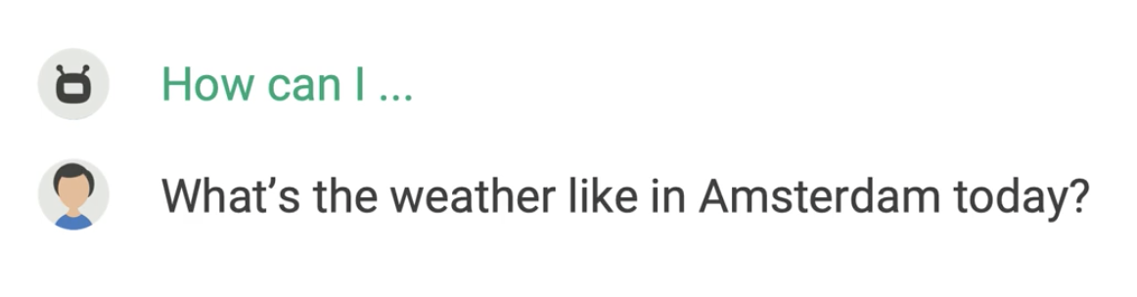

(2)

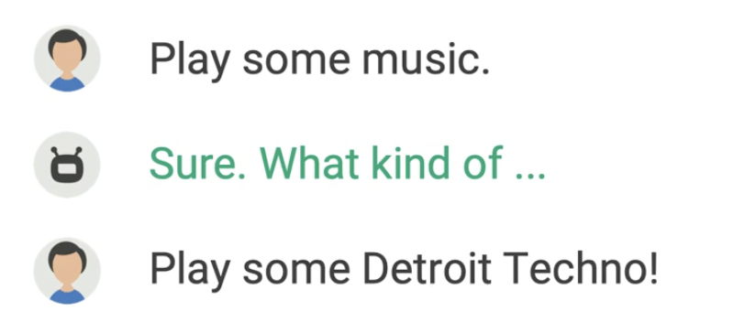

* List of options

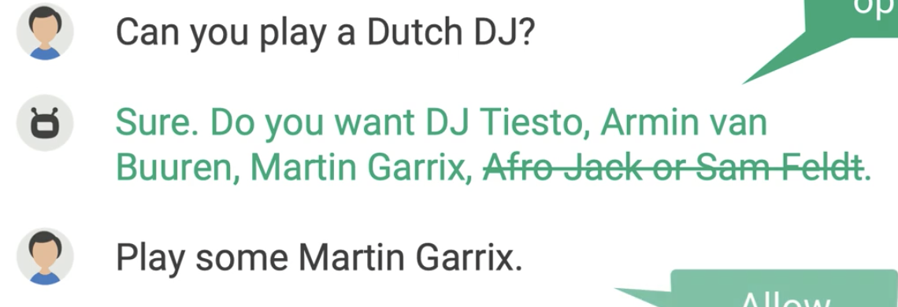

* When making a choice

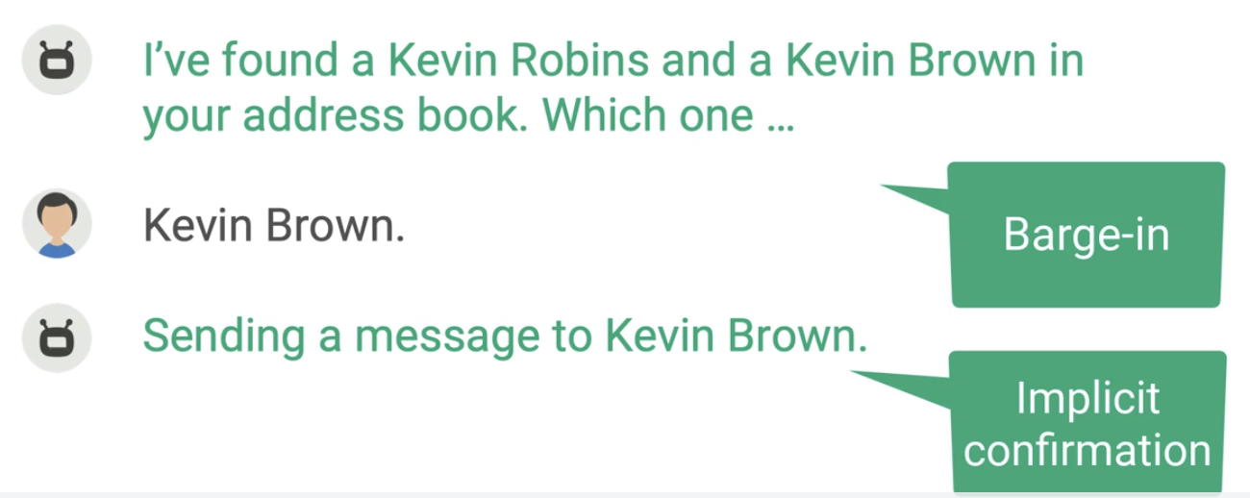

### When the barge-in is NOT appropriate

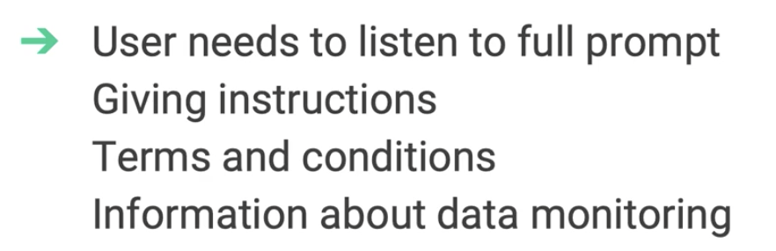

We don’t allow the user to do barge-in all the time.

## Empathy

* Def: you show you understand the user’s situation

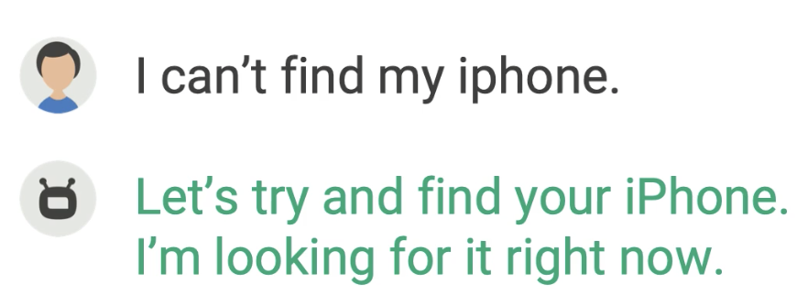

### Compliment as empathy (even with an AI)

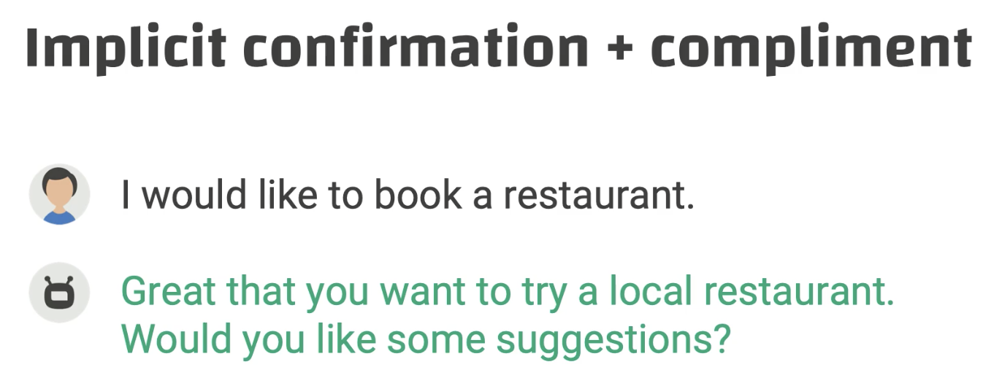

### Guessing the user’s emotions + repeating the user’s problem

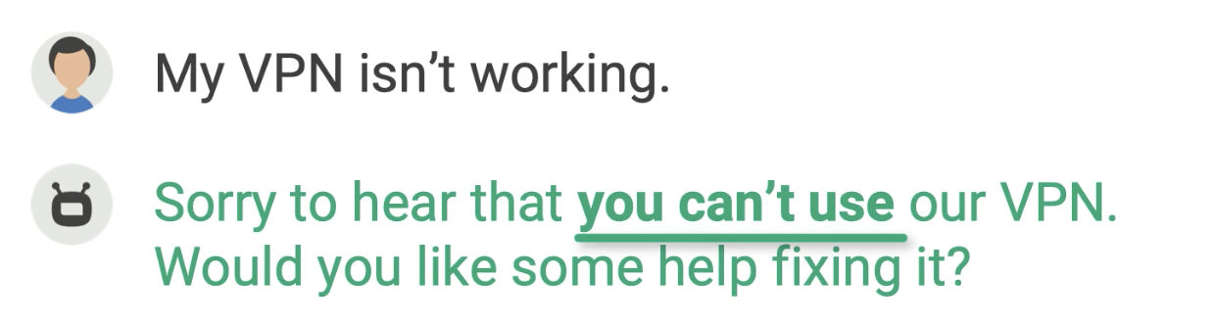

### Problem solver: doesn’t help much

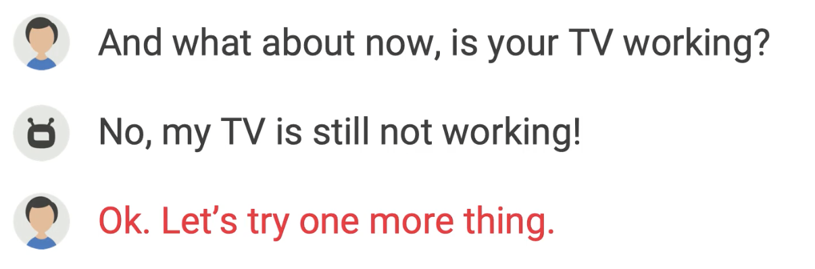

### Write from the user’s perspective

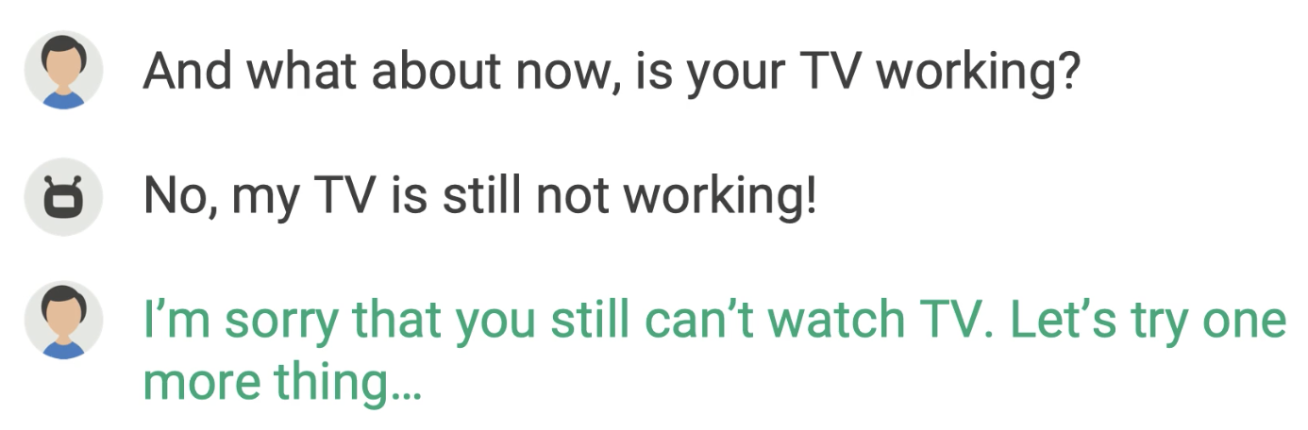

### Empathize with the user’s effort: supreme empathy

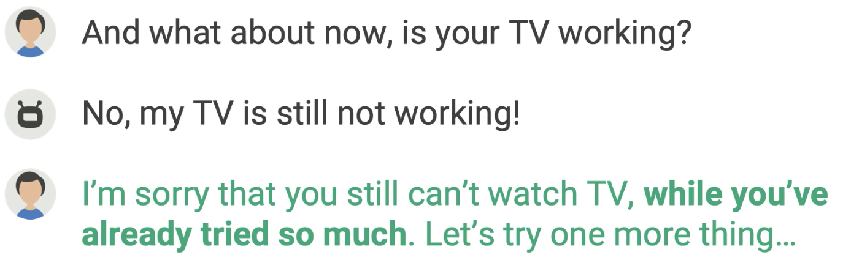

### Apologize on behalf of the company

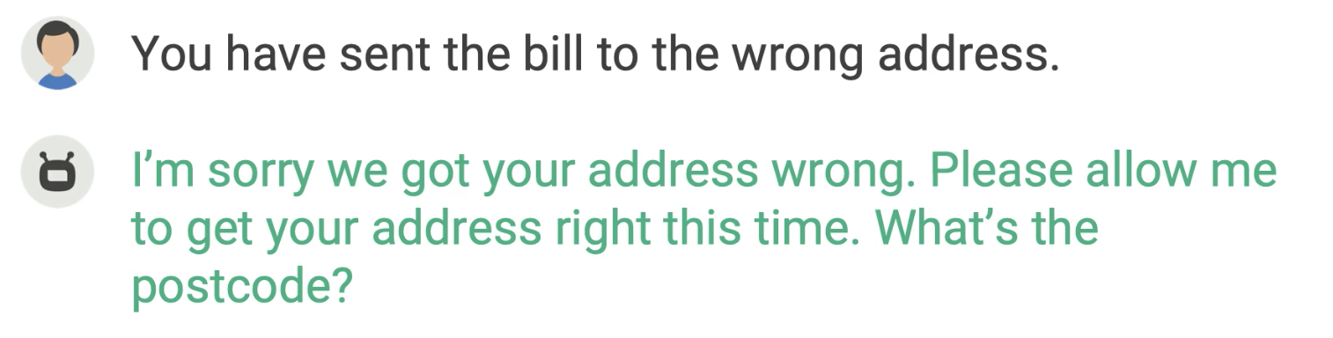

### Show gratitude

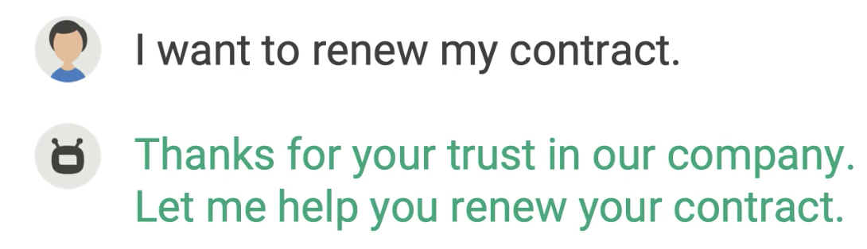

We need to avoid risky assumptions

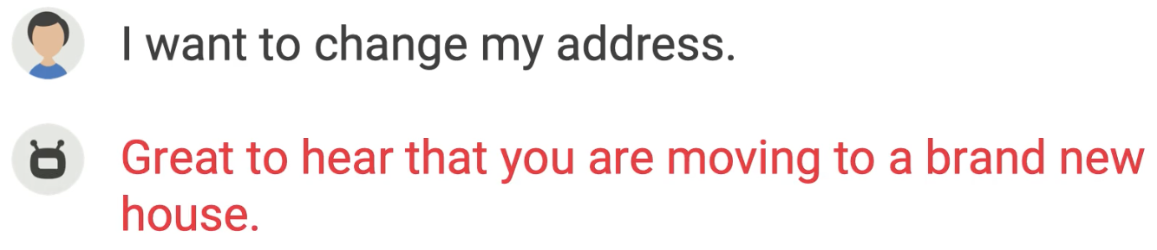

### Don’t ask for the user for empathy → this is NOT user-centric

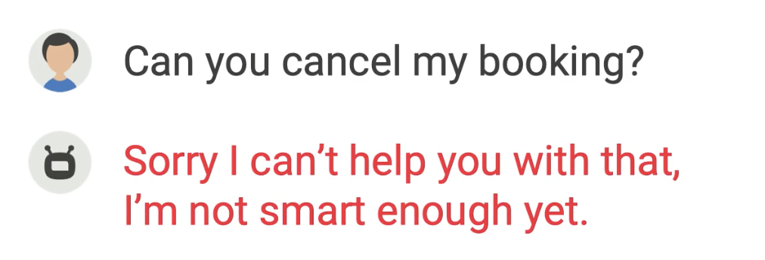

Rewrite:

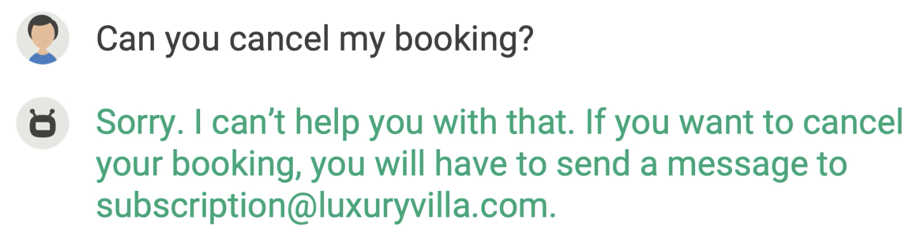

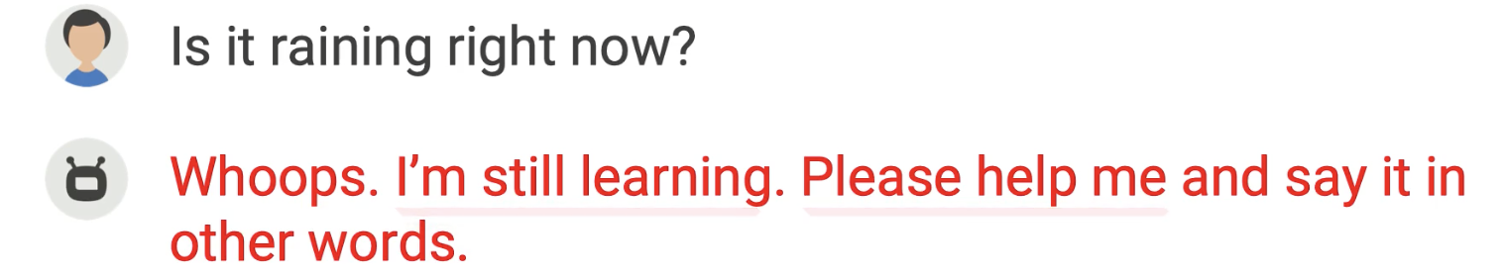

Revision: Can you put your words in a different way?

Another bad example:

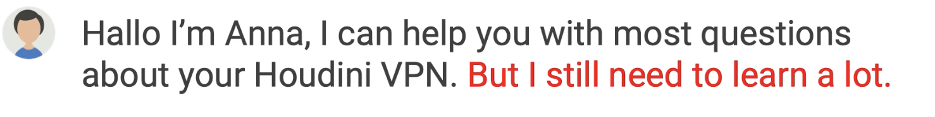

Revision: change the red line into “What do you need?”

* Sometimes full of emotions is not a good thing either

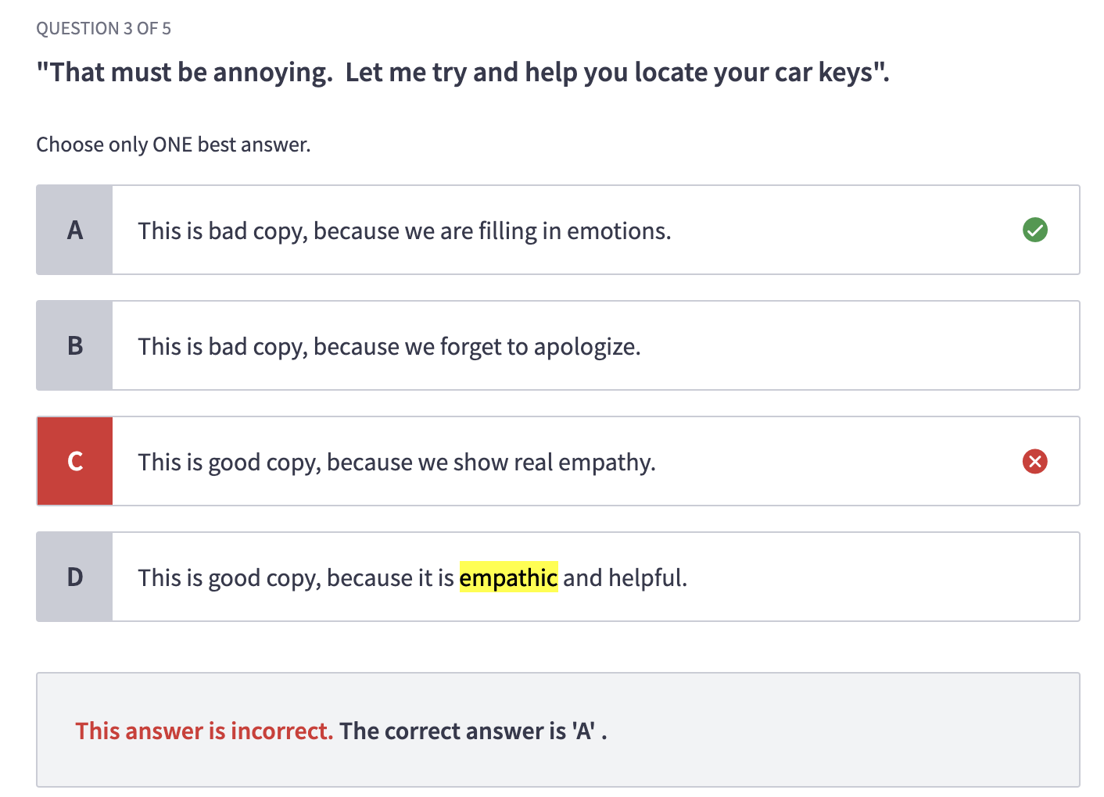

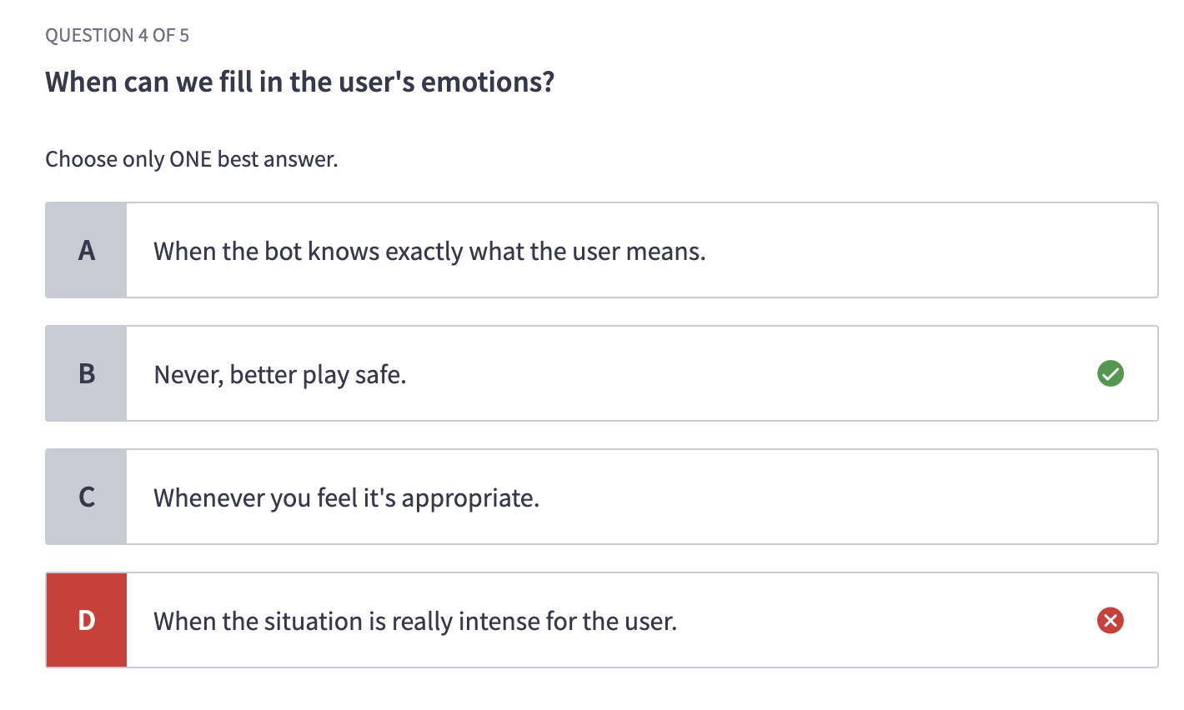

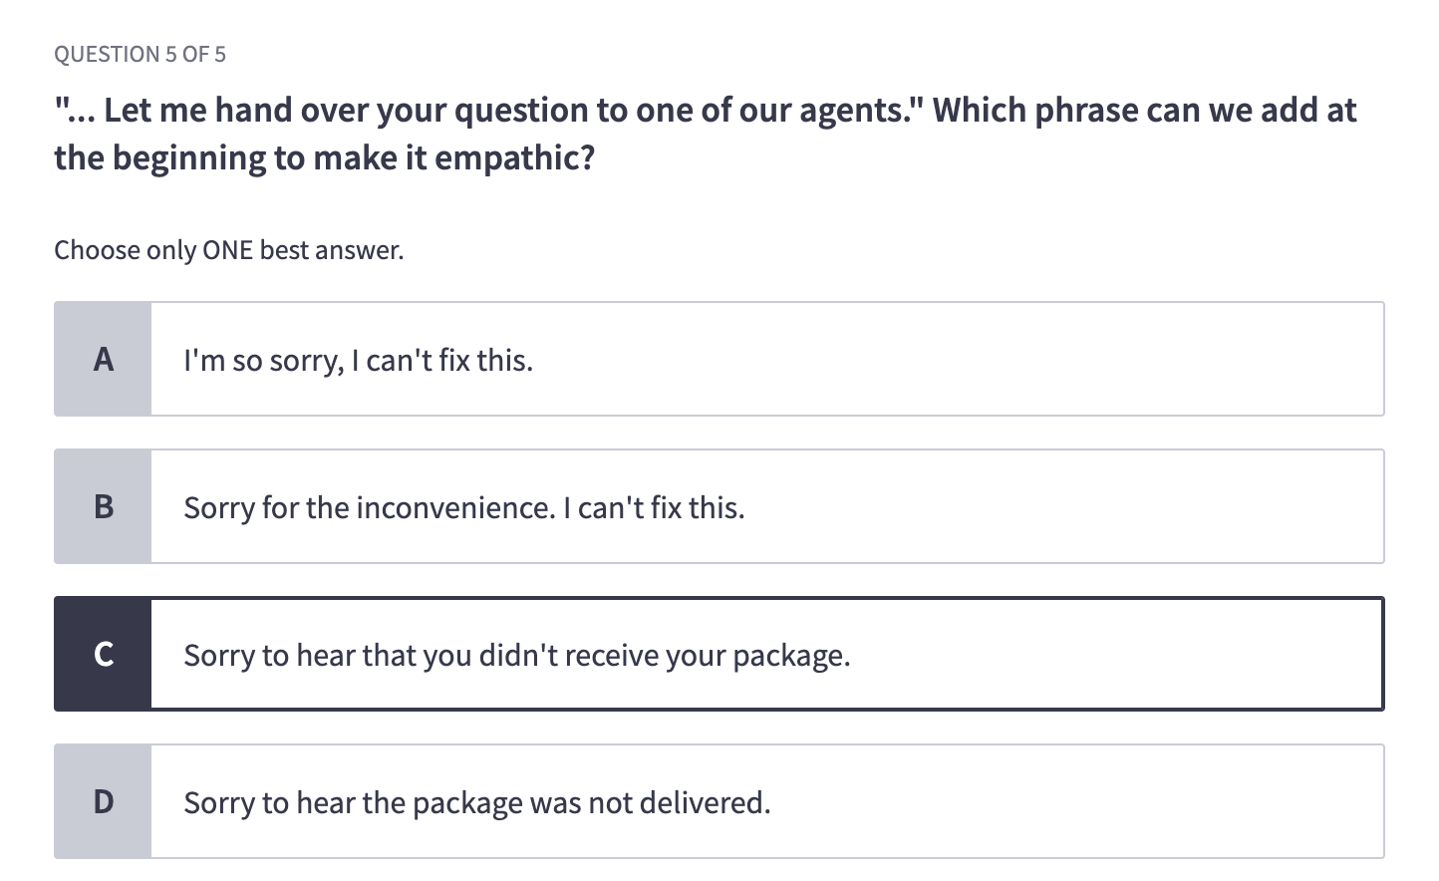

## Tapering: make it shorter

* Tapering means making your conversation **shorter** if the user already knows the context

Ex1 (answers)

Initial:

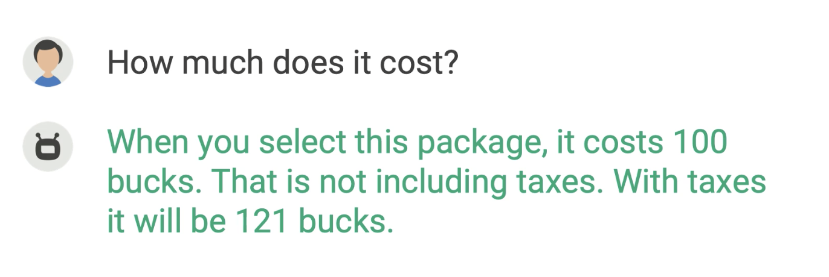

Tapering:

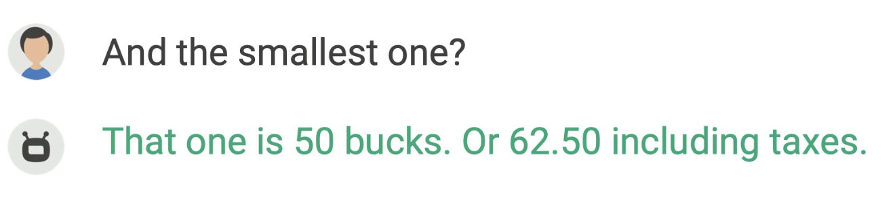

Ex2:

Reduce asking the same question again and again

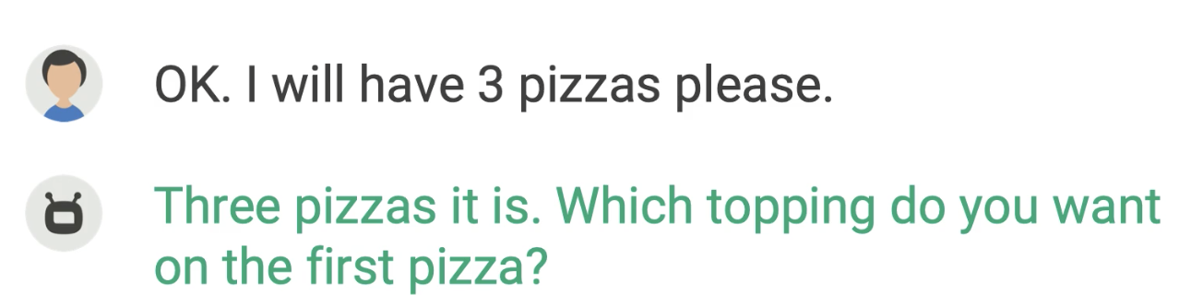

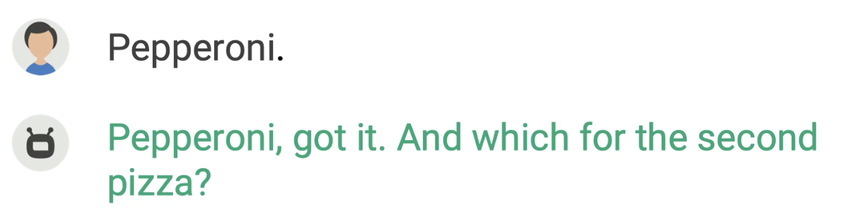

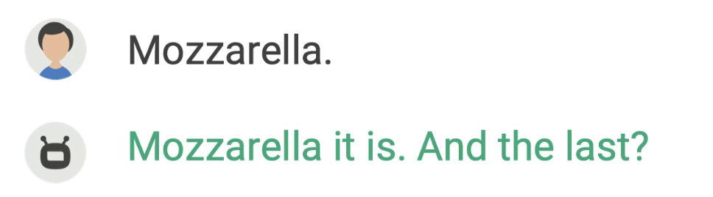

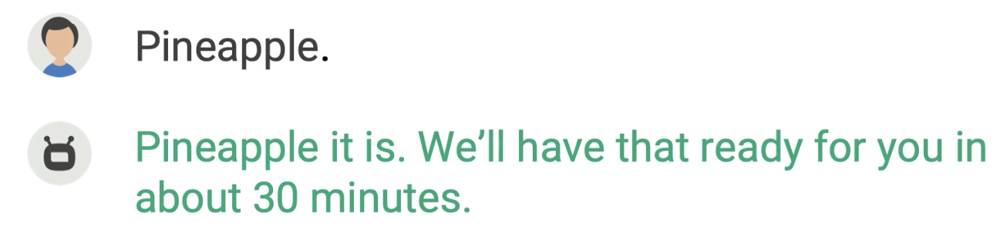

## Jenga technique

* Goal: taking out words can make your conversation short, fresh, and natural

Ex:

Do you want more conversion on your website? → Do you want more conversion?

→ Want more conversion?

* **250 ms for your brain to process a word; 25s to read 100 words**

## Discourse markers

* Words and expressions related to the context/discourse; functions like a glue
* Organizing:

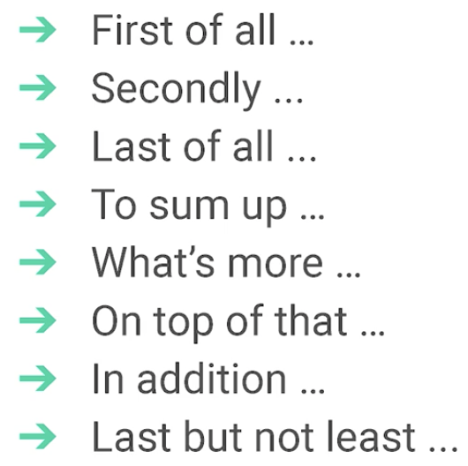

Ex1:

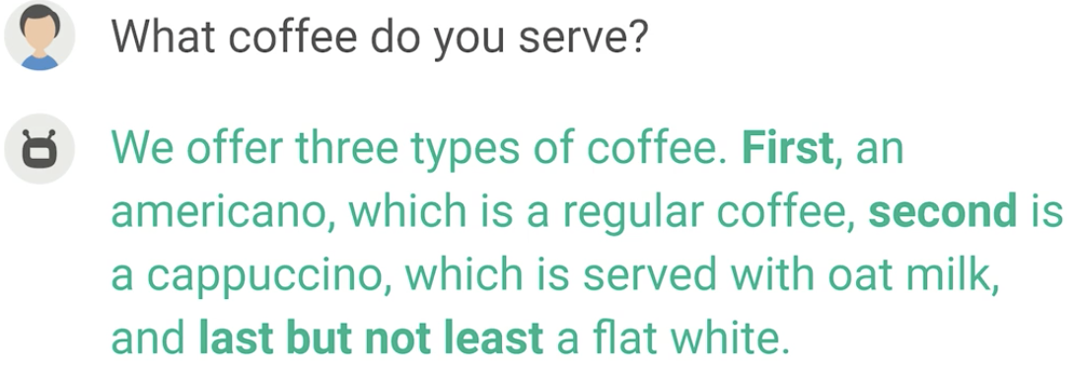

* Cause and effect

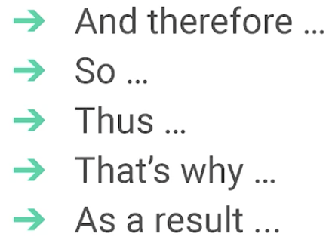

Ex2:

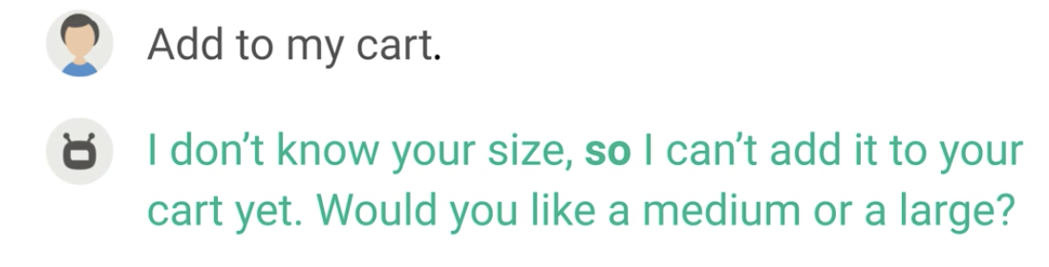

Ex3:

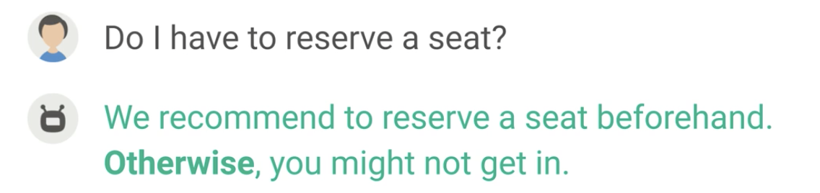

* Change the subject:

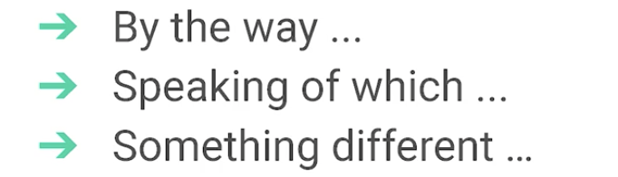

Ex4:

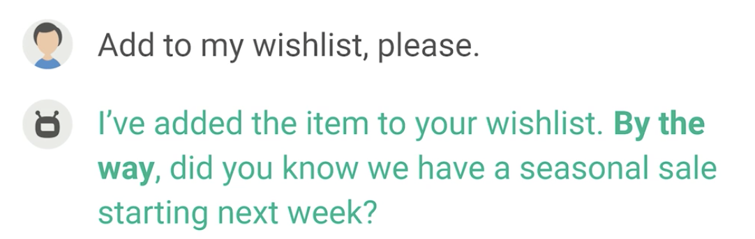

Ex5:

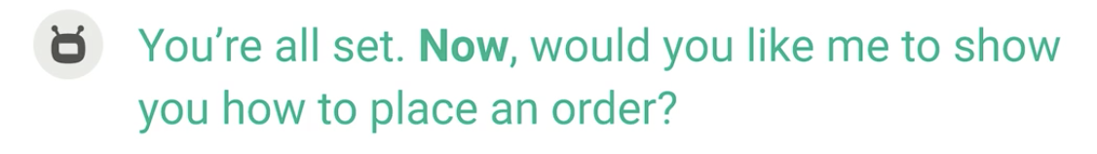

Showing emotions

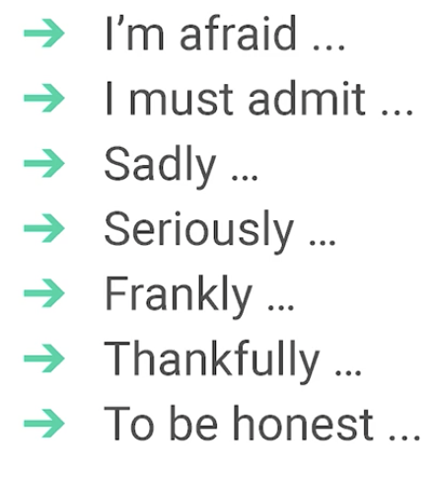

Some quiz questions:

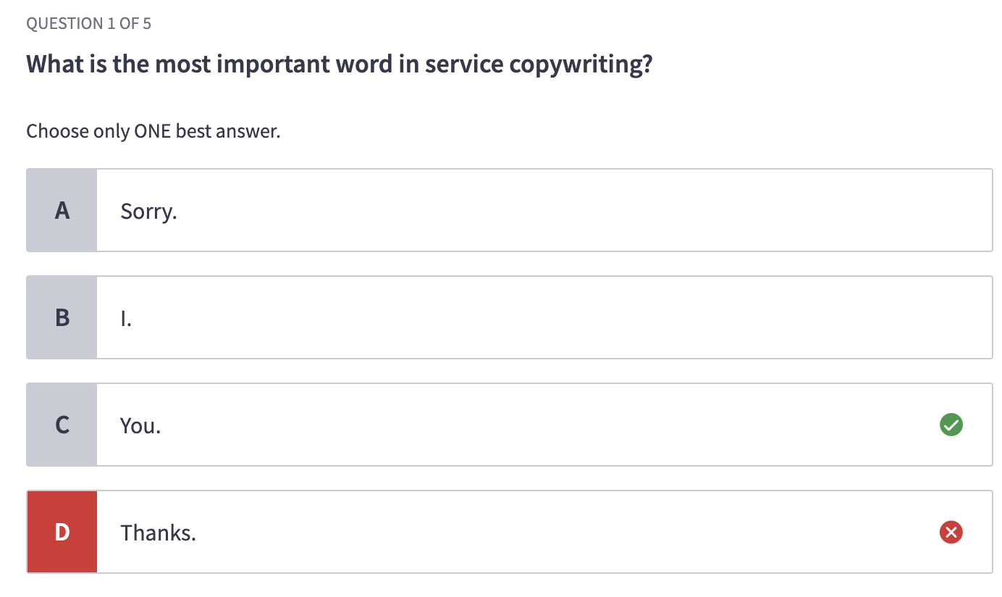

## Error handling

Four basic types of errors

### No input: I (the bot) heard nothing

* Various causes (general): maybe what the bot gives doesn’t match what the user wants; maybe the user is still thinking of what to say and needs more time; maybe the user is confused or distracted
* Voice-specific reasons: the user didn’t hear it clearly; the user’s input is not correctly recognized (signal problem); connection errors
* Chat-specific reasons: the user is talking on an different chat; the user is limited to certain platforms like emails; time delay or absence

HOW

* Voice
  + Wait for 5-8 seconds
  + Ask questions again in different ways, usually with more details
  + After 2 attempts, give up
  + **DON’T repeat the same prompt**

**Ex1:**

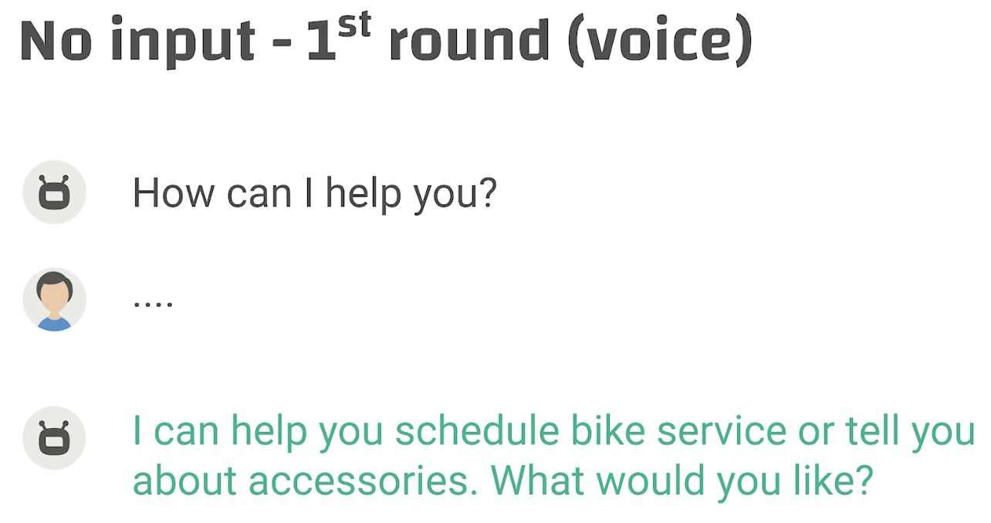

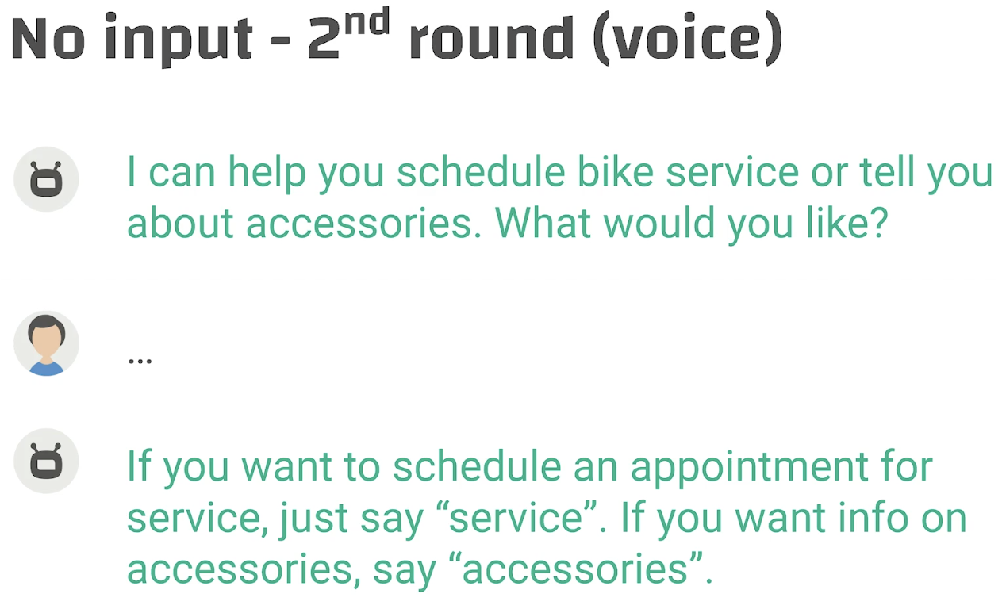

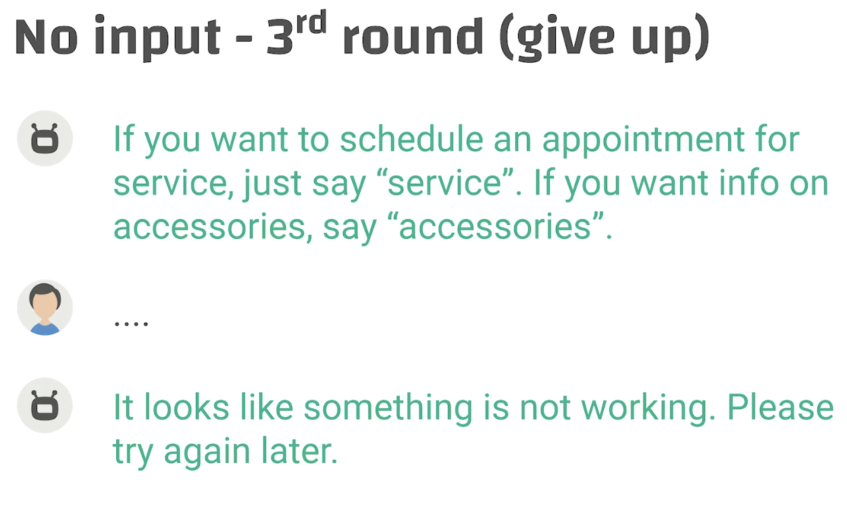

Ex2: At the end the voice, the bot sent info through another channel

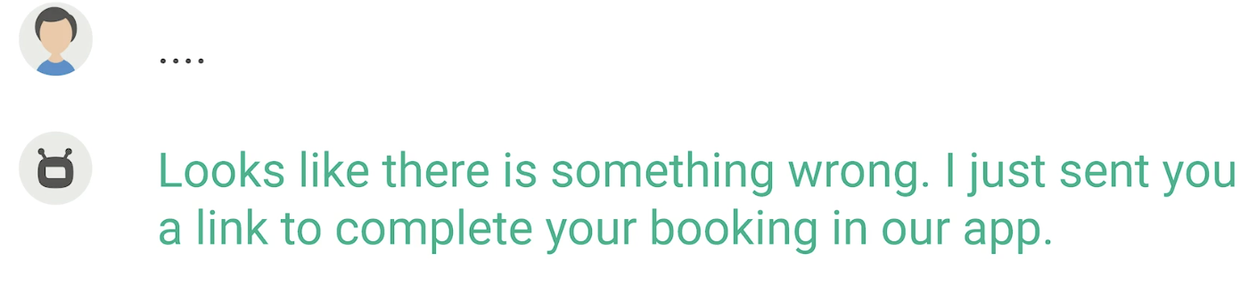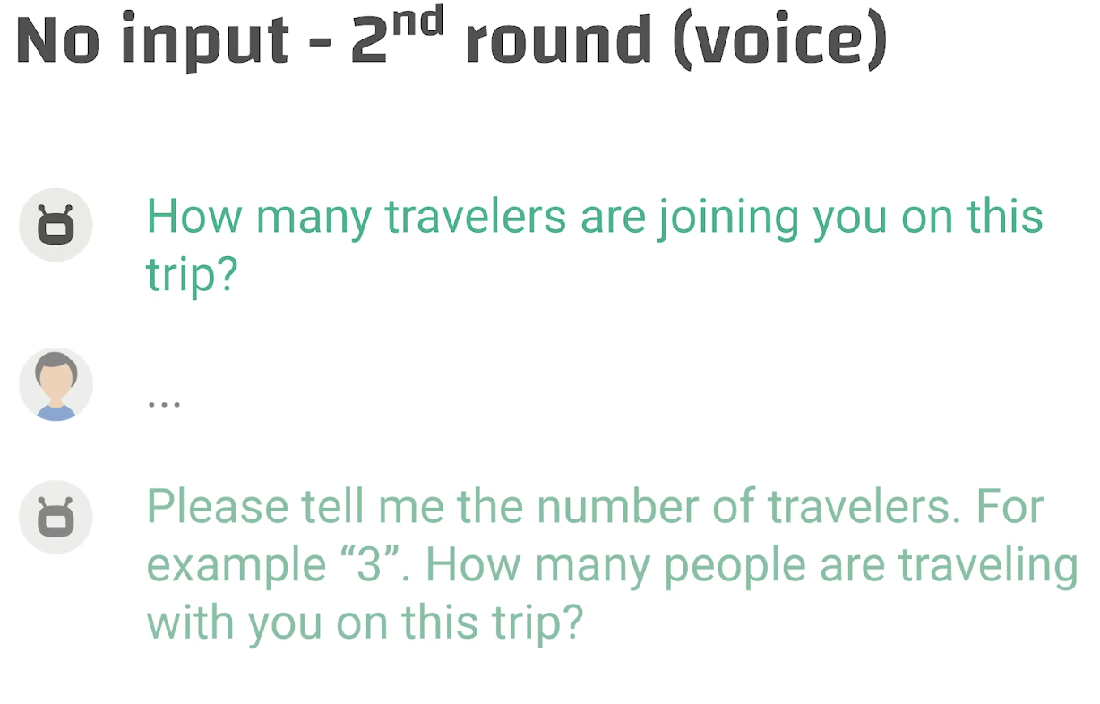

* Chatbot
  + Send some reminder like 3 dots, question marker, or emojis like 👀
  + Wait a bit longer like 10-30 seconds
  + Optional: ask questions in other words

Ex3: no need to repeat the question

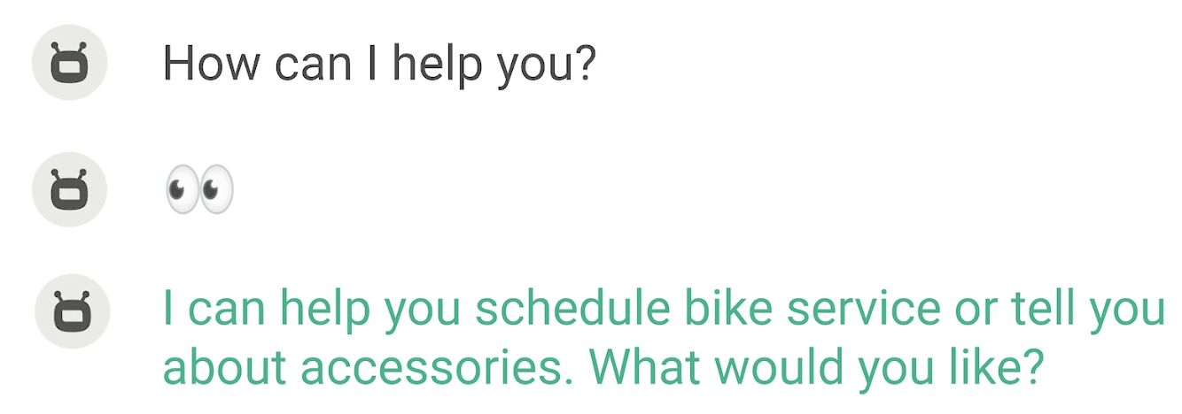

Ex4: transaction

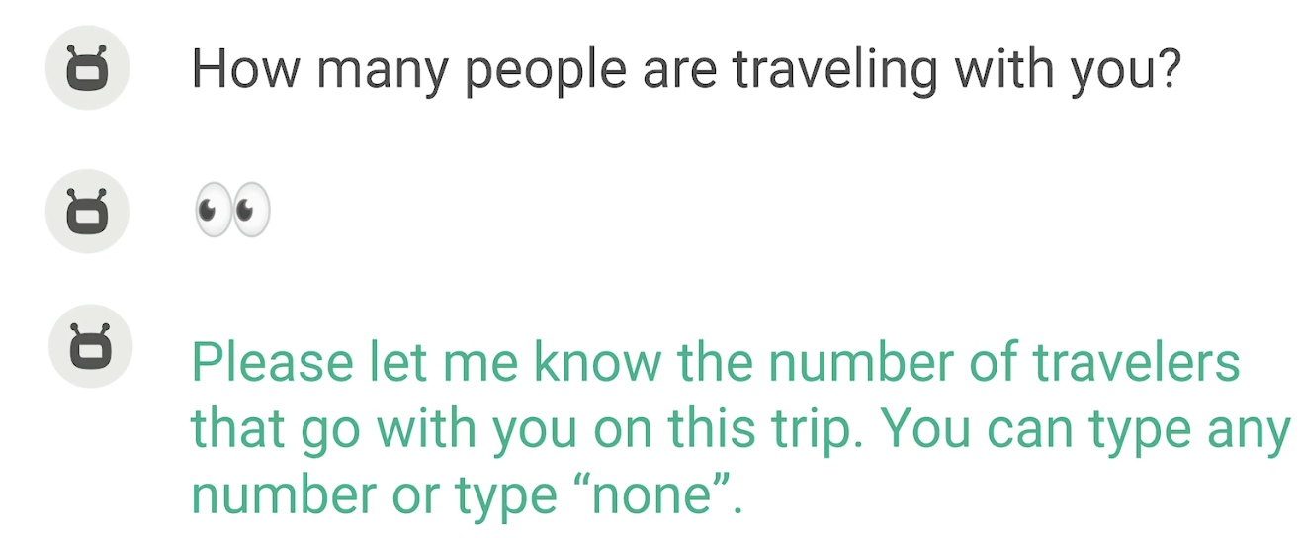

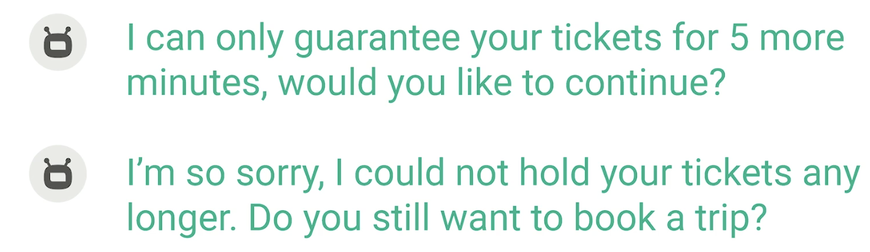

### No match: I didn’t understand what you said.

* No match happens when the user said something out of vocabulary, so the bot cannot recognize it, or said something that is in vocabulary but environmental factors caused the recognition to fail
* Reasons (Voice)
  + Out of grammar
  + Non-native speakers / other languages
  + Talking to other people
  + Heavy accents
  + Noisy environment
  + User has a cold
* Reasons (Chatbot)
  + Out of grammar
  + Other languages
  + Typos and misspellings
  + Cat jumps on the keyboard

Ex1:

escalating details

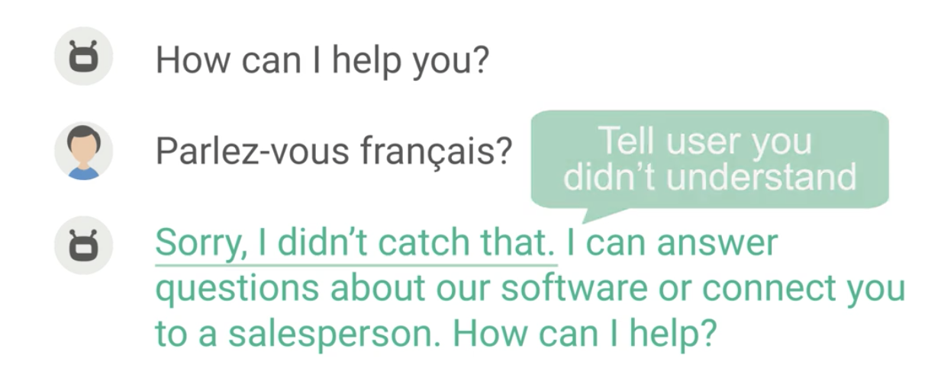

rephrase

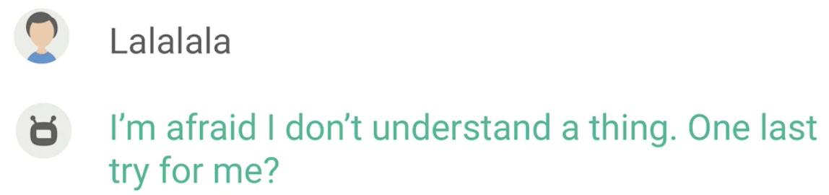

Give up

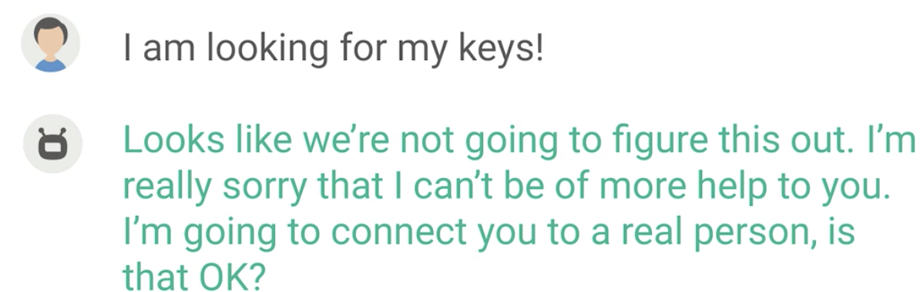

OR:

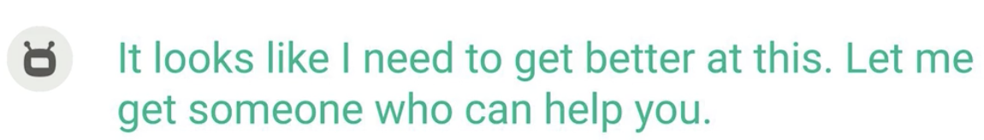

Generic repair prompt (not recommended)

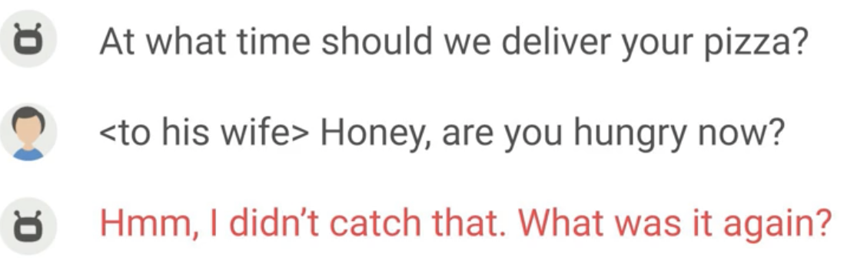

Escalating with more details

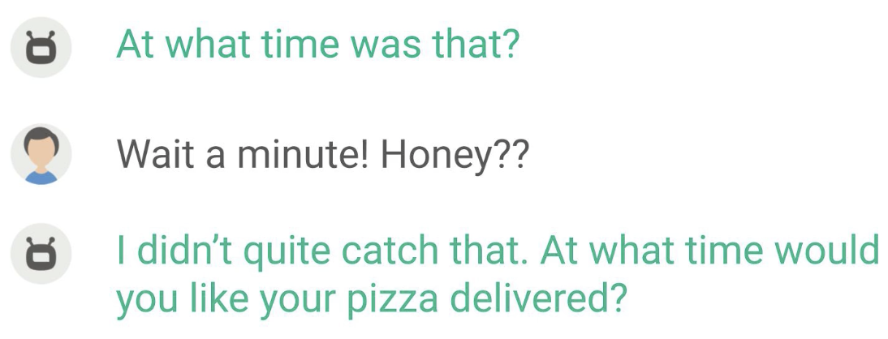

Give up

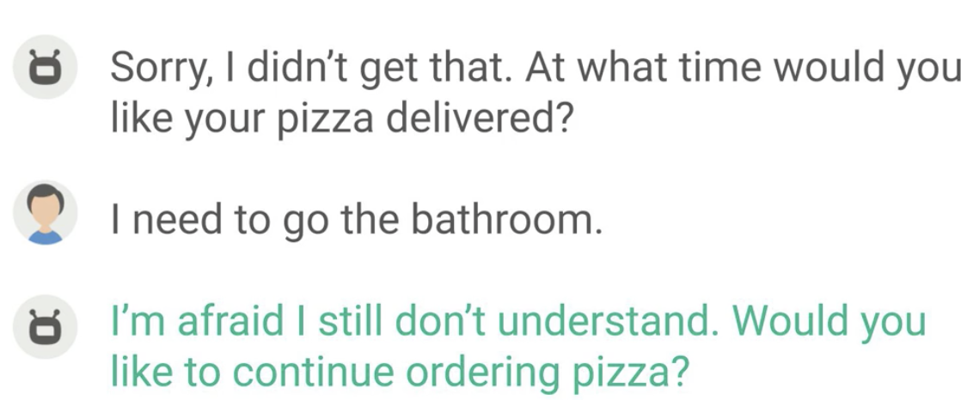

**DON’T BE RUDE**

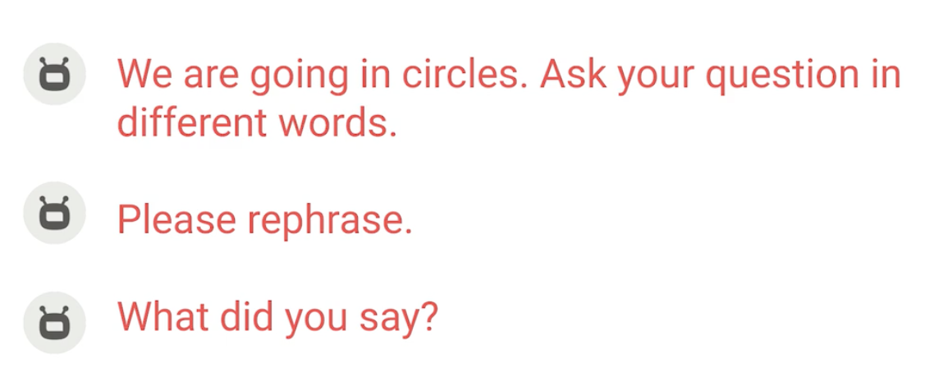

**DON’T FOCUS ON THE BOT’S NEED TO LEARN**

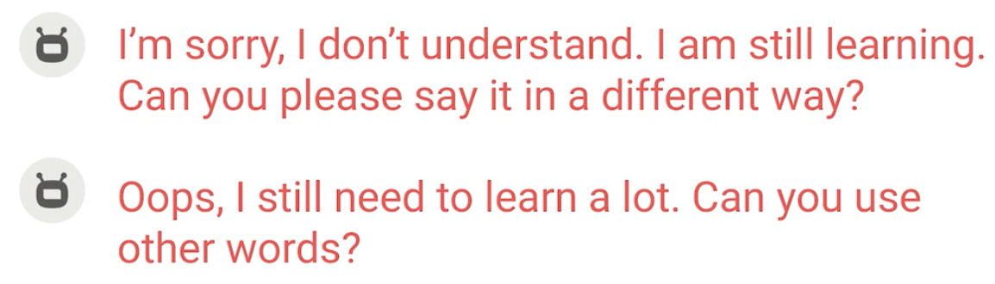

**DON’T APOLOGIZE**

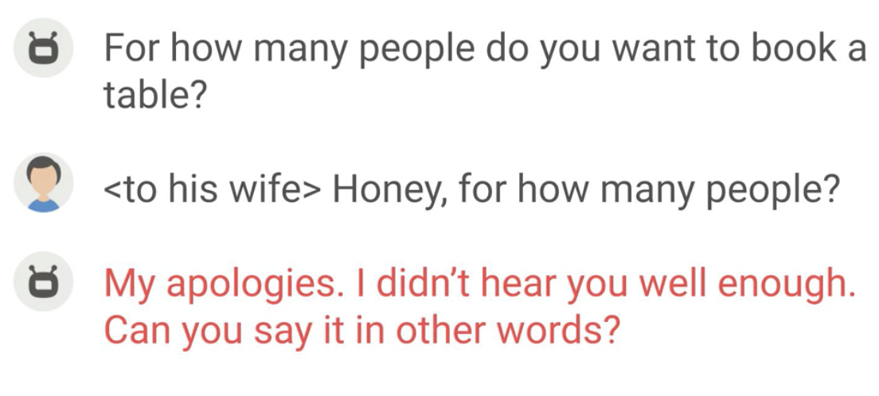

Solution:

### 

### Misrecognition: I understood the wrong thing.

* Goal: learn to reprompt for misinterpretations
* Def: the user may have said something out-of-vocab but the bot recognized it as something in vocab or the user said something in-vocab but the environment made the bot recognize it as something else
* Causes: NLU is not accurate; overlap in terminology;
  + Voice: other ppl’s talking OR talking to other ppl; sneezing, laughing; other languages
* The general strategy is explicit or implicit confirmations

#### Explicit confirmation (**ask if the intent is correct**)

Ex1

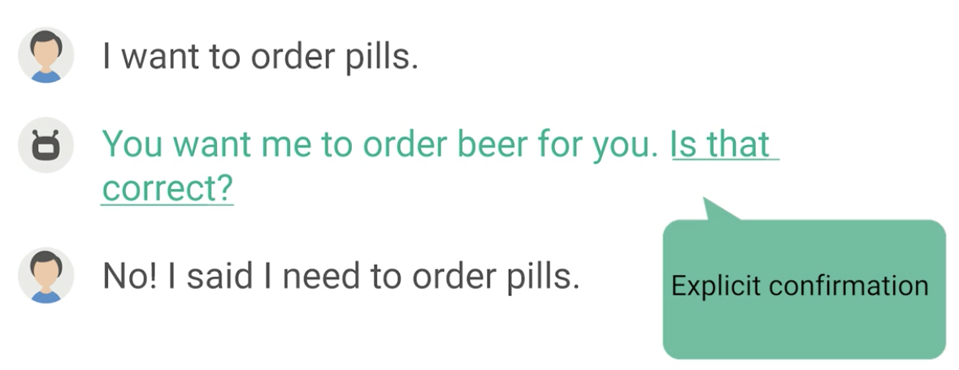

**NO NEED TO APOLOGIZE**

#### Implicit confirmation (directly take the user to the next stage + NEED to apologize)

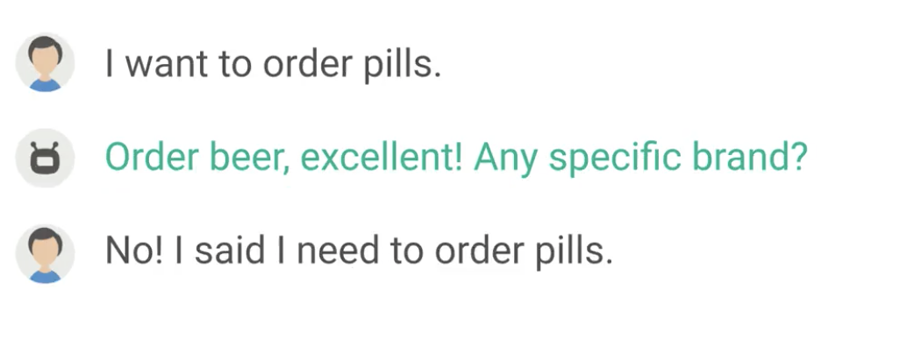

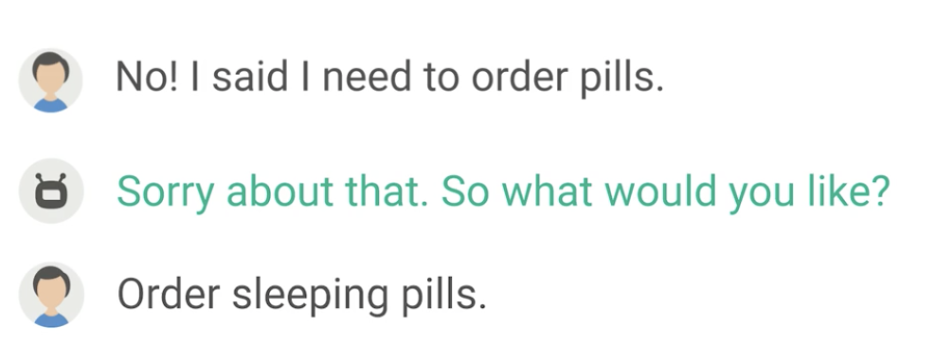

#### Reaction to misrecognition

Ex1: a button design to consider the cancellation condition

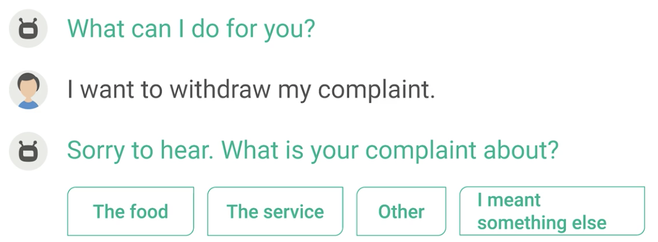

### Task failure: I cannot resolve the issues even if I understand it.

#### Ask to try again later

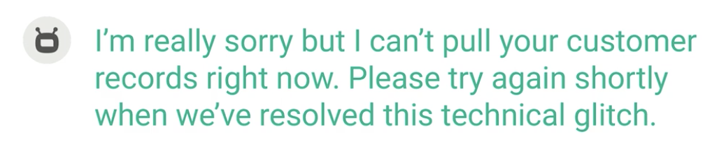

#### Too many restrictions

→ give new suggestion

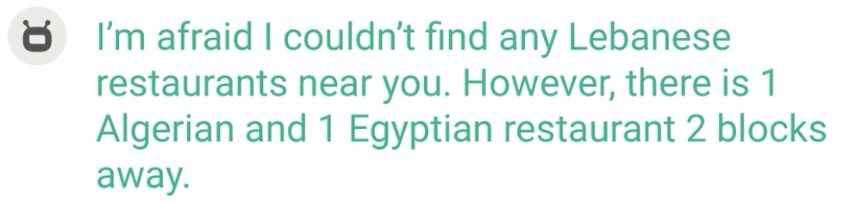

#### The user doesn’t qualify

→ tell the user that you cannot help them and offer further suggestions/help, e,g., escalation

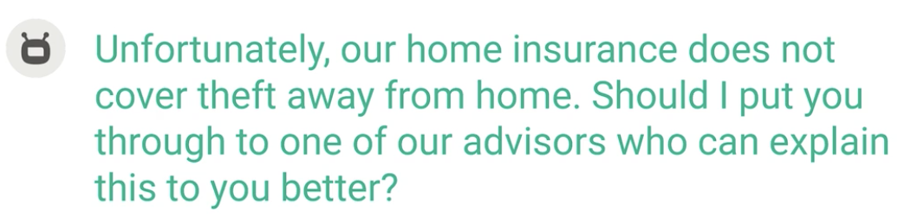

#### Solution is not yet developed

→ tell the user that you are not capable to help and explain what you can do

→ only apologize if you think you are not meeting realistic expectations

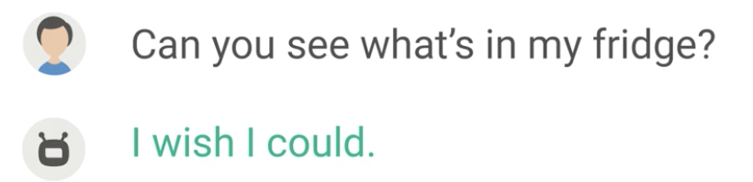

When giving suggestions, you can put close ones (instead of anything):

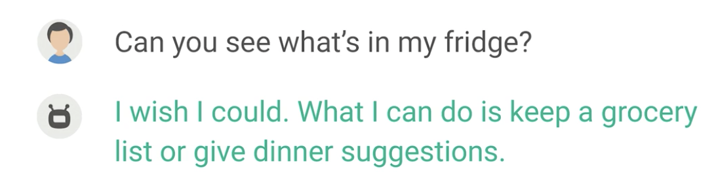

#### (Chatbot) There is no need to say I cannot do it

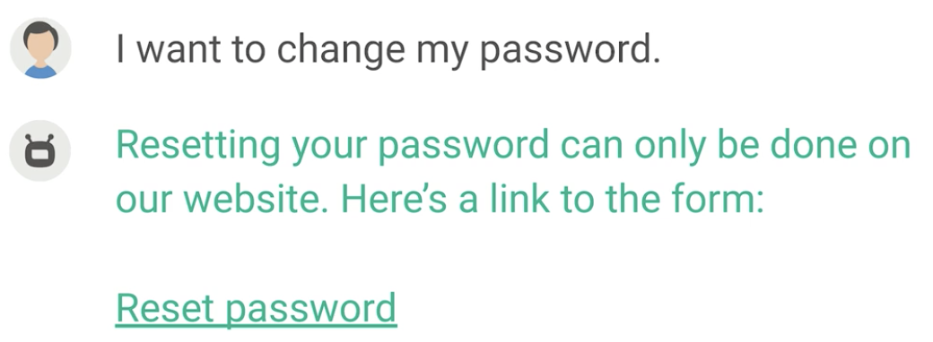

## How to represent lists (for VUIs)

* Chatbots have a menu for selections
* As for voice, we need to use our limited auditory memory; we need to specify a common plus pause (350ms) between items by using SSML (speech synthesis markup language), but a complicated item takes 450ms

Ex1:

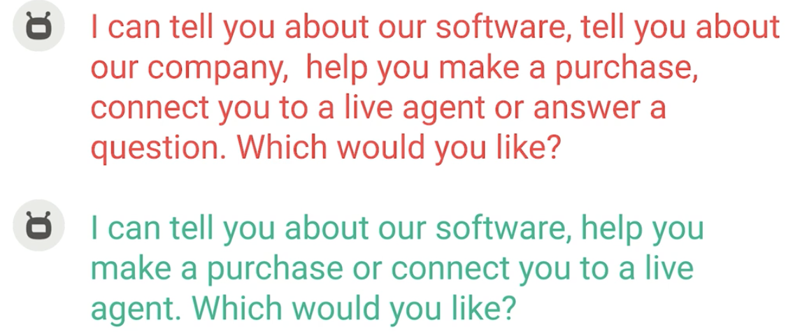

* Make your list brief: need personal recommendations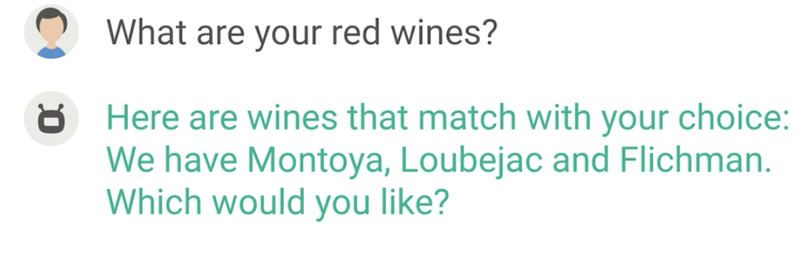
* Make items consistent in forms/phrase types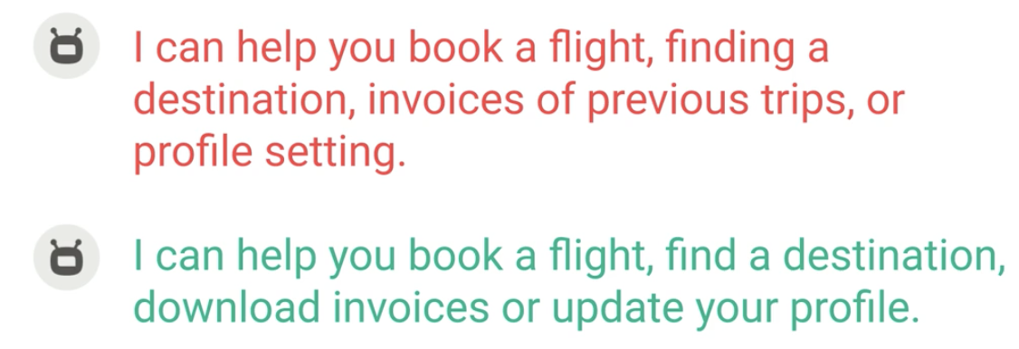
* Announce and split list items

**Announcing the numbers + picking up some items**

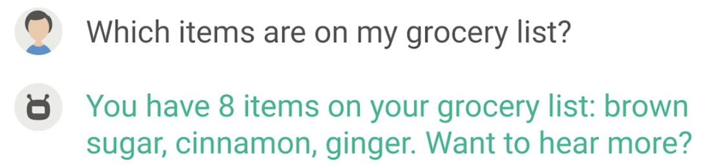

* Make options sound distinct

Branch - ranch; long - lonely

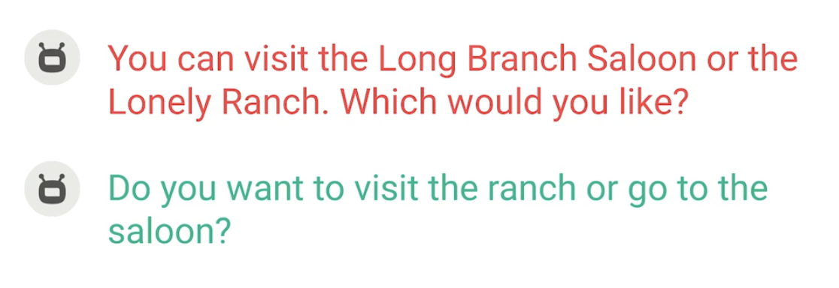

* List familiar litems; don’t list unfamiliar items

It’s easier to list things like colors

Some items like search results of hotels/restaurants are not recommended to list in VUI

* Don’t list unfamiliar items without additional information

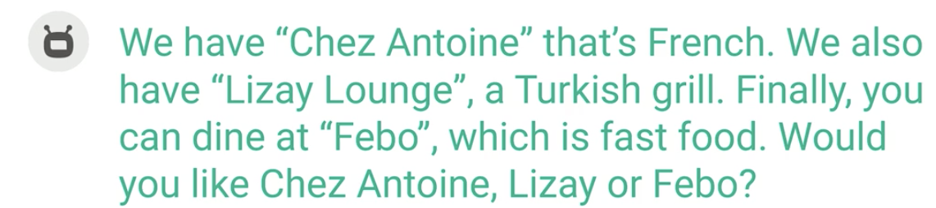

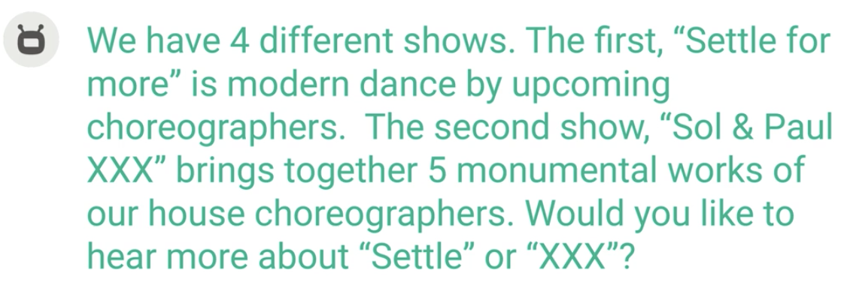

The second example has use of numbering discourse markers

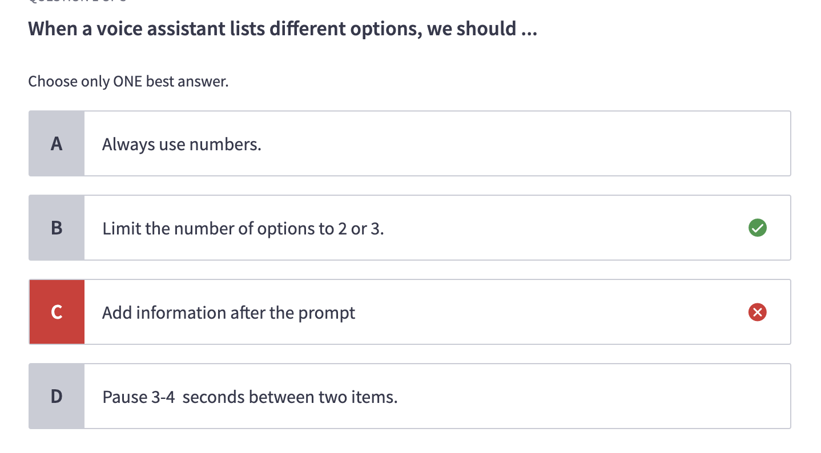

## Add more variety

* Vary acknowledgments

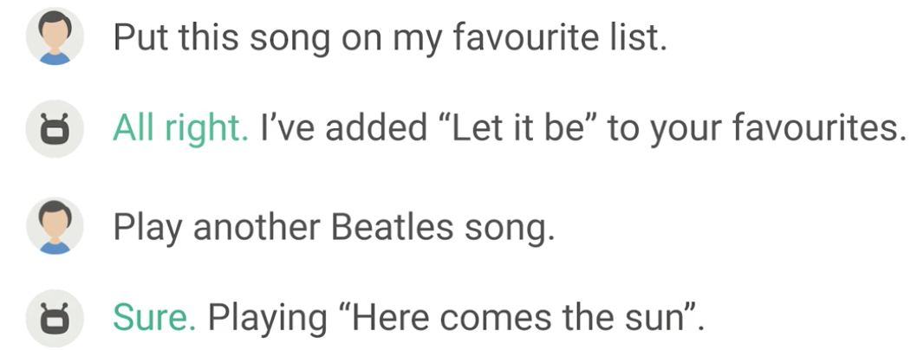

* Vary responses

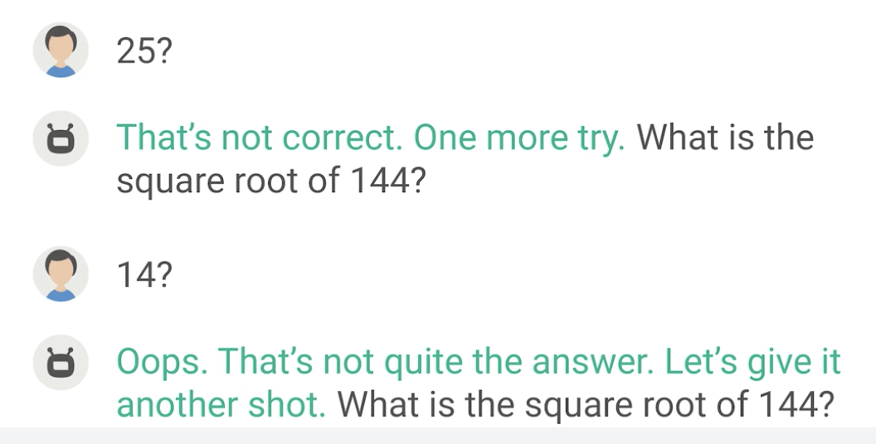

* Escalating detail is a form of variety: elaborating the details

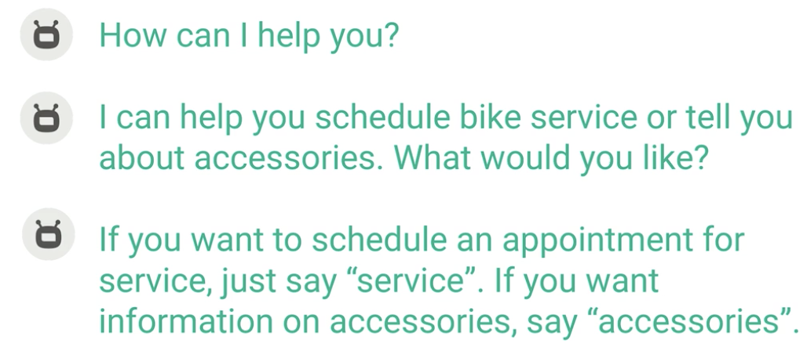

# Section 2: Conversation design workflow

## Intro

* General process

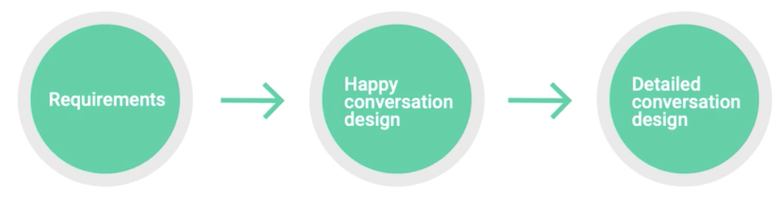

* Requirement:

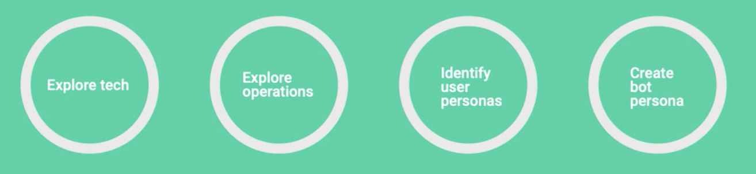

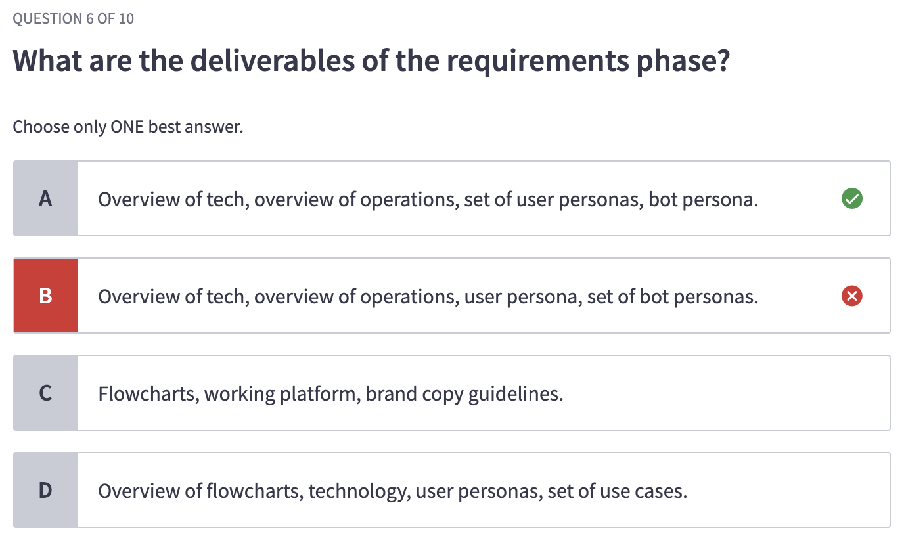

* Explore operations
* Identify user personas

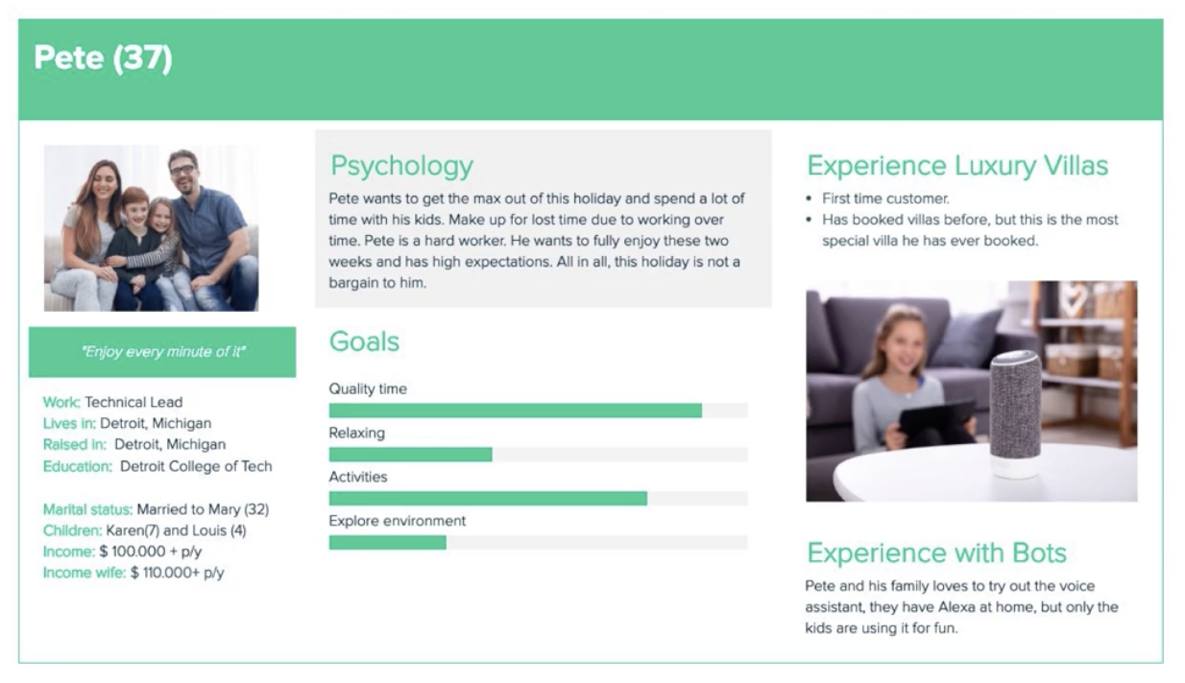

* Create bot personas

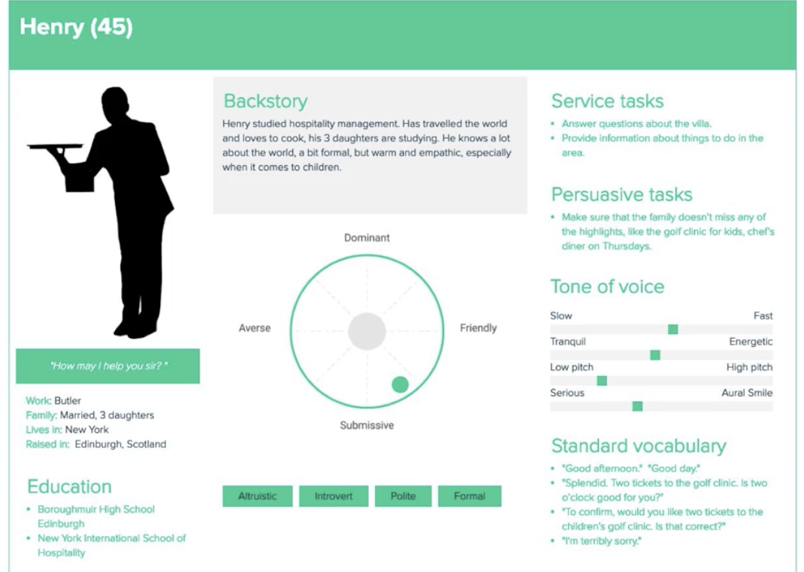

* Happy conversation design

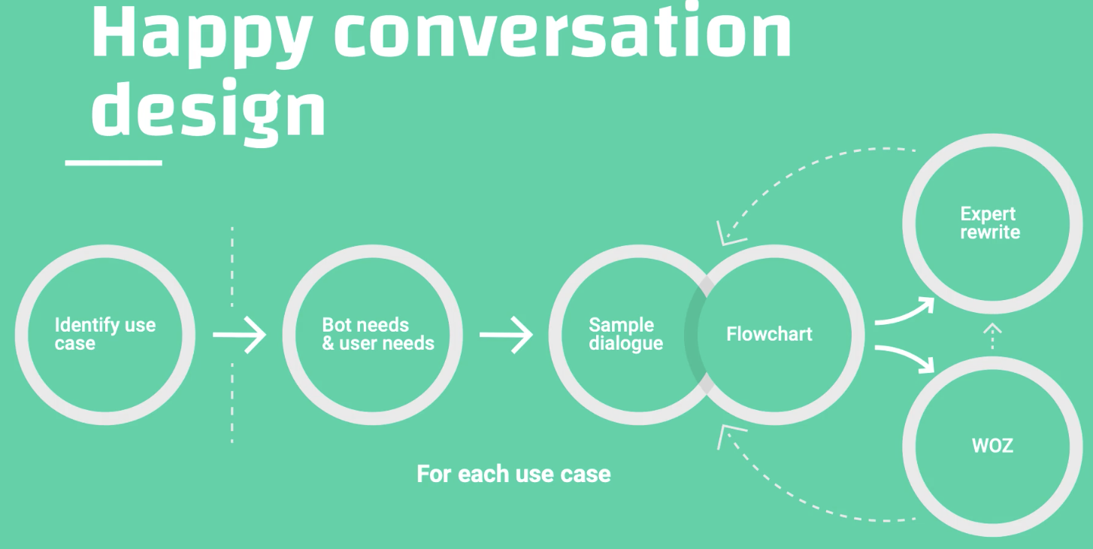

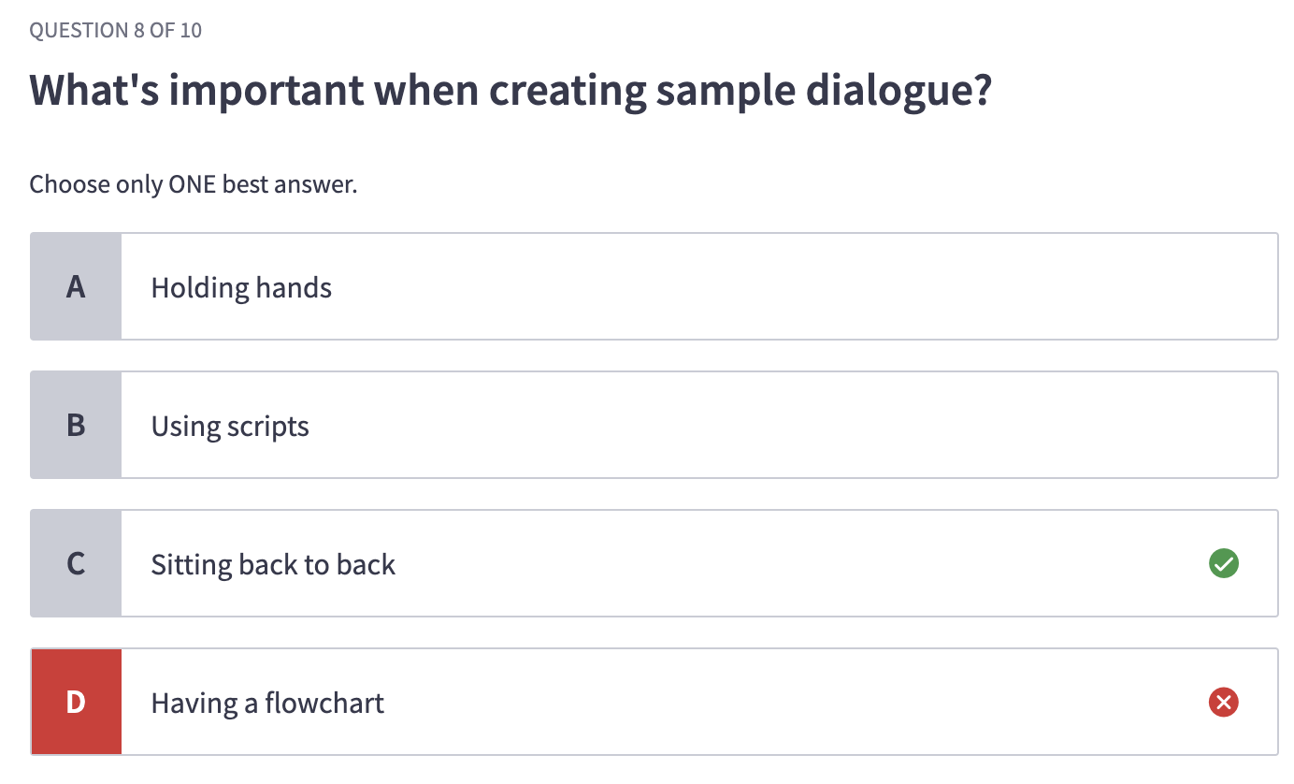

* Detailed conversation design

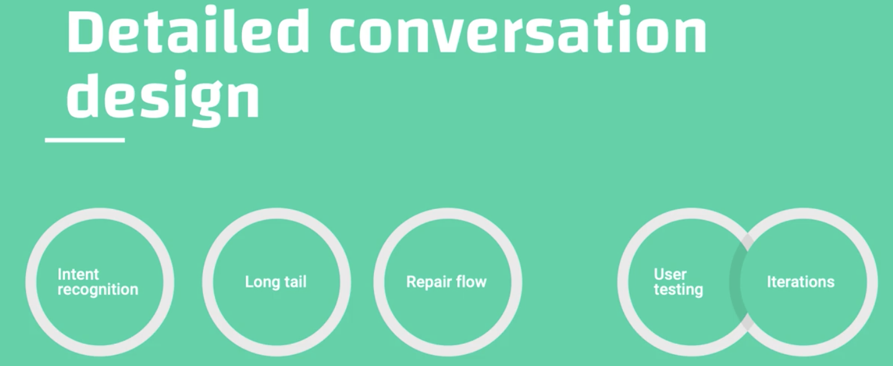

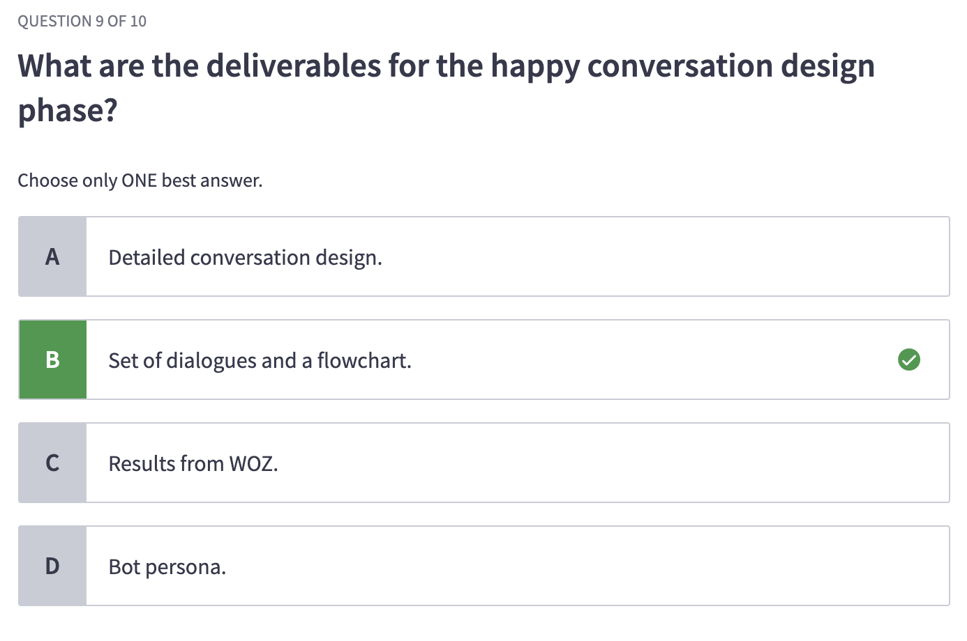

Requirements

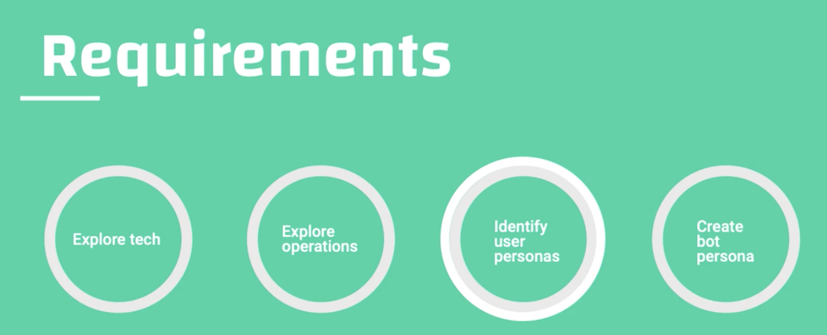

## **Explore tech**

* Goal: understand the technologies behind the bot and how it affects your design
* What to explore
  + Tech team
  + Platform
  + Integrations
  + Channels
  + User identification
  + Hand over options
* Tech team

What does the team look like? Roles? Who is part of team? Who support the team?

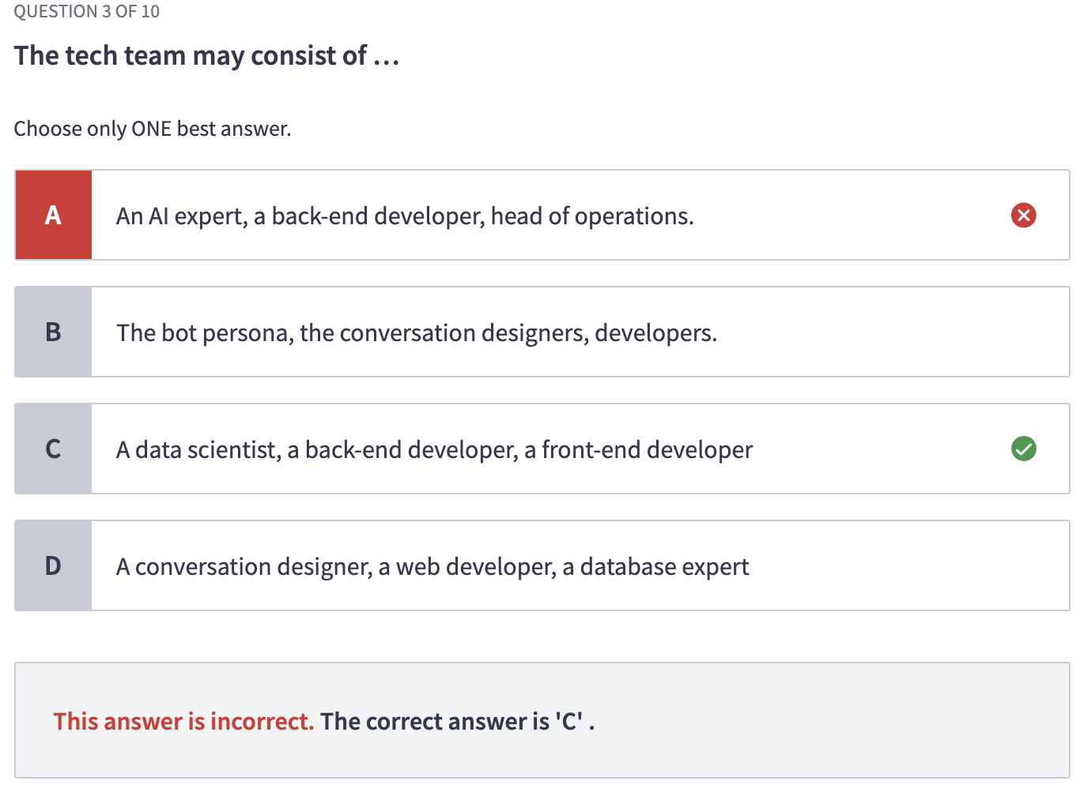

Ex1: VUI in a hotel

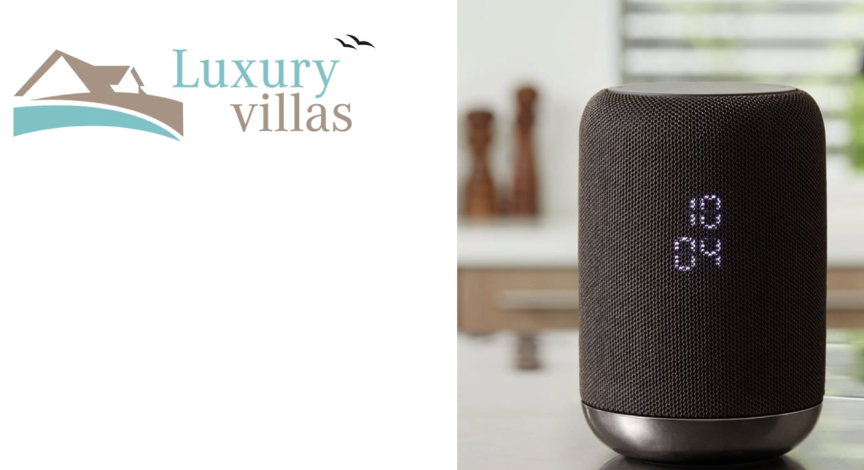

1. Who are working on this project or related to the work?
2. Which conversational platform do we use for this project? Which other platforms does the organization use?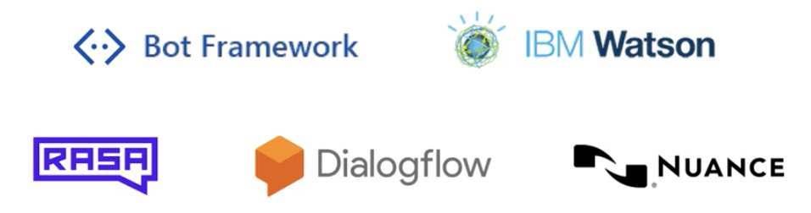

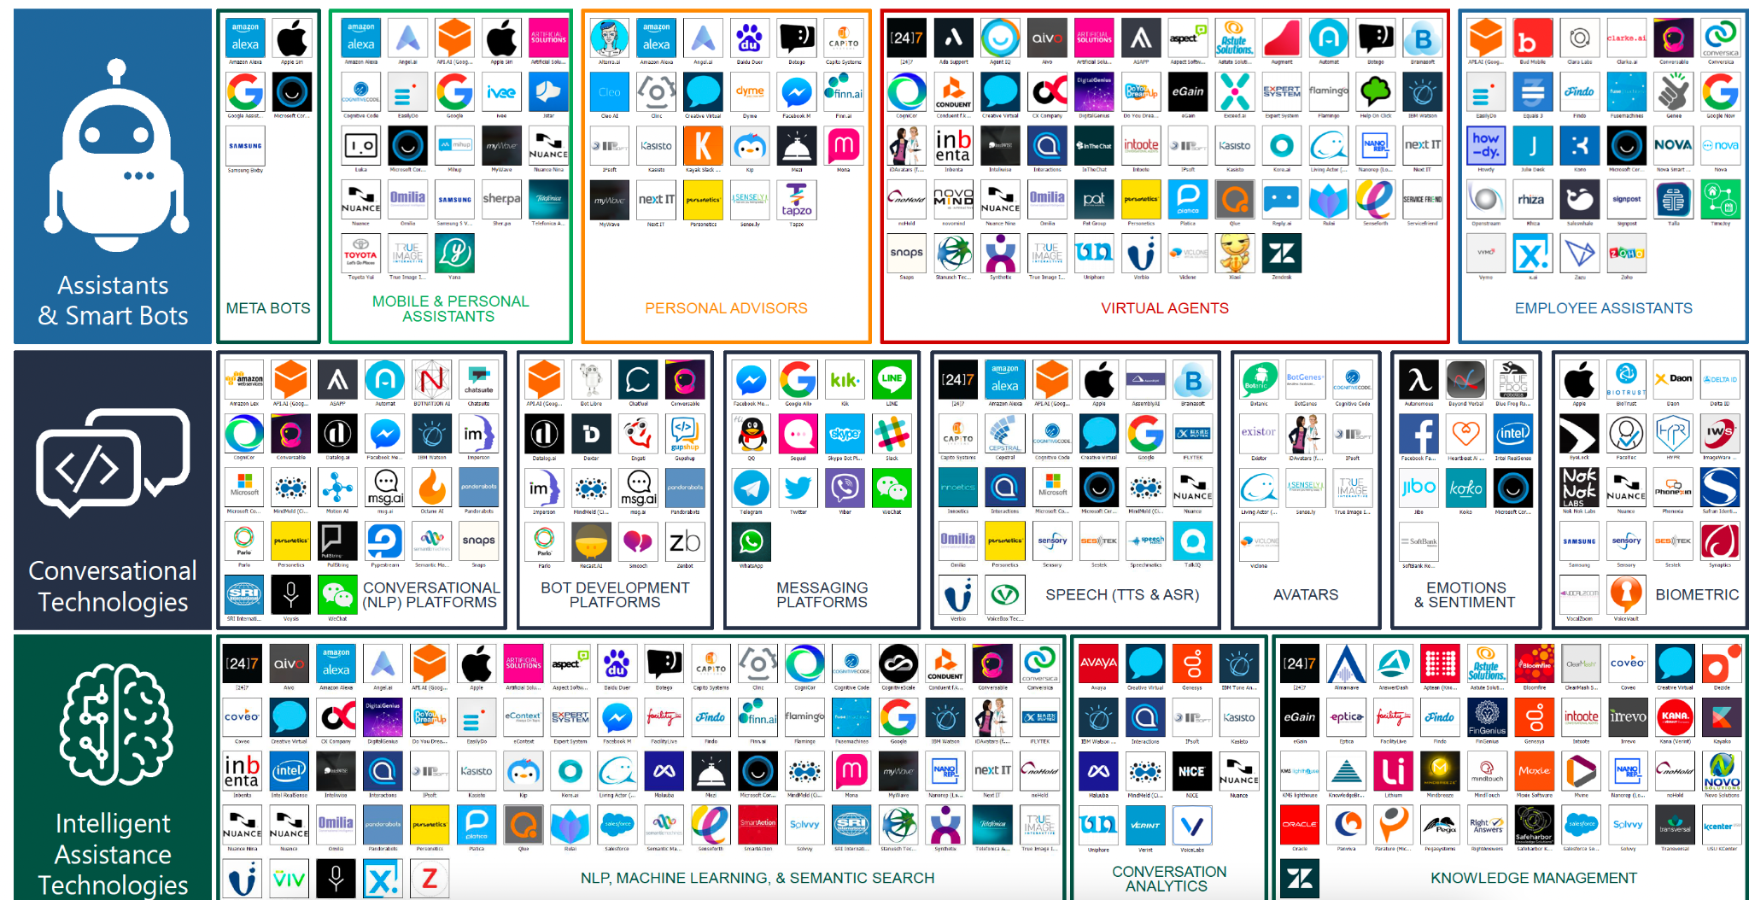

→ for this UC we gonna use dialogoverflow

1. What integrations are there? Which are available in the future?

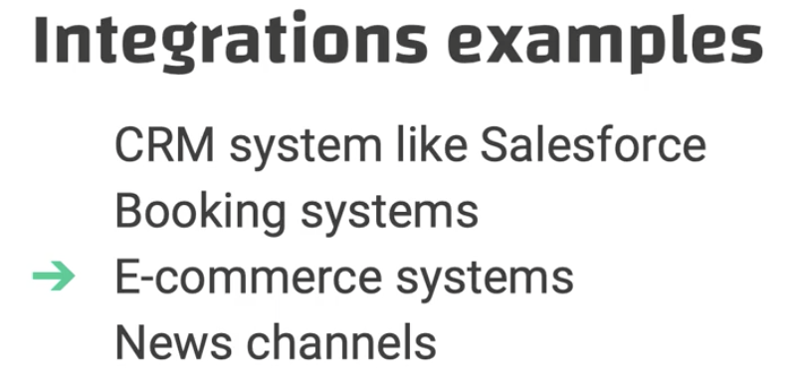

Result of research:

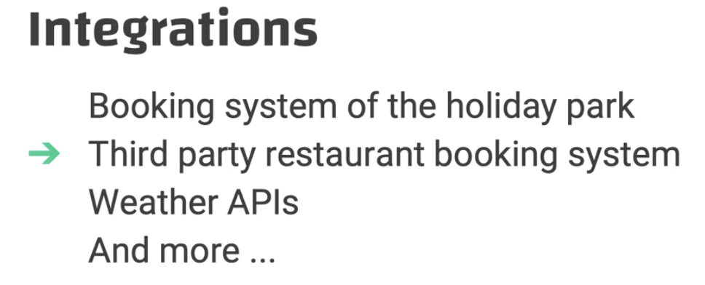

Channels:

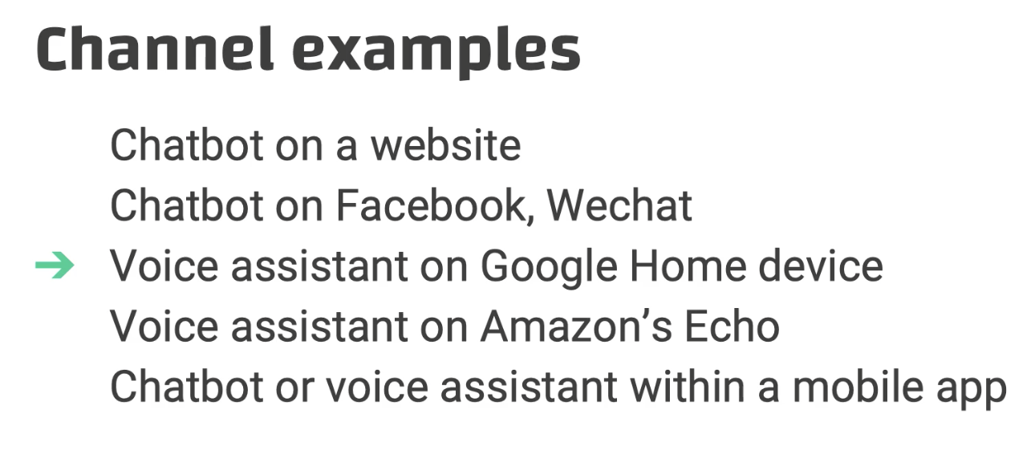

User identification

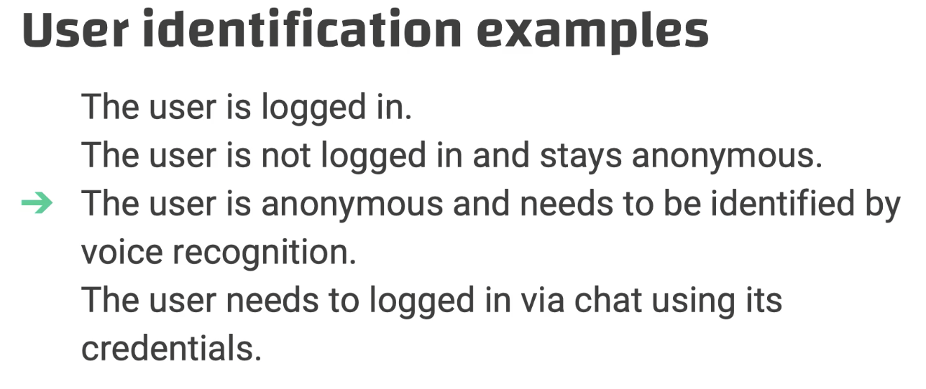

In our case:

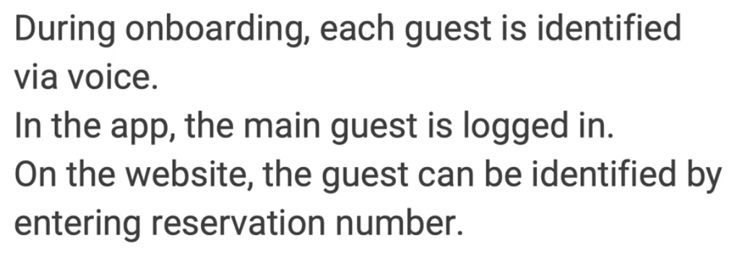

Hand over options:

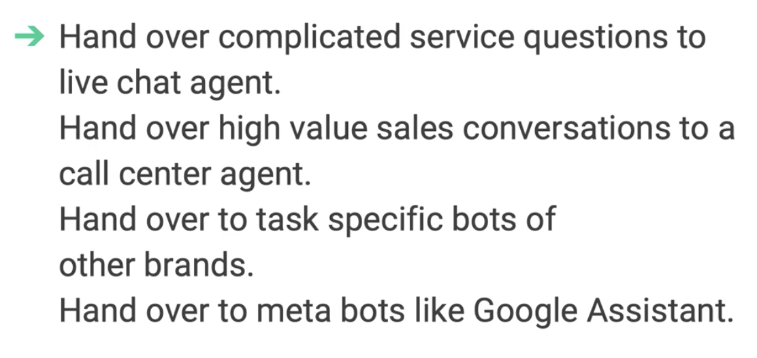

In our case: handover complicated reservations and questions to the receptionists; call me back requests outside business hours

## Explore operations

* What to explore?
  + Business, department, stakeholders, KPIs
* Business
  + What business are you in? What is the bot’s role?
* Department

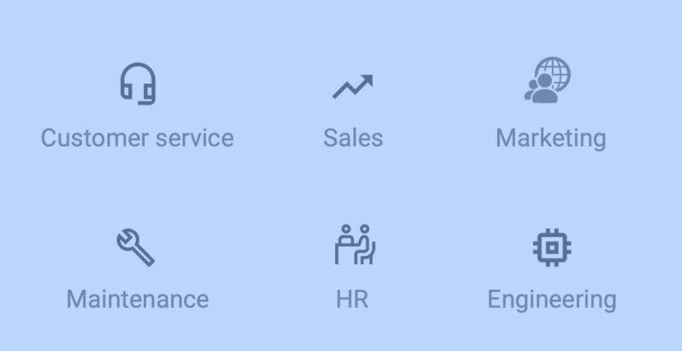

* Stakeholders
  + Who are the people involved in this project?

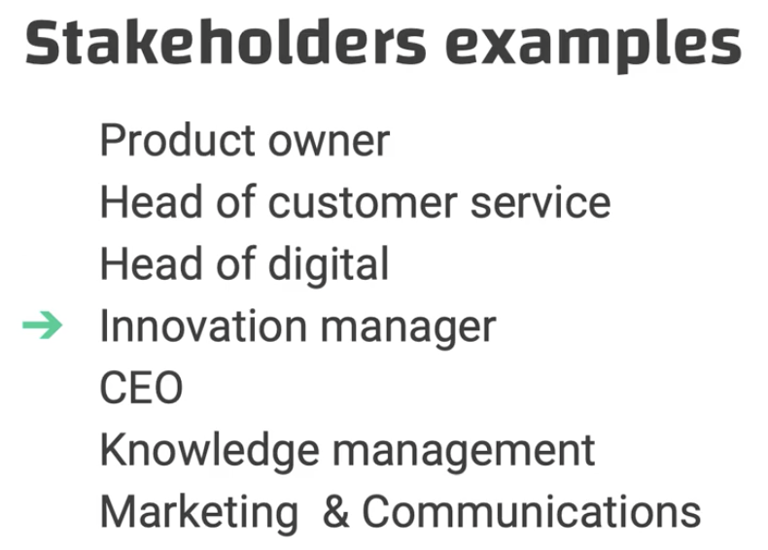

In our case: digital team, local concierges and guides, customer service department, director of operations

* KPIs: what determines the success of the product

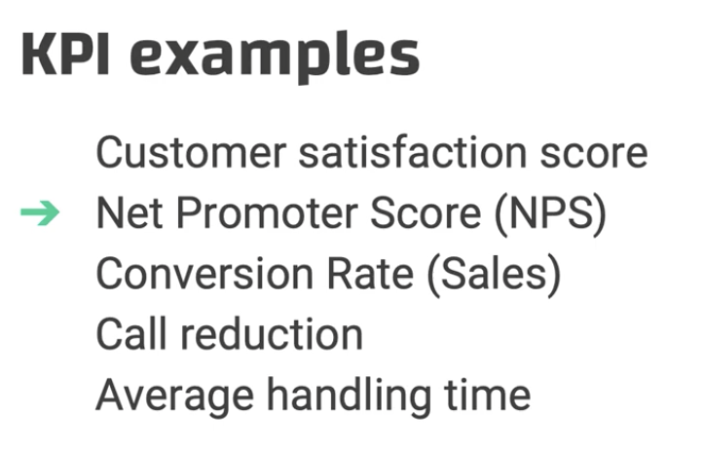

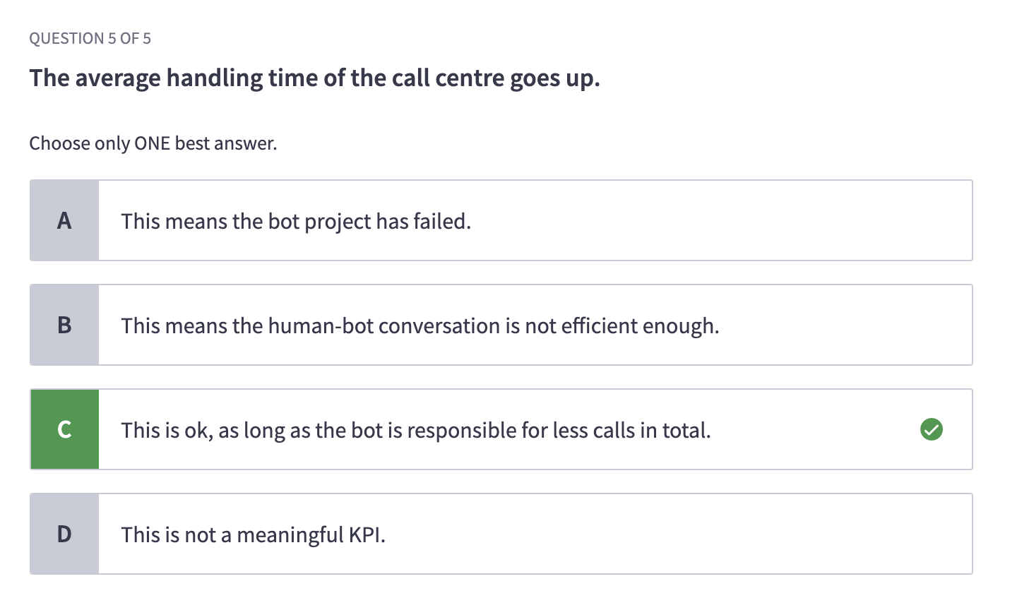

NPS: how likely you are going to recommend the service

In our case: user-centric → satisfaction score & customer retention rate

## Identify user personas

Goal:

* Understand the concept of user persona
* Know the difference between bot and user persona
* Know how to develop a user persona based on insights

What is a user persona?

* A fictional person, that is representative of a specific segment within your audience
* Based on real insights, not on guessing or stereotyping

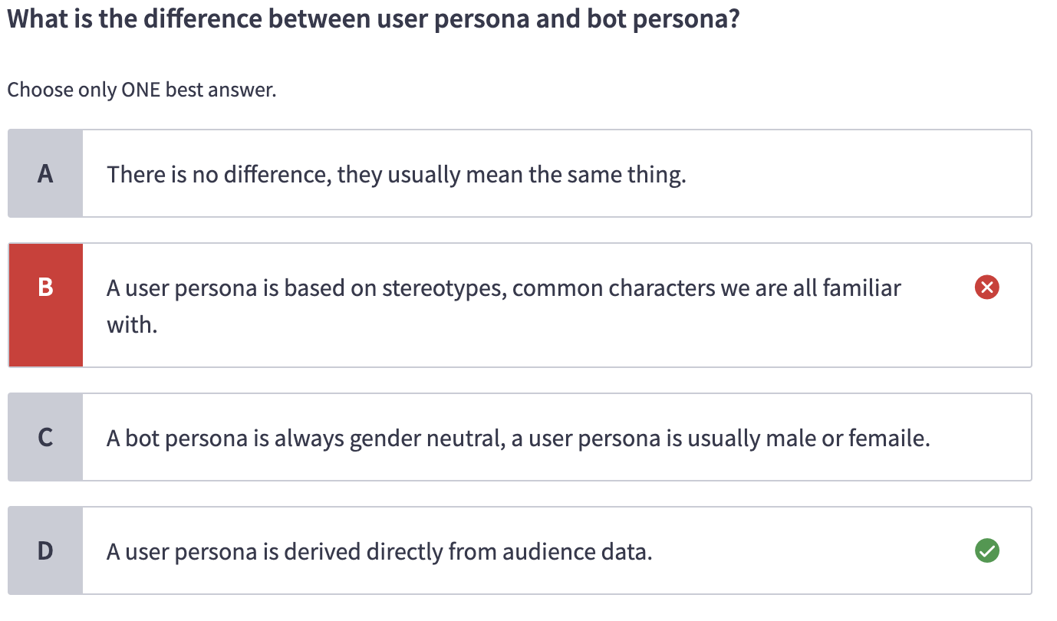

Why a fictional person?

* It helps the designer emphasize with the user
* Especially important when acting our sample dialogues

Before you do anything

* Check UX or marketing department if there are existing personas available

To create a user persona, you need to analyze:

* Demographics
  + Age, gender, marital status, geography, education, and income

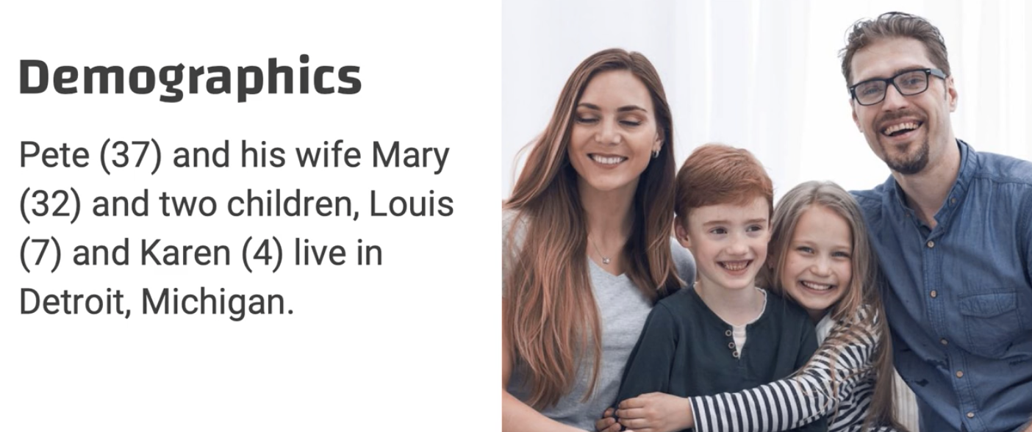

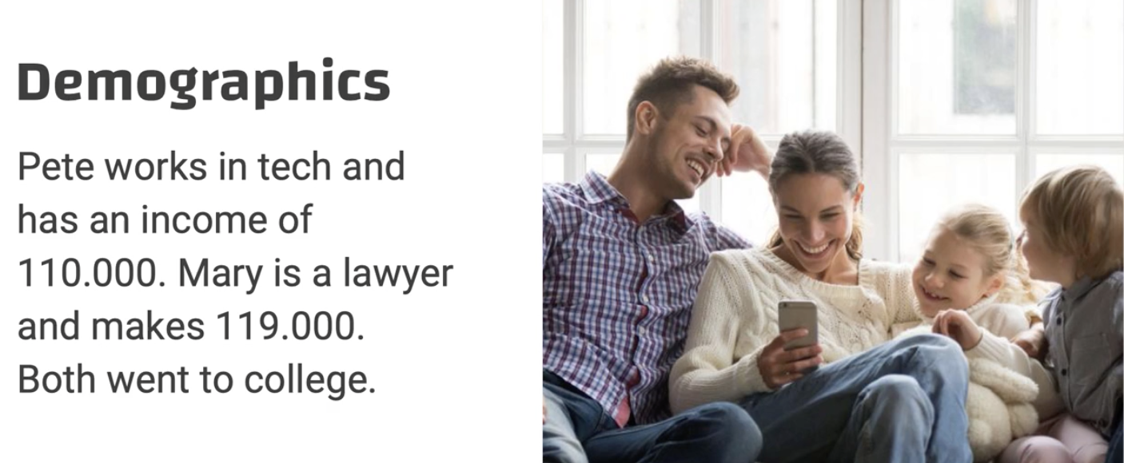

* Psychology
  + Goals, motivations, preferences, world view, and others

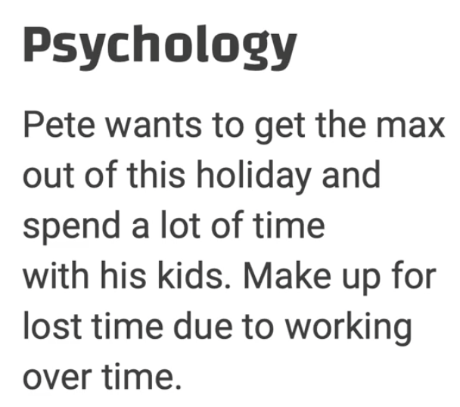

* Experience
  + Prio exp with the product or service, prior exp with chatbot or VUI

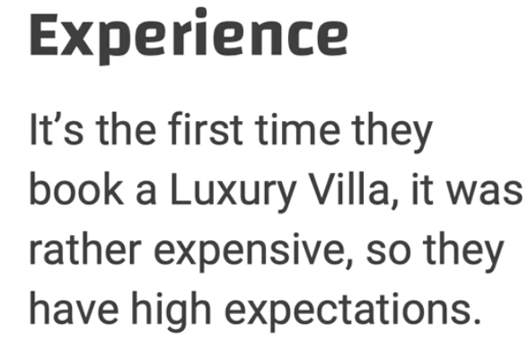

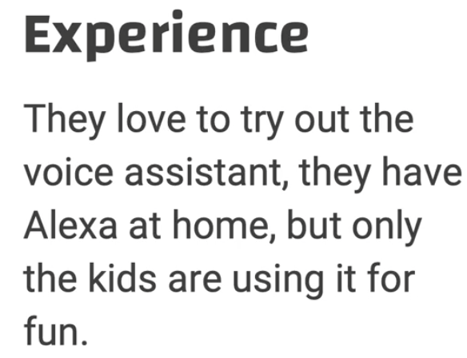

* Others

## Identify bot persona

* Bot persona: a set of human characteristics that determine the way your bot is interacting with your users; the fictional character of your virtual conversational partner
* Meanwhile, a **user** persona is a fictional person that serves as an example for a specific **audience segment**
* Pareidolia: people have the tendency to find human traits in non-human objects

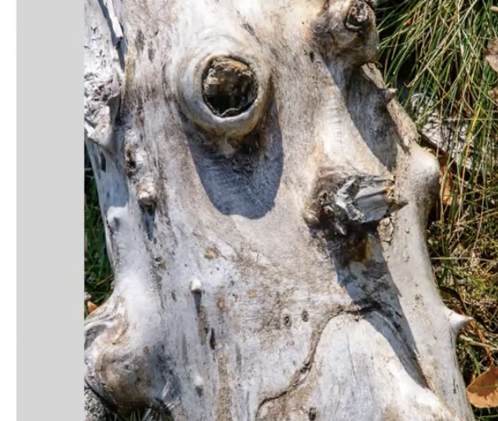

Within one and half sec, the user will assign personality to a voice bot

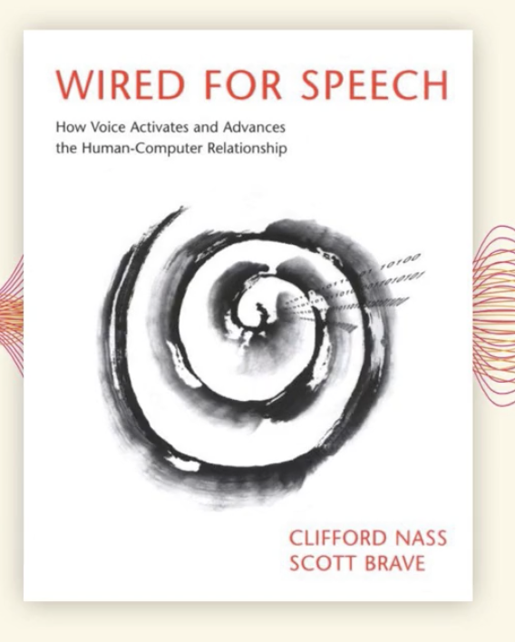

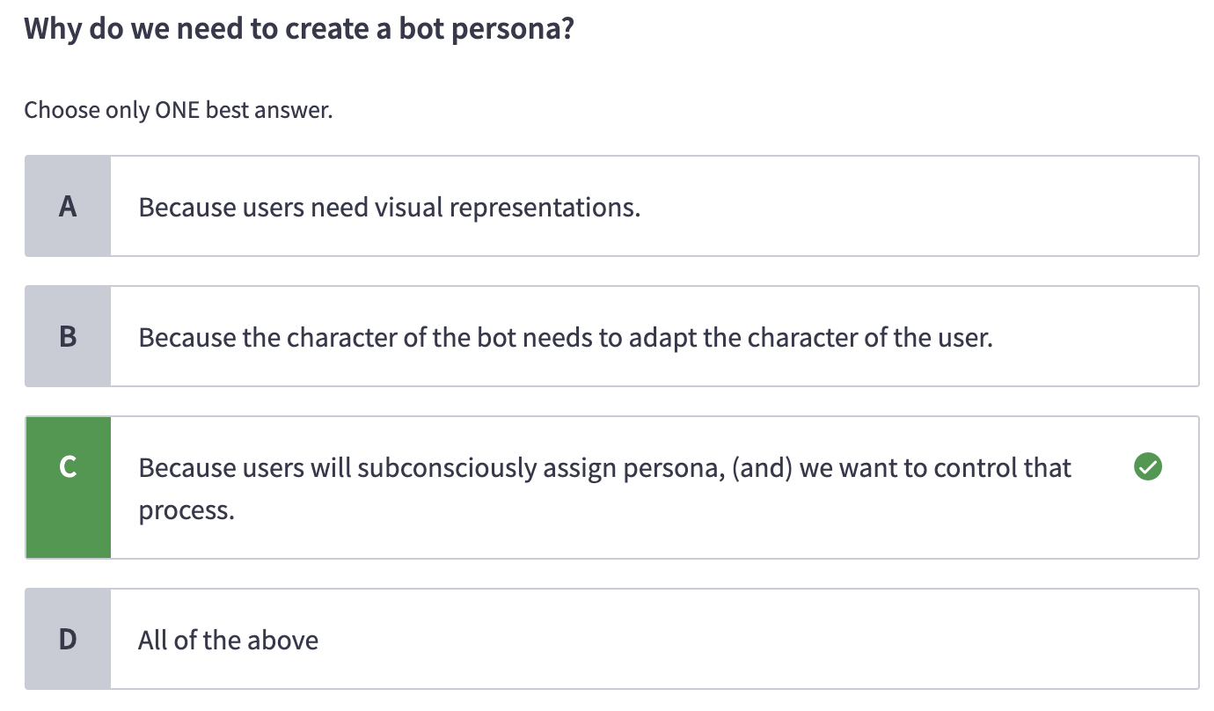

* The risk of wring without persona: inconsistent, less likeable, and less trustworthy
  + Inconsistency
    - Polite + casual

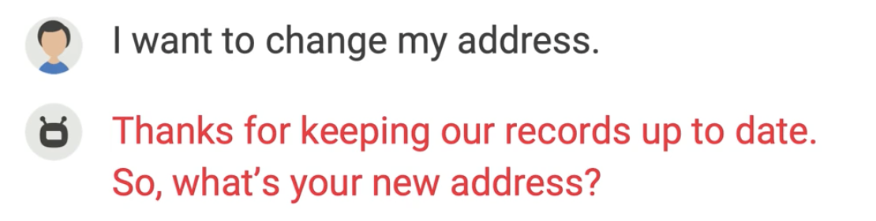

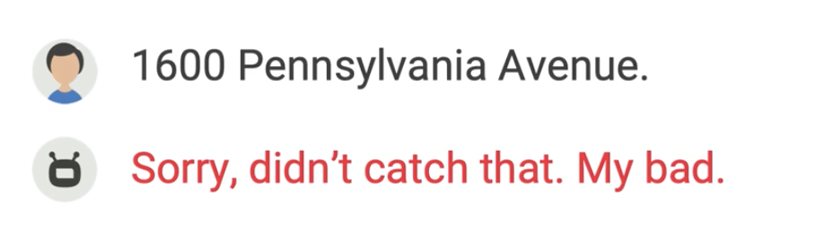

* Uncanny valley: neither mechanical nor human → sucks

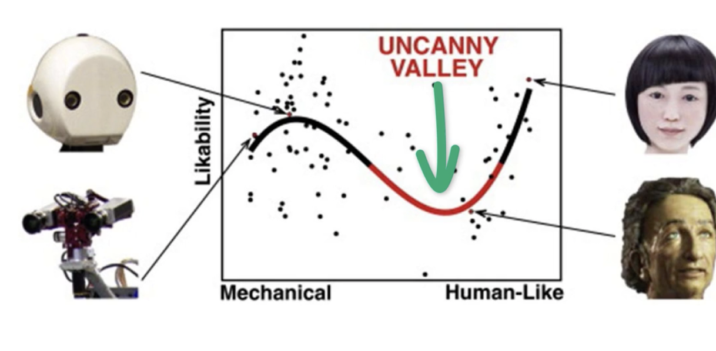

## Create a bot persona

* Back to the example:

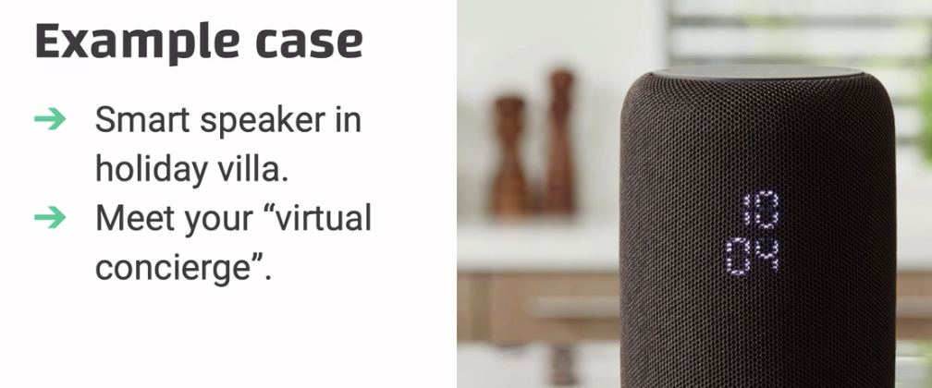

### Bot persona template

* + **Context, identify, tone of voice, standard vocabulary**

#### Context

* + **Organization**
  + **Brand identity**
  + **Audience**
  + **Service tasks**
  + **Persuasive tasks**
  + **Channel**

**Also: chat style**

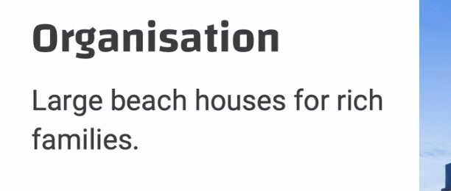

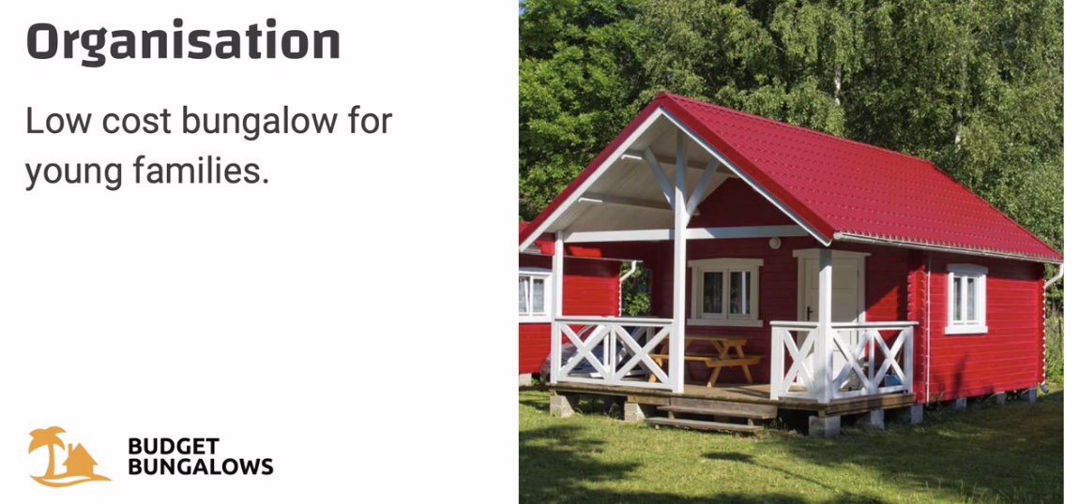

Brand comparison:

Luxury villas - exclusive, high service, traditional, VIP

Budget bungalows: challenger brand, young, open, fun, friendly

Audience:

LV: high income families; holiday for two weeks

BB: income 25,000 euros a year; a weekend over a year

Service tasks / use cases:

LV: ask questions; provide info about the area

BB: same

Persuasive tasks:

LV: need to make sure the family doesn’t miss any highlights, .e.g, the golf clinic, chef’s dinner on thursdays

BB: make up sells, e.g., cleaning the room, laundry service, breakfast service, and other add-ons

Channels:

LV: room/website/mobile app

BB: room/website

### Bot identity

* + Bot-user relationship / register, gender, age, body type, geography, personality, back story, and name

#### Register

* + Humble servant, peer, advisor, coach, challenger

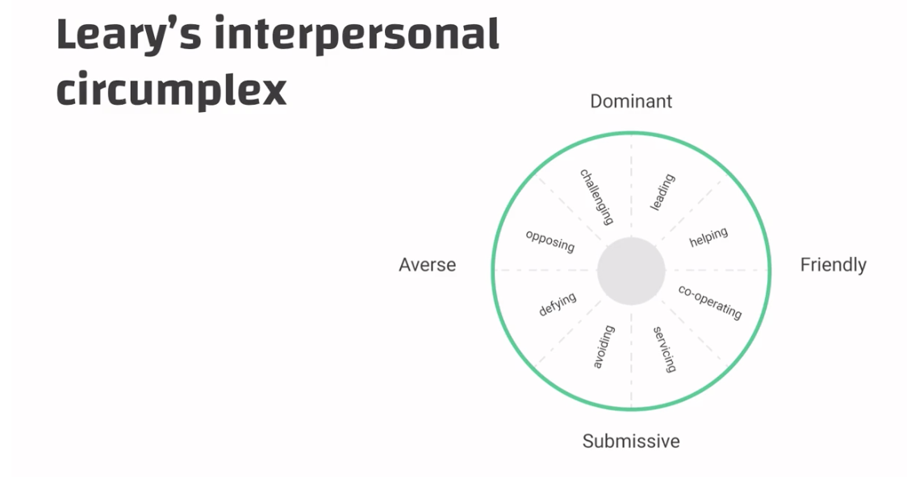

Ex:

register

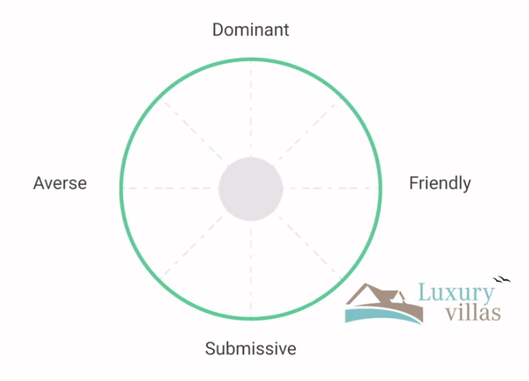

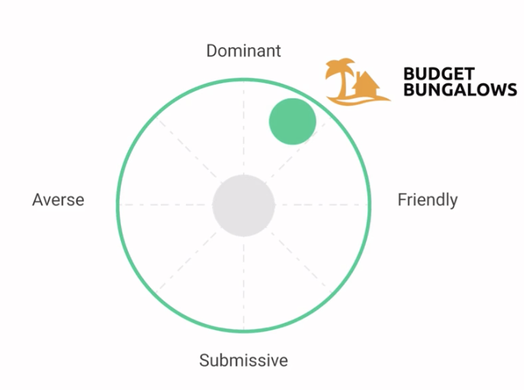

name/age/gender/body type

Why does body type matter? → it helps define the bot’s voice type.

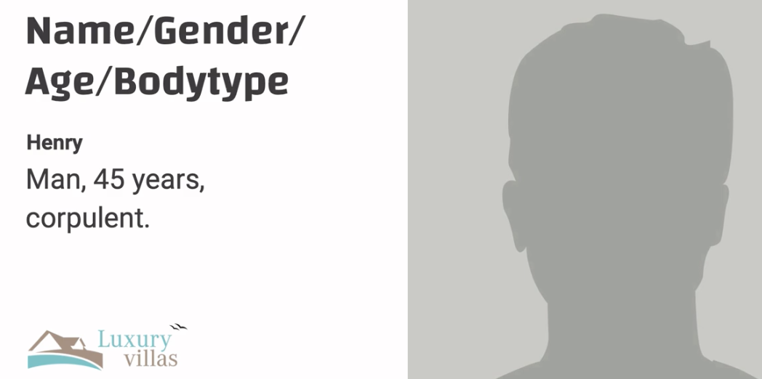

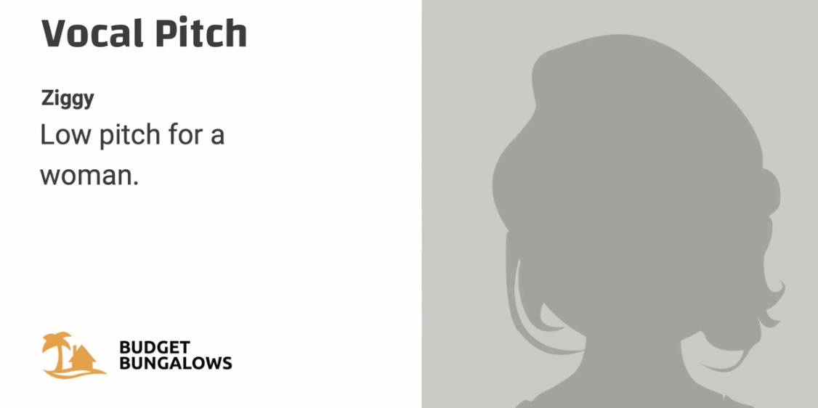

Personality:

Henry - polite, introvert, altruistic

Ziggy - extravert, helpful, energetic

Detailed back story:



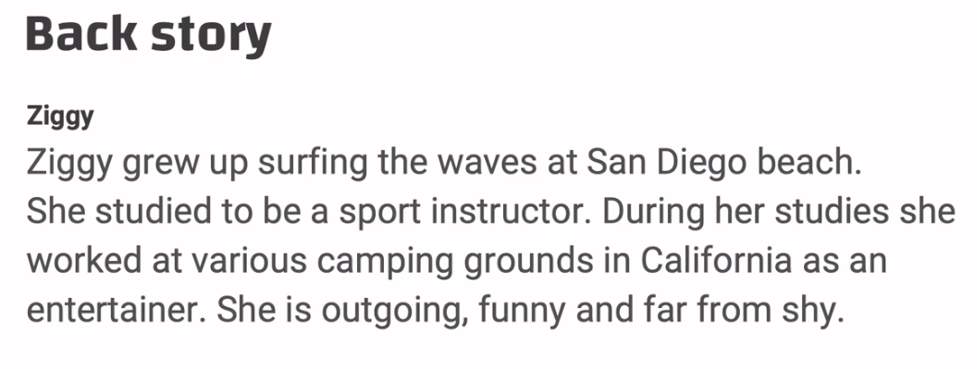

Geographics

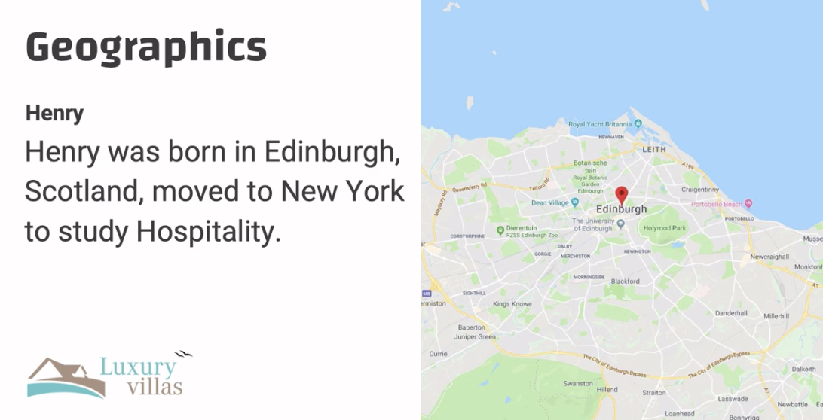

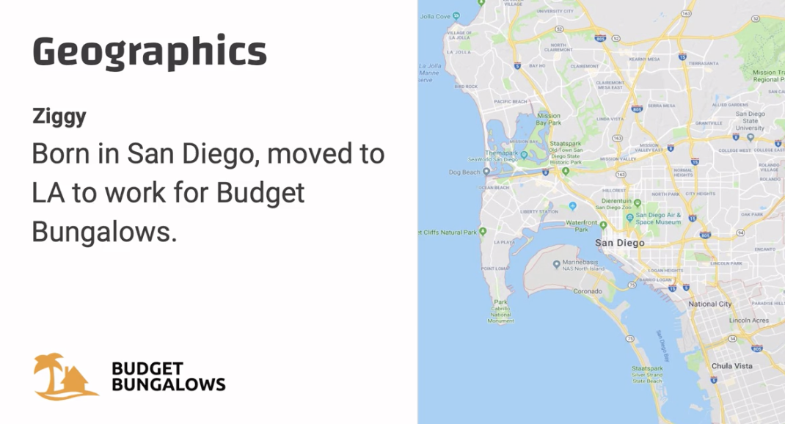

### Bot tone of voice

* + Voice type (text-to-speech vs. human actor)
  + Vocal pitch
  + Speed of talking
  + Energy (e.g., calm vs. energetic)
  + Aural smile (friendliness)
  + Accent

Voice type:

Henry - voice actor

Ziggy - text-to-speech

Vocal pitch:

Henry - low voice

Ziggy - high pitch

Speed: henry - slow and clear; ziggy - fast and rushed

Energy:

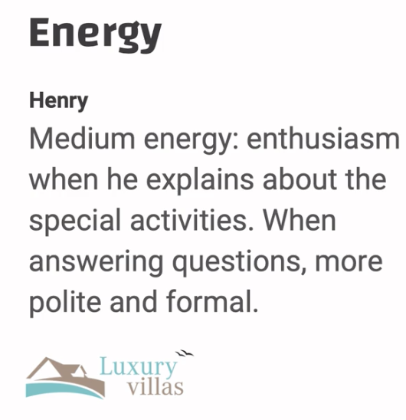

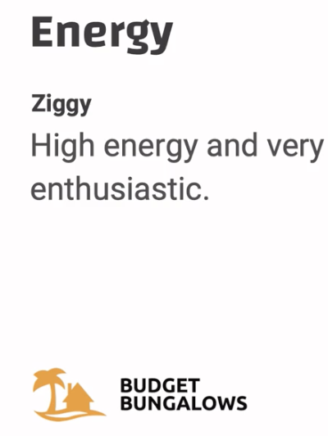

Aural smile:

Henry - not showing emotion, just friendly and polite

Ziggy - you can hear smile when she talks

Accent:

Henry - light Scottish accent

Ziggy - Californian but we are not gonna overdo it

#### Standard vocabulary / idiolect / personal catch phrase :

* + Greetings, implicit confirmations, explicit confirmations, apologies

Greetings:

H - Good afternoon! / Good day.

Z - Hey what’s up? / Ciao

Implicit confirmations:

H - Splendid. Two tickets to the golf clinic. Is two o’clock good for you?

Z - Three tickets to the banana boat. I like your style. Should I hook you up for two o’clock tomorrow afternoon?

Explicit confirmations:

H - To confirm, you would like two tickets to the children’s golf clinic. Is that correct?

Z - Ok, so you are saying that the three of you are hopping on the banana boat? Say Banana if that’s a yes!

Apologies:

H - I am terribly sorry

Z - My bad!

## Chatting style

* Avatar, emoji, images, punctuations, and answer delay

### Avatar

* + **Visual representation of your bot persona**

Henry - none, only sound and text

Ziggy - a cartoon image (to avoid misunderstanding)

### Emoji

Henry - none; Ziggy - lots of smiley faces

### Images

Henry - normal use of images; Ziggy - emotional images like gifs, stickers, and funny images all the time

### Punctuations

Henry - periods and commas; Ziggy - exclamation marks, but not too much, no period or comma, short sentences.

### Chat delay

Henry takes time to think; Ziggy is pretty fast

### AVOID MACHINE-GUN CHATBOT → unnatural

## Identify use cases

This step belongs to Happy path design

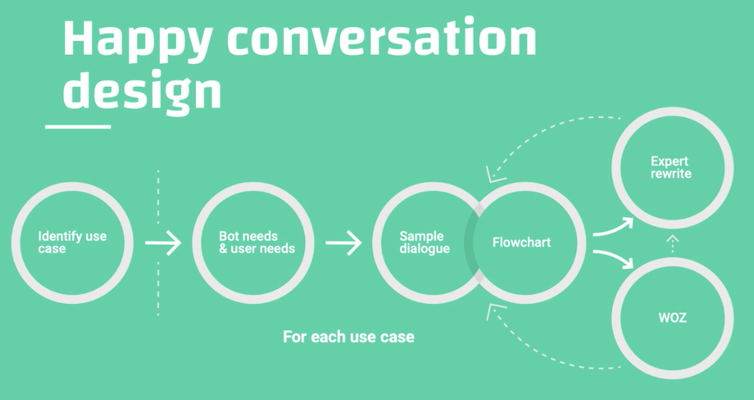

* Use case: a specific situation in which a product or service could potentially be used and be useful
* Some examples of UCs
* Use case categories

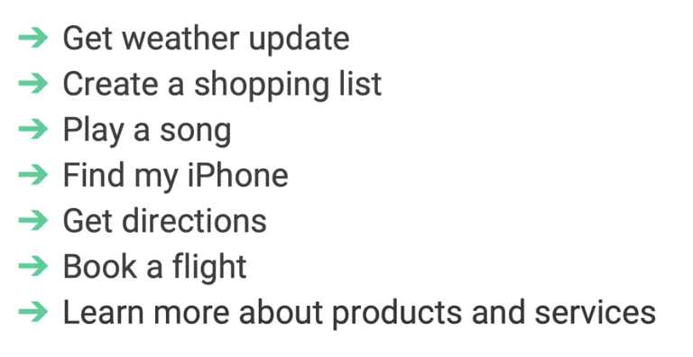

* UC vs. tasks: a UC may have several tasks
* Examples of tasks:

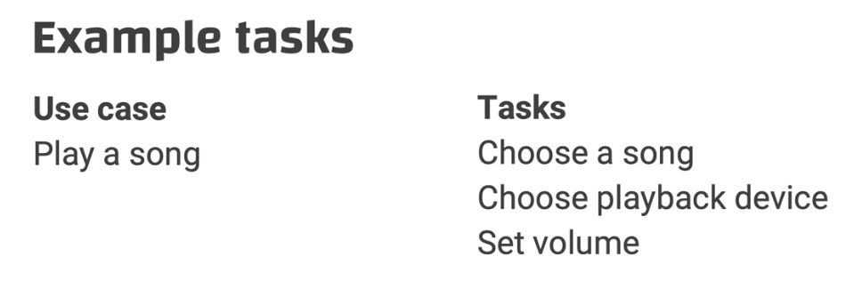

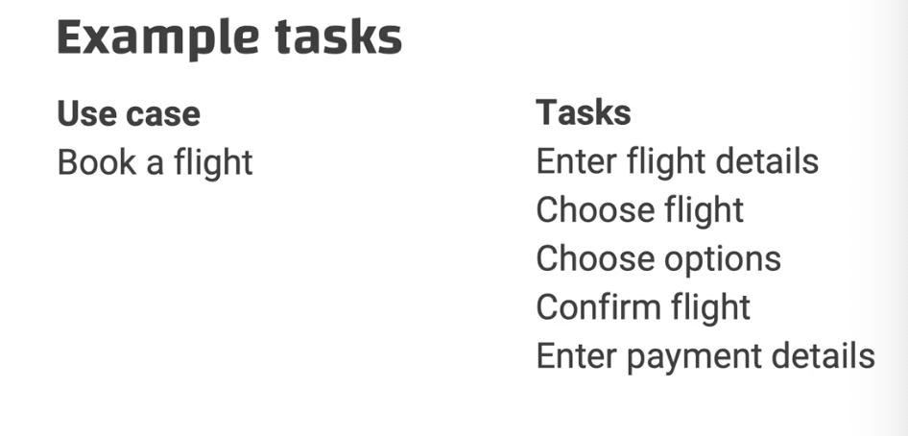

The Villa case:

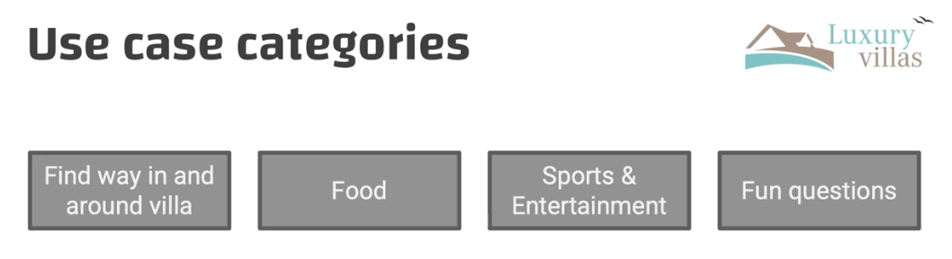

Zoom-in

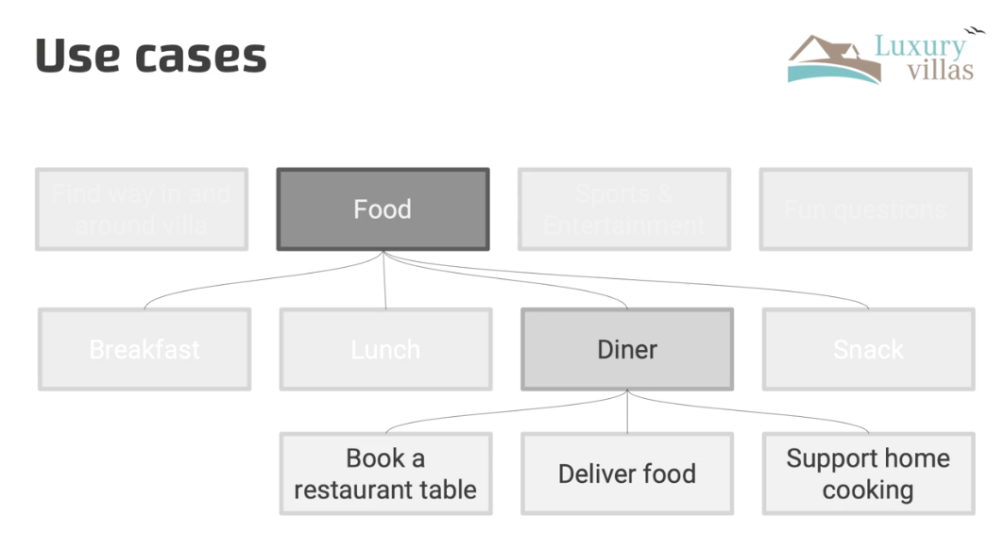

Under “Book a restaurant table”

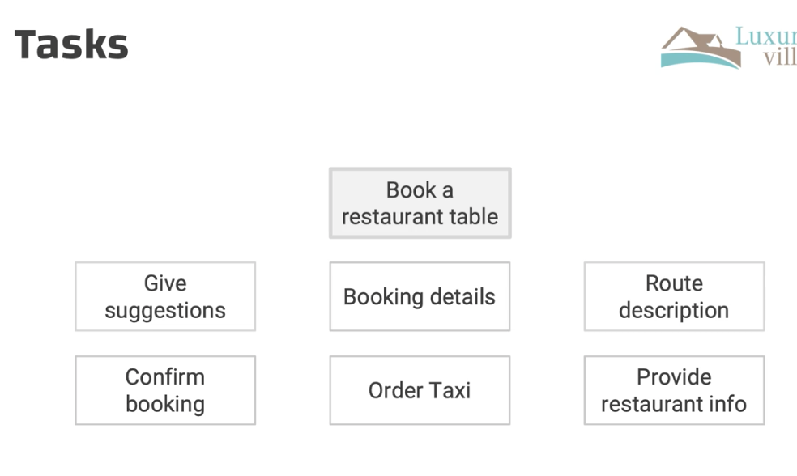

* UC and intent: from the bot’s perspective, this UC is called an intent; the first part is always intent recognition

## Conversation design canvas

* Goals: learn to prepare your sample dialogue by analyzing user context, user needs and bot needs; get familiar with the conversation design canvas
* **Before we create sample dialogue, we need identify the bot and use needs**

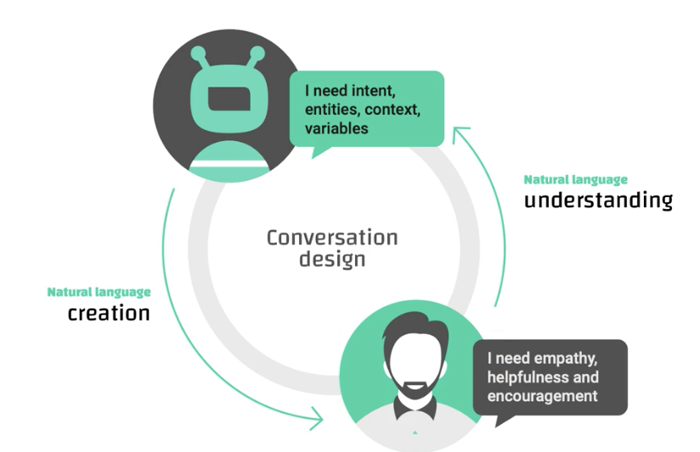

### Canvas Sheet structure

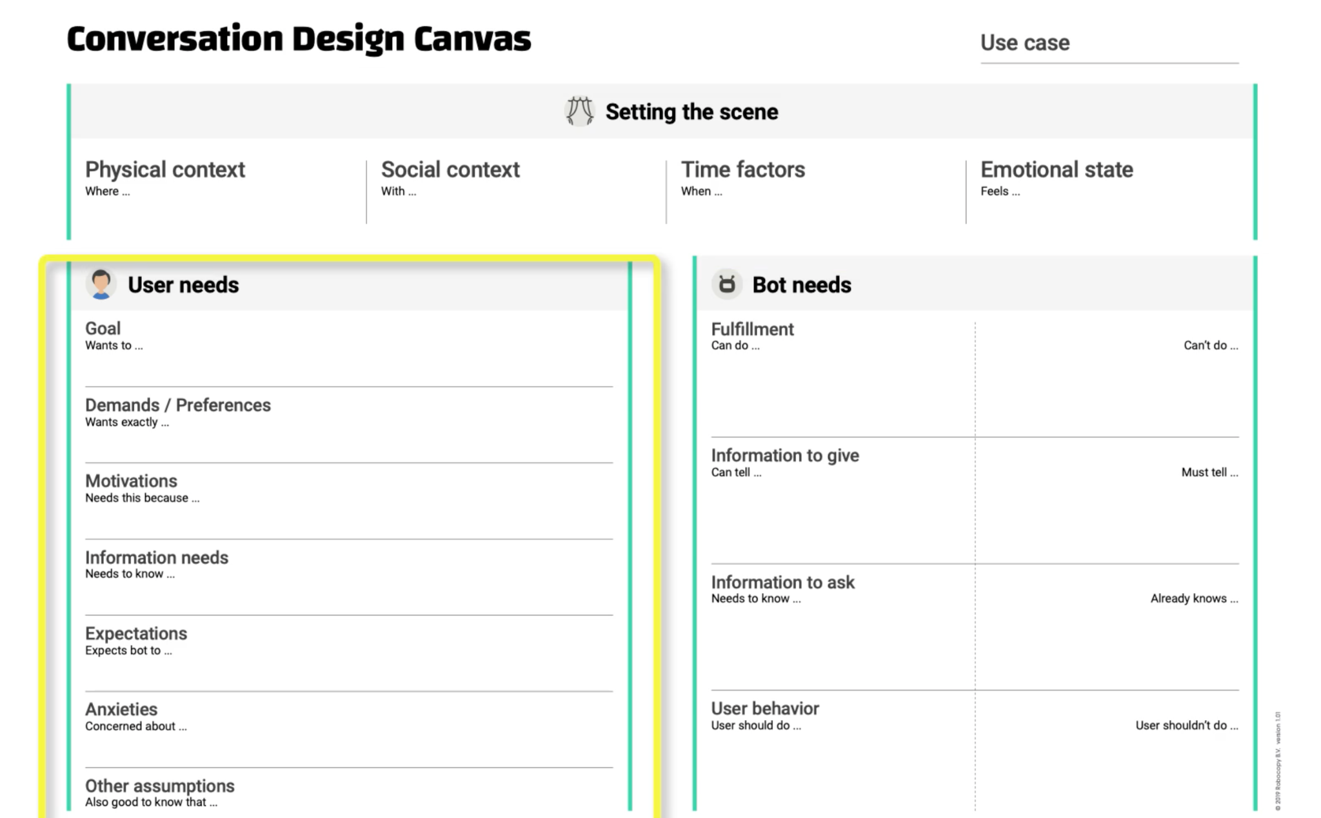

### Setting the stage

#### Use case

Example: book a restaurant

#### Physical context

* Where is the user? Which object is around? Who else is around?

Example: alone in the kitchen, cooking

#### Time factors

Example: 8 pm in the evening, no rush

#### Emotional state

* How does the user feel about the conversation?

Example: stressed, boring, relaxed

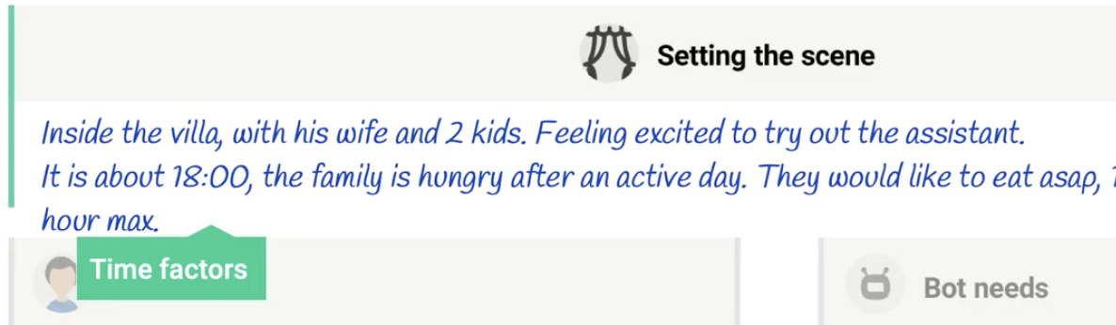

## User needs

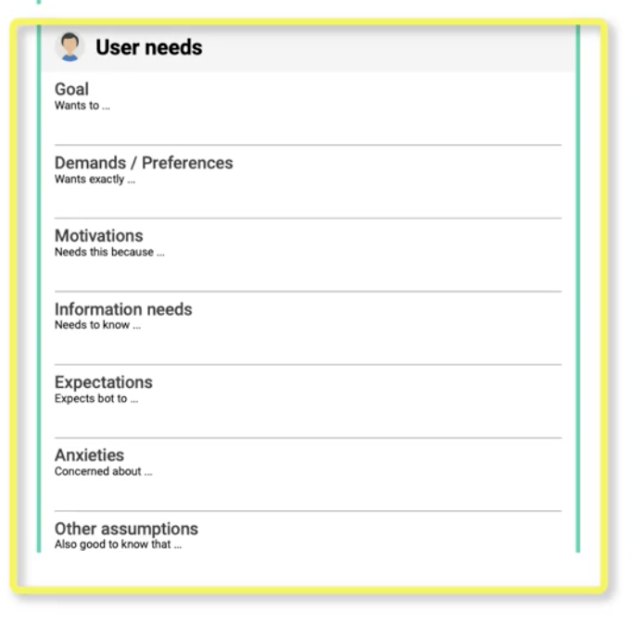

* Goal: similar to UC, e.g., get weather update, play a song, get news, cancel an appointment
* Demands & preferences: weather at where, what kind of song, what type of appointment
* Motivations: **the underlying needs** related to the user’s goal

For example, GOAL - get weather update; MOTIVATION - decide on taking the car or bike

* Information needs: what does the user needs to know

For example, delivery time of pizzas, time of flight arrival, …

* Expectations:

For example, expect the correct answer, expect nothing, expect info about opening hours, …

* Anxieties: what does the user worry about? Anything to address?

For example, is the answer correct? Does the conversation take long? …

* Other assumptions:

For example, the user’s hands are wet, …

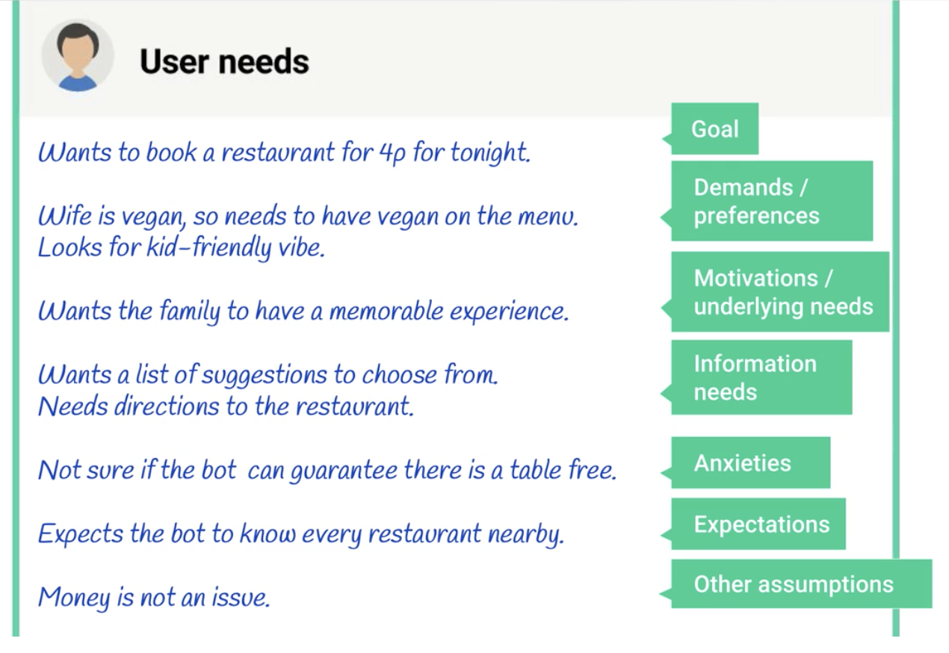

## Bot needs

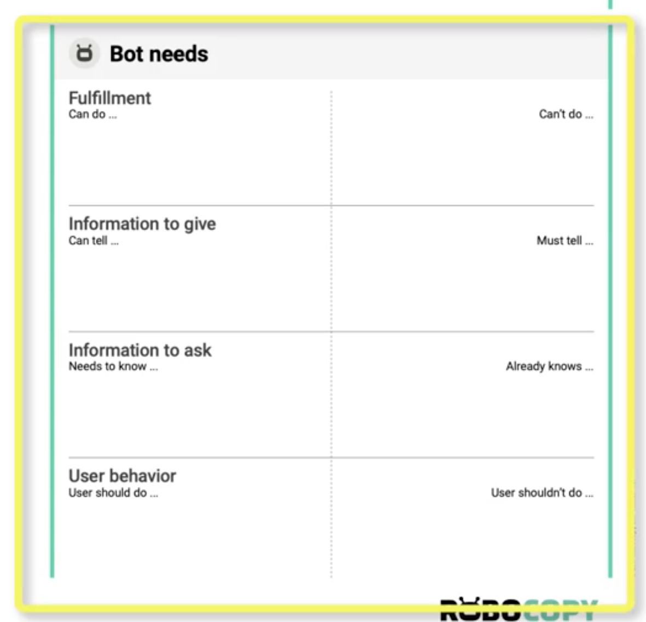

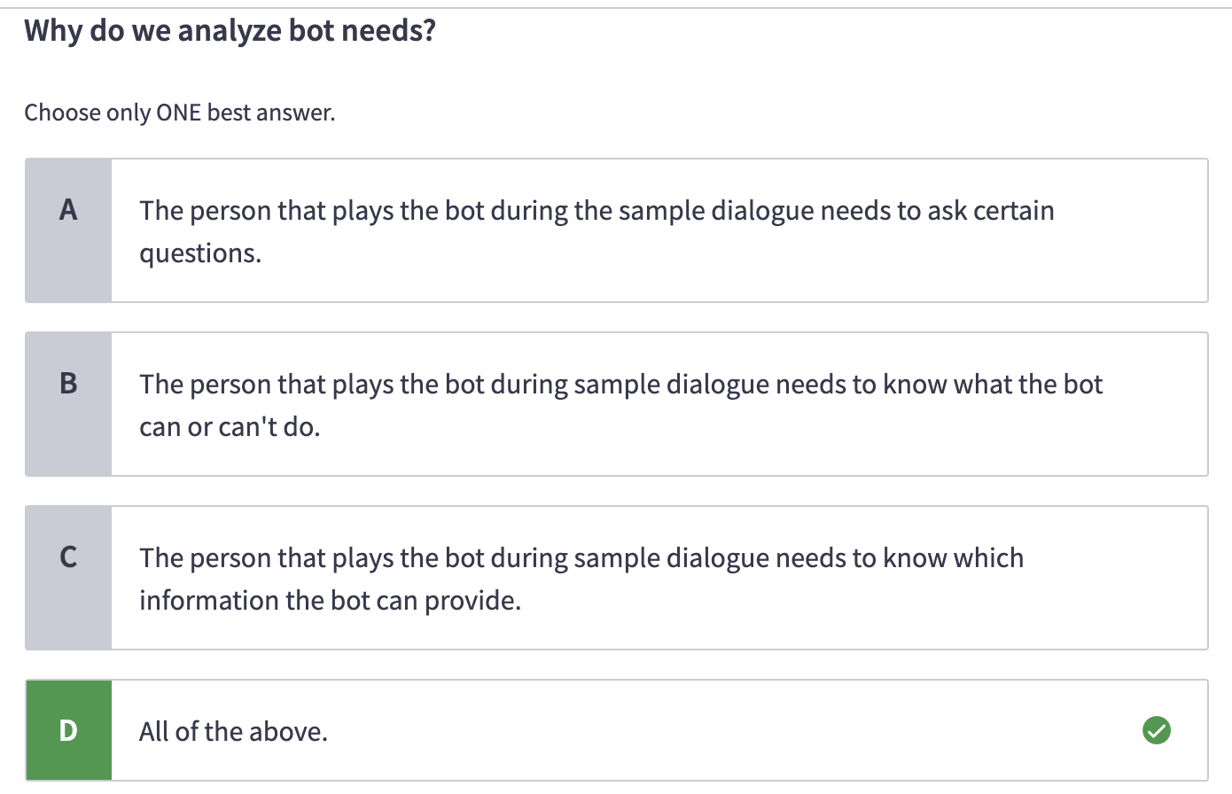

* Fulfillment [can] - what can the bot do for the user?

For example, bot’s abilities like changing temperature, booking an appointment, integrating with systems

* [cannot] - limitations

For example, the bot doesn’t know the actual delivery time

* Information to ask:

[Need to ask]

For example, what type of pizza, what song,what price range, what time, what price, …

[Already knows] If the bot knows certain info, they do not have to ask

For example, history, preferences, names, …

* Information to give

[Need to know]

[Must know]

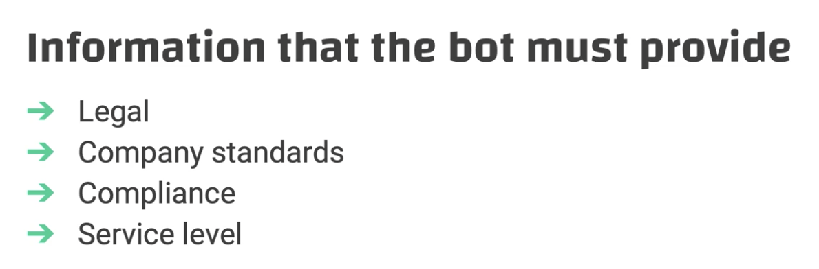

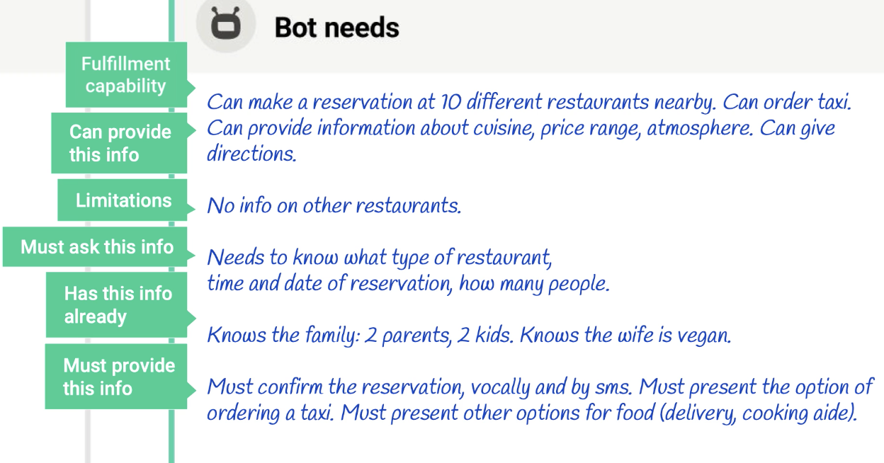

## Sample dialogue

* Goal: how to act out and write sample dialogue as the starting point of any good conversation design
* Two roles to act: bot and user personas
  + Bot needs
  + User needs

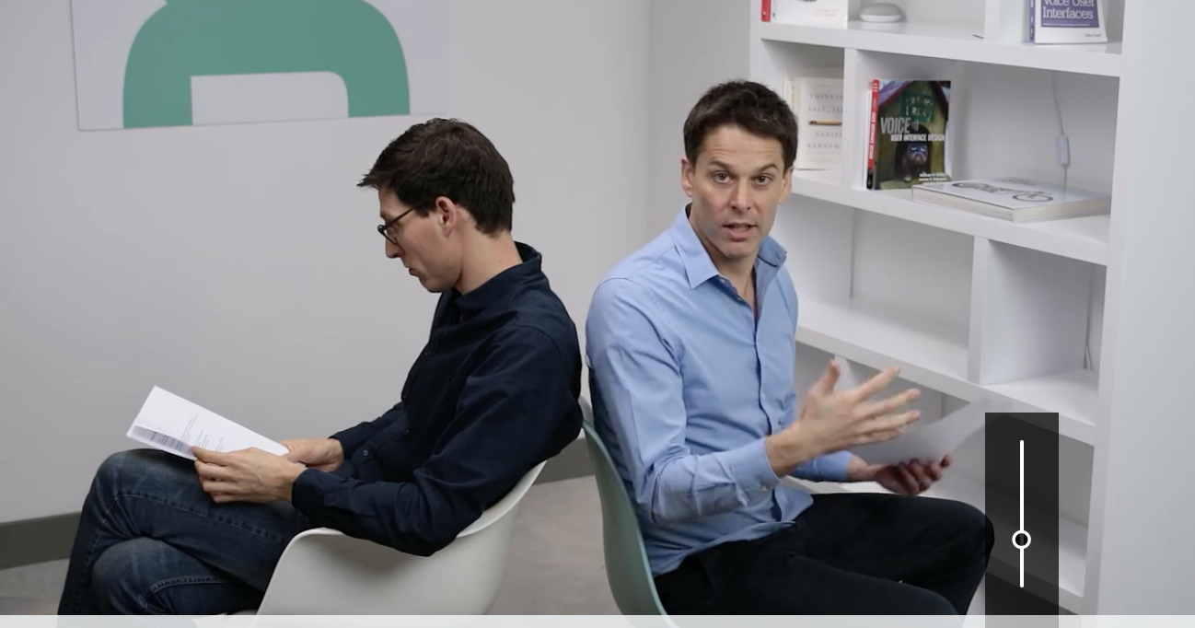

User: Pete (37)

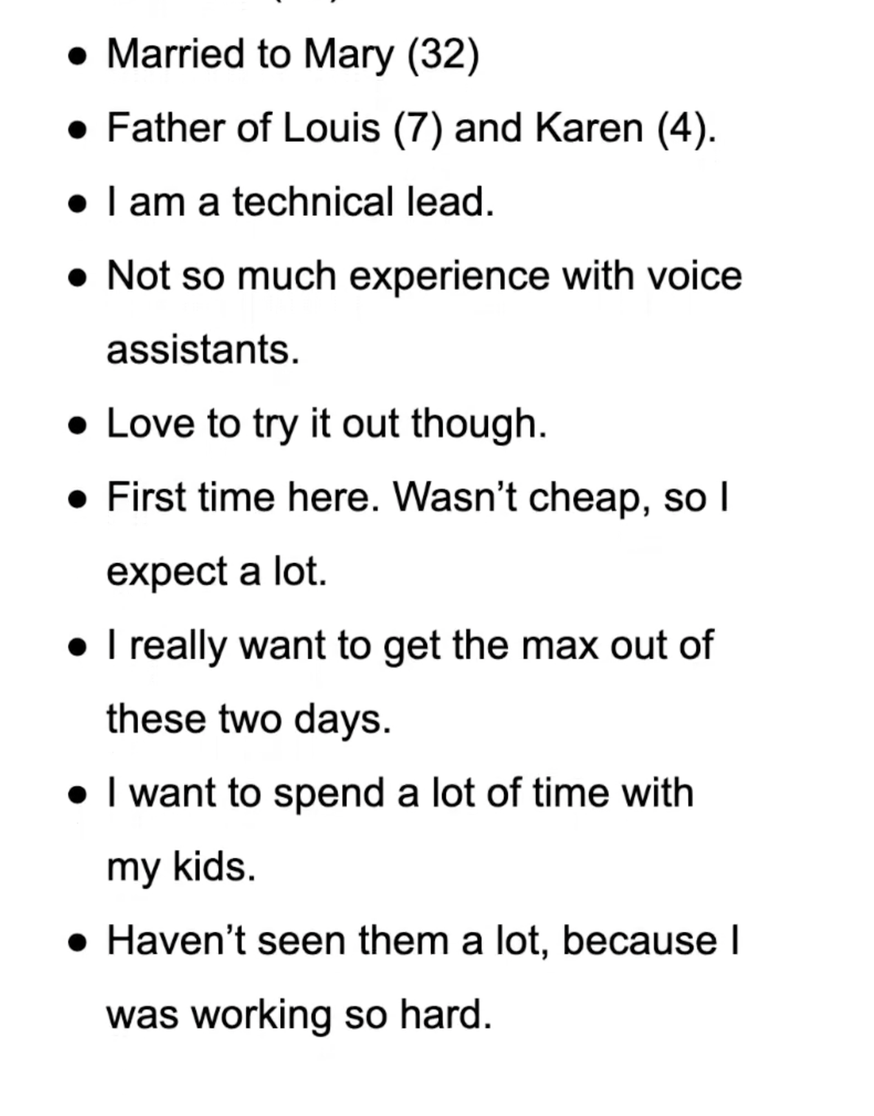

User needs:

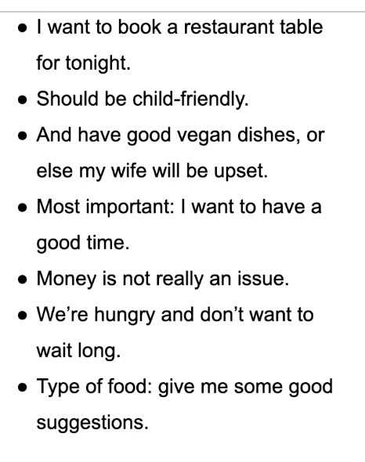

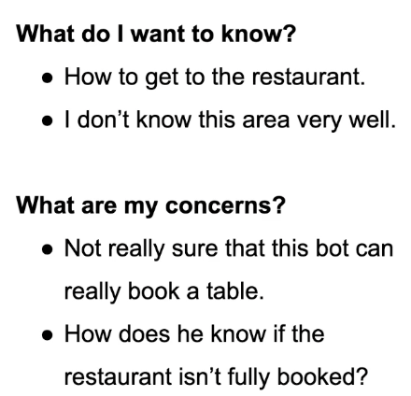

Bot (Henry)

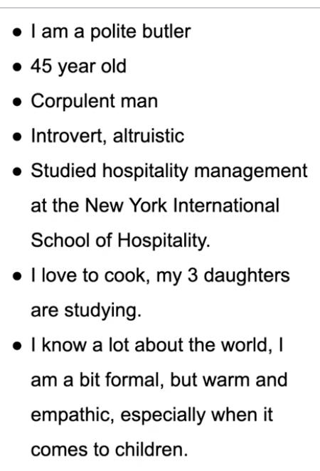

Bot Needs:

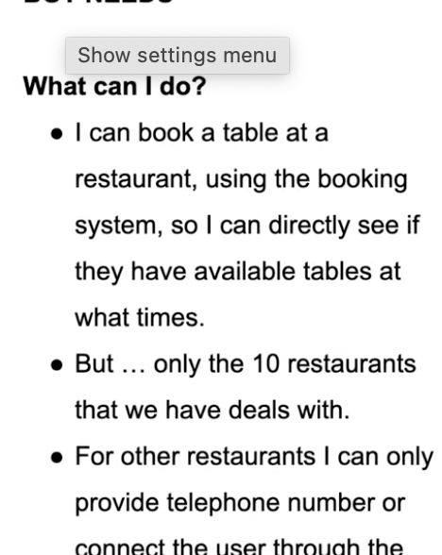

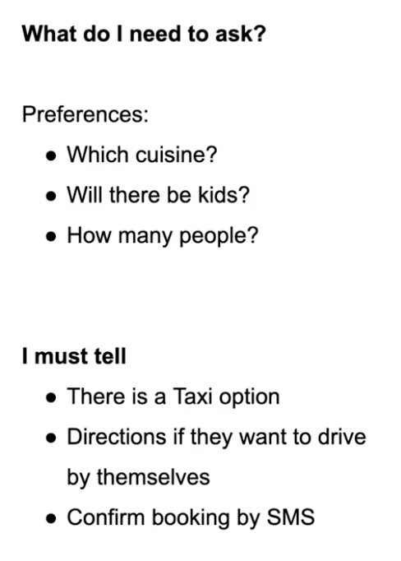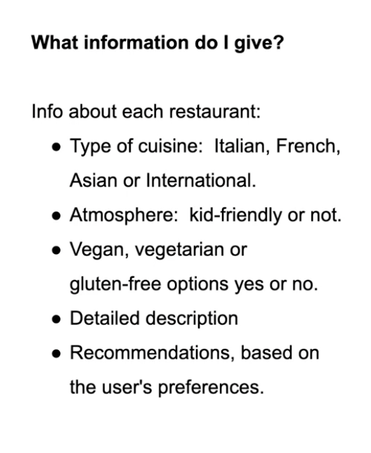

* After the sample dialogue, we need to gather feedback

Ex1: the user needs some suggestions

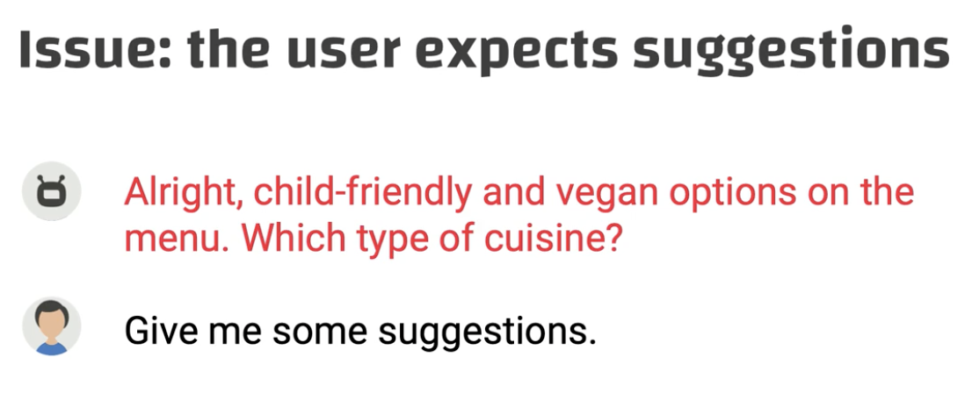

Solution: add “would you like Italian, Asian, or international cuisines”?

Ex2: the user expected the number of family members

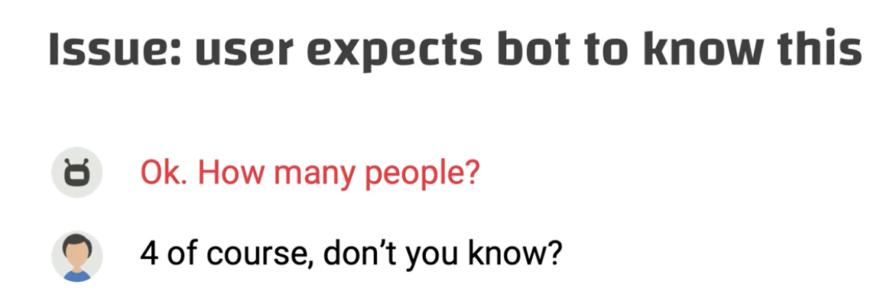

Solution: is it for your whole family?

## Flowcharts

* Goal: use flowchart to get a grip of the happy path scenarios in the same use case
* Put action items in the flow

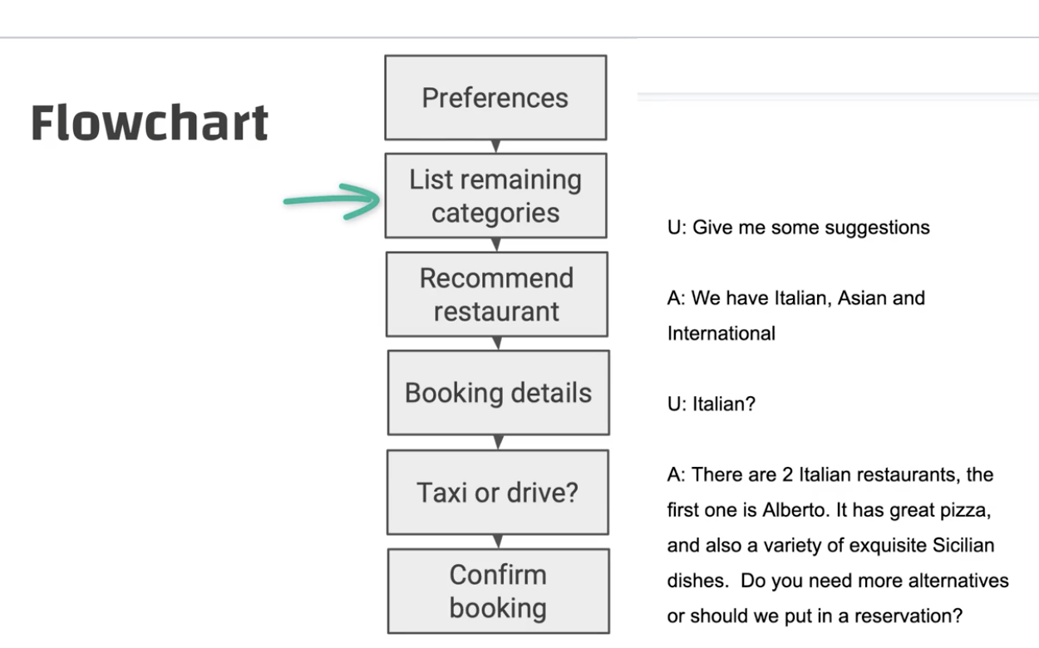

* Zoom into each item and revise the sample
  + Avoid open-ended questions

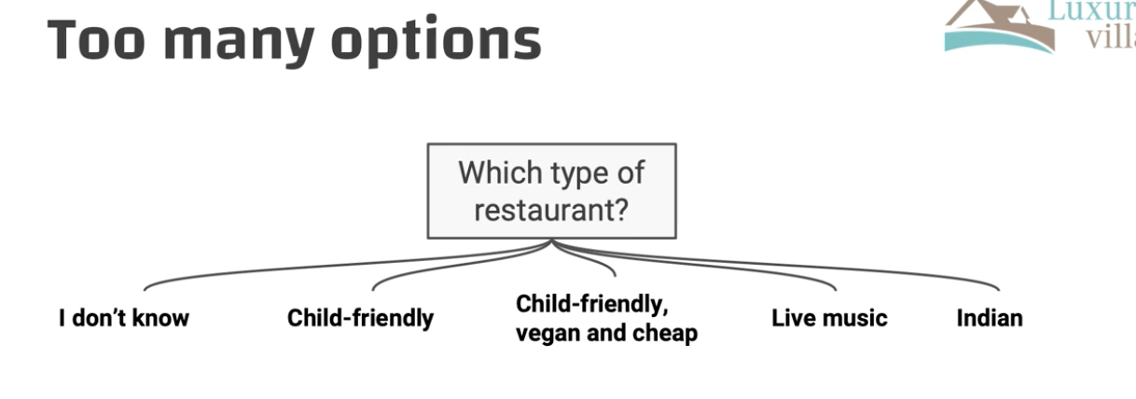

→ use yes/no questions:

*Would you like to bring some kids?*

*Do any of you want to eat vegan, vegetarian, or gluten-free?*

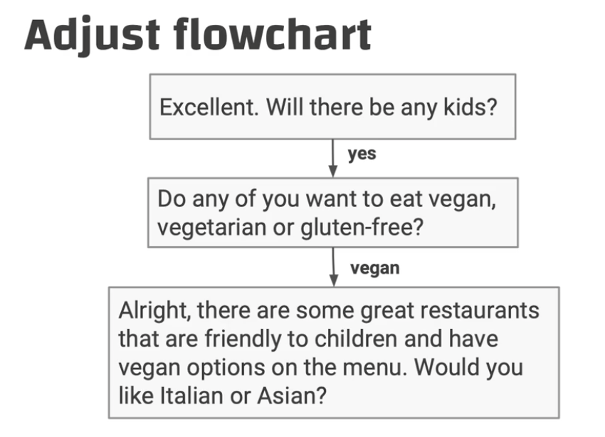

* In the second question above, some users would just answer with yes
* Some users might not include their whole family

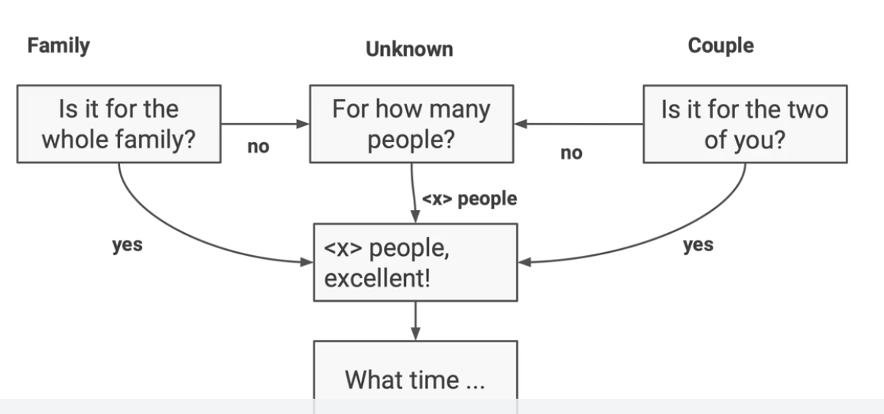

## Expert rewrite

* Improve your sample dialogue by **applying copywriting techniques**
* Table reading
* **Copywriting techniques**

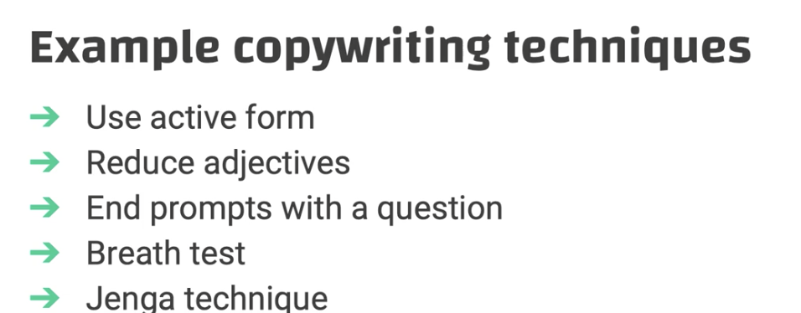

Ex1:

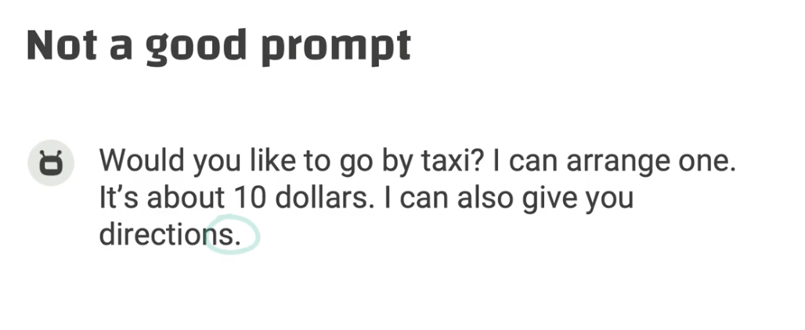

Problems: it doesn’t end with a question; it has too much info (taxi & directions)

Solution: ask separately

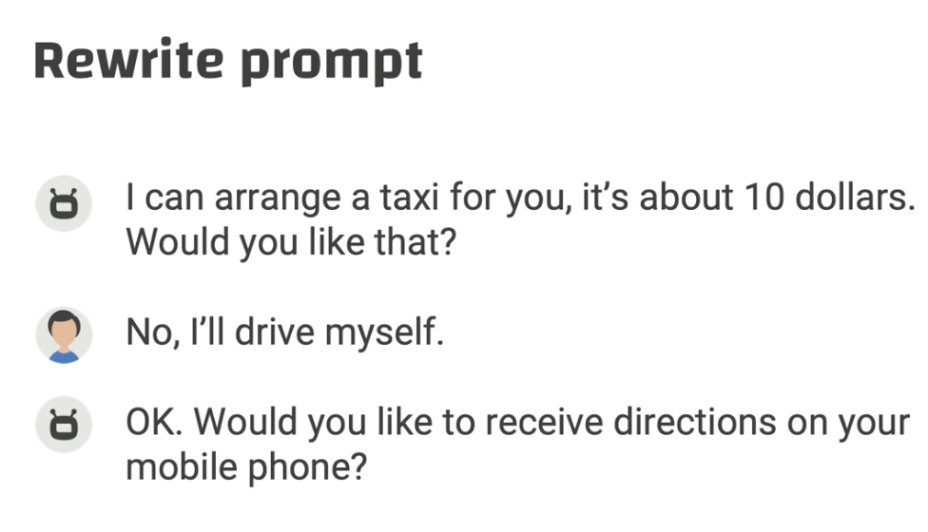

Ex2:

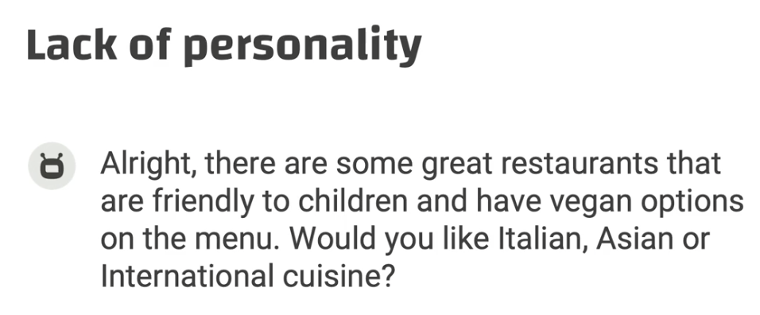

Problems: there is no personality

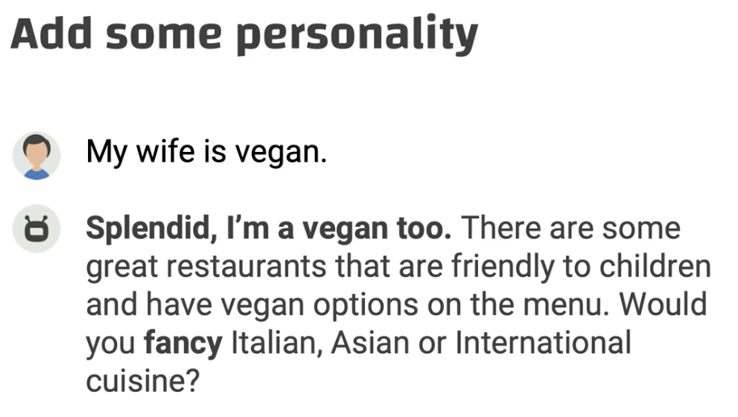

Wizard of OZ testing

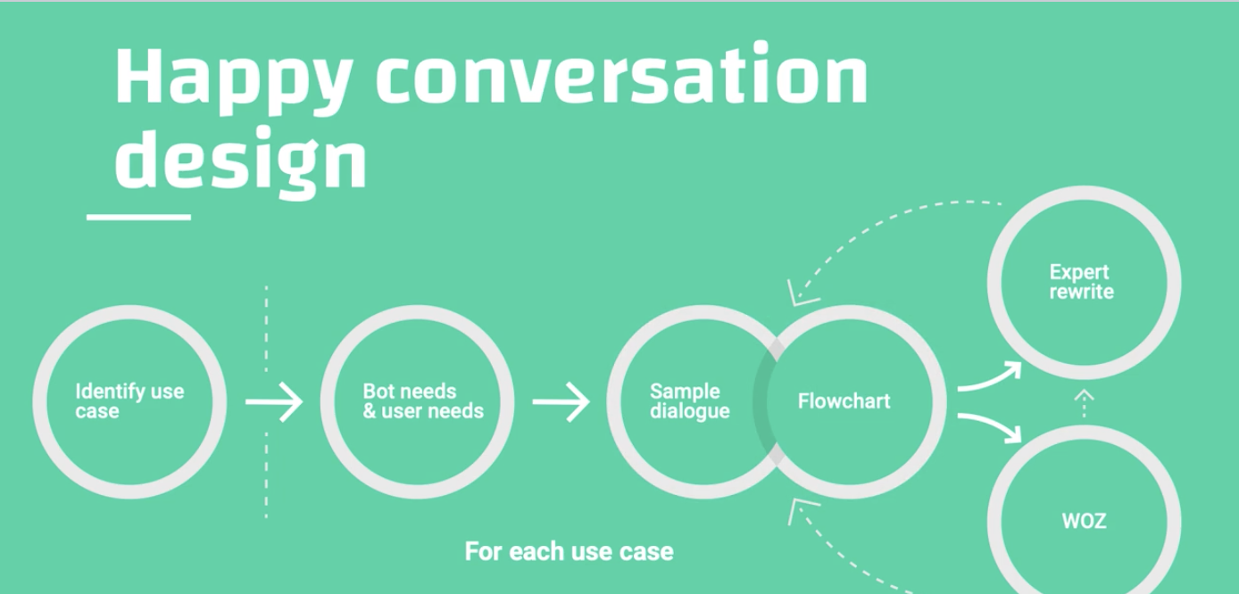

Person simulating how the bot would act

Types of WOZ

* Read out your rough version
* Create audio files

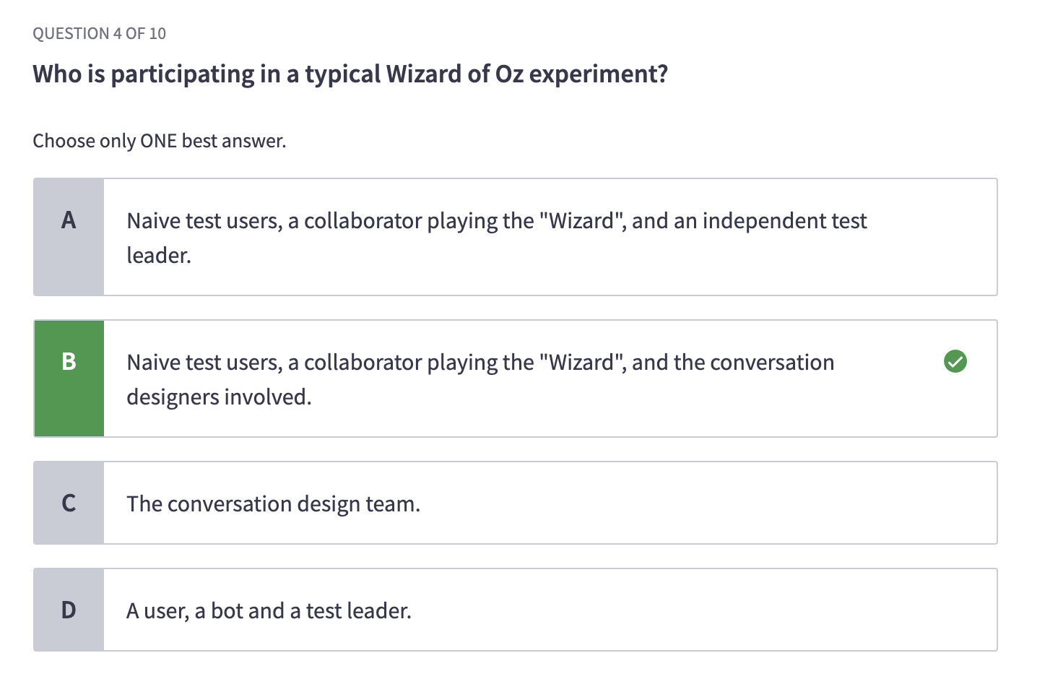

An example of Improvement test

1. The user said “can you repeat it?”
2. Make one prompt simpler by reducing the personality

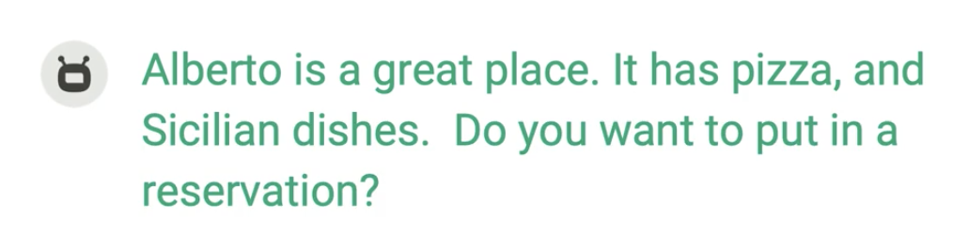

## Intent recognition

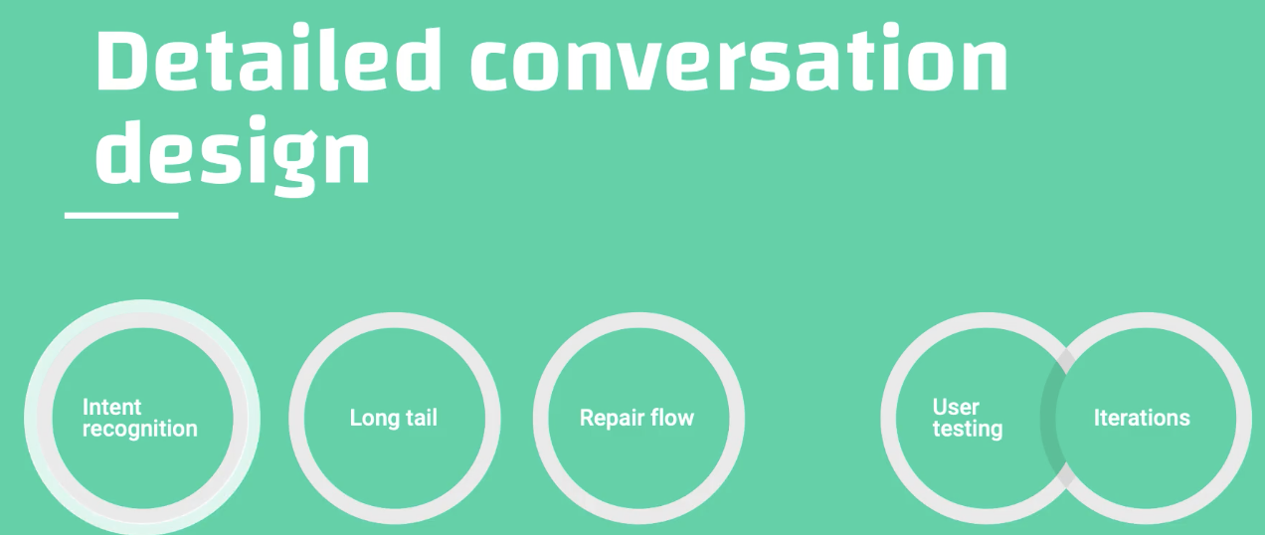

Example: there are two situations for restaurant booking

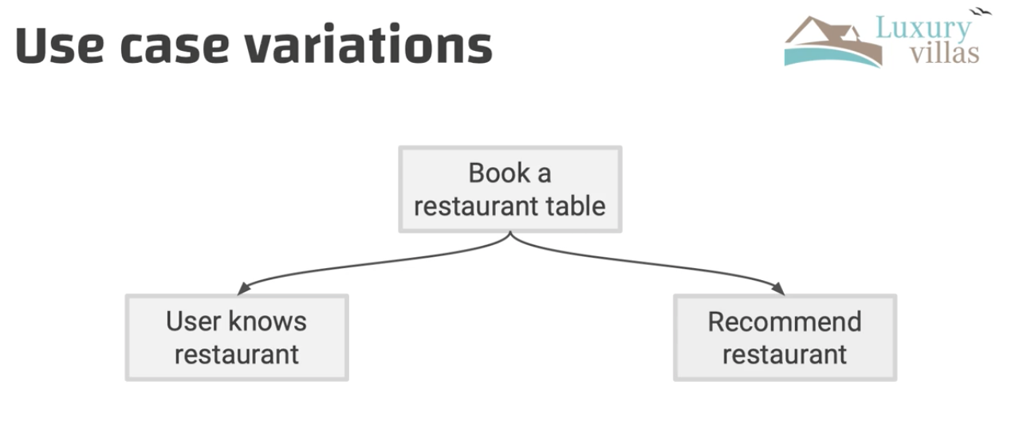

Solution 1: listing the options

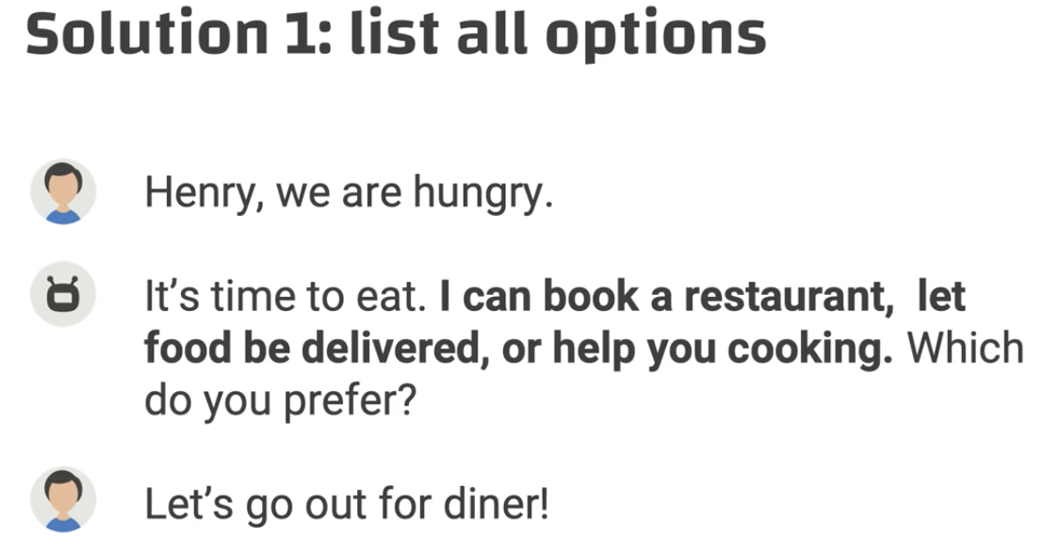

Solution 2: asking questions one by one

* Would you like me to book a restaurant?
* Would you like me to order food?
* Would you like me to help you prepare food in the villa?

**Button design**

Note: DON’T list the options in the sentence and THEN give buttons

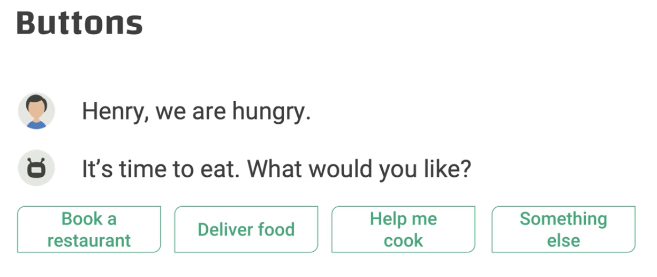

Menus

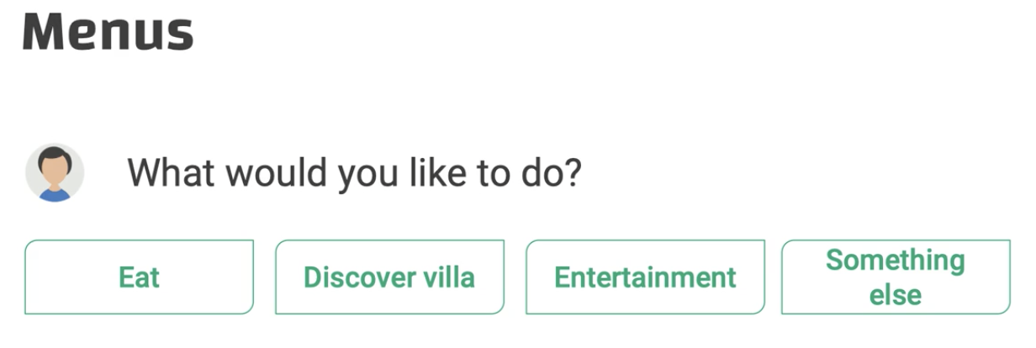

## Long tail

* Goal: you will learn to write copy for all different scenarios; you will learn how to find balance between your effort and added values

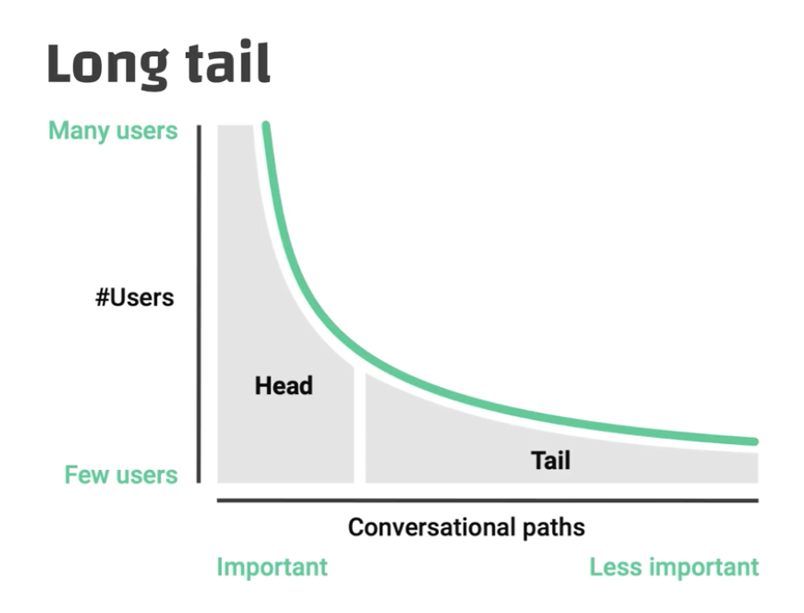

Example:

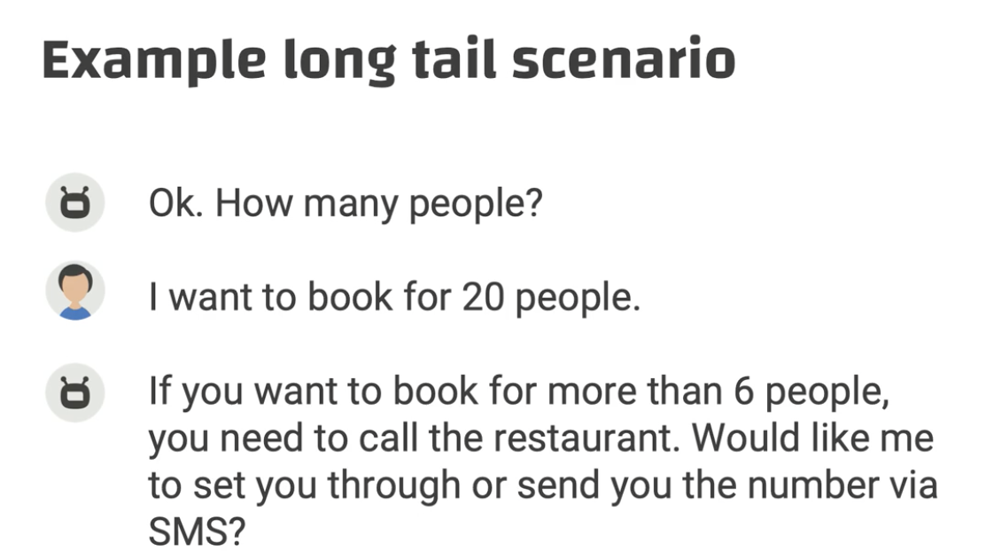

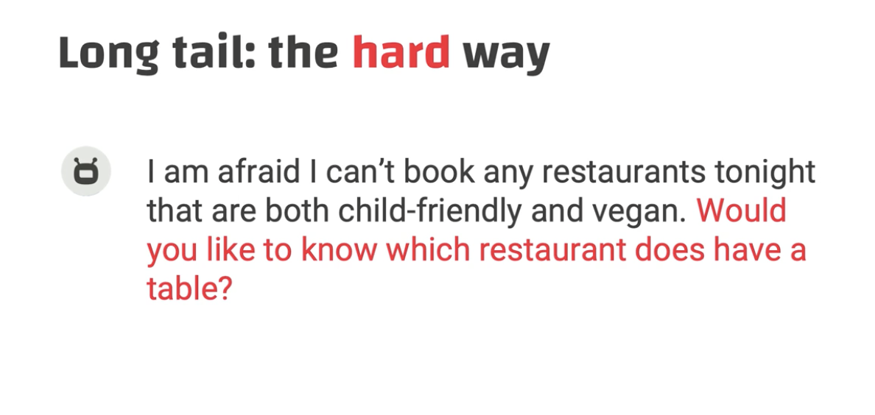

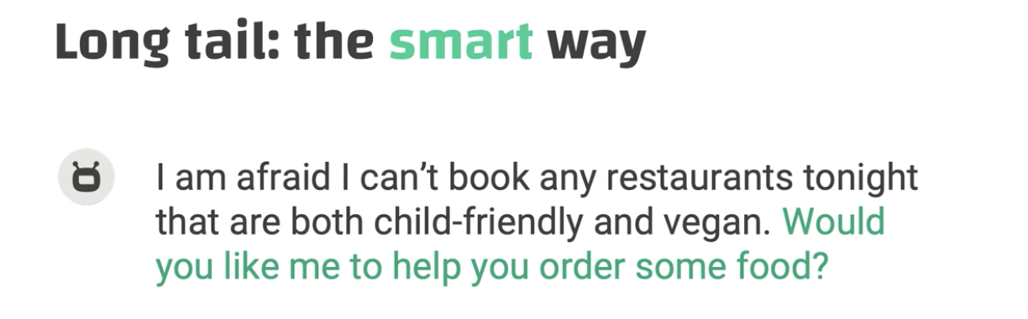

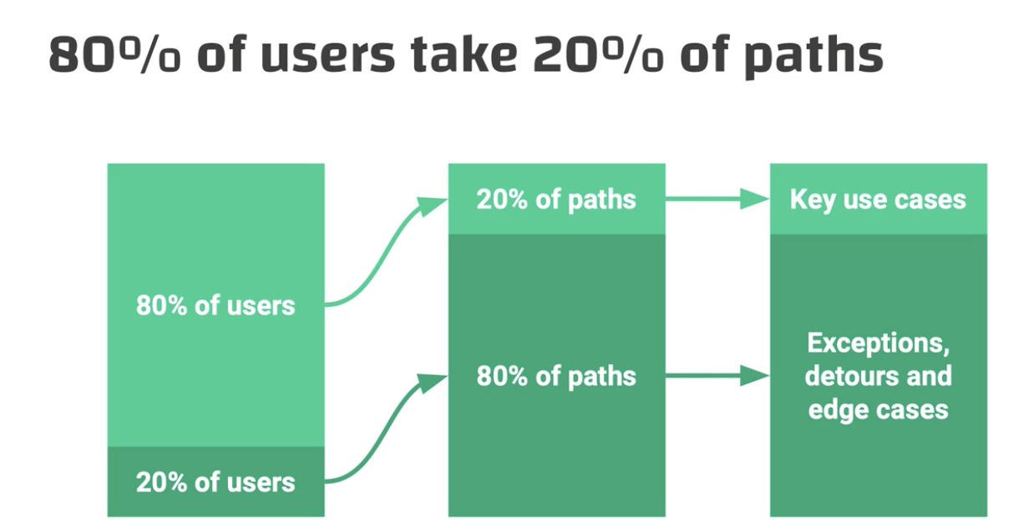

### Tips for designing the long tail

* Keep in mind costs versus benefits
* **Handover to human agents**
* Educate the user on what the bot can and cannot do

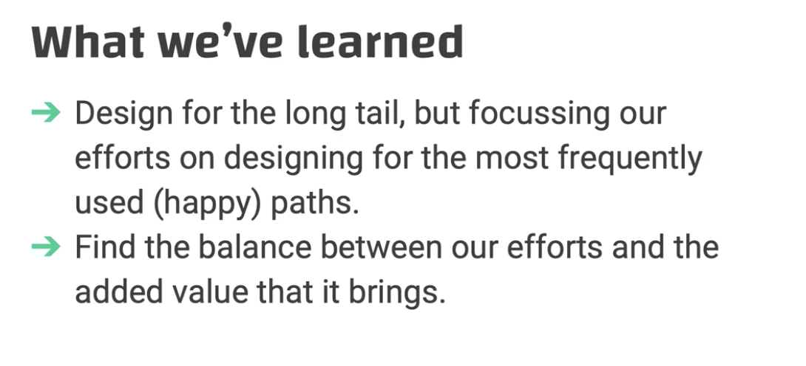

## Repair flow

Write repair prompts for

* NoInput: we don’t hear anything
* NoMatch: cannot make sense of the answer
* Disambiguation: we need a better answer

### No input

Reasons: user is confused/hesitated/quiet; nothing said; none choice matches; connection error; user is not sure

Escalating details: add more details and invite the user to speak more

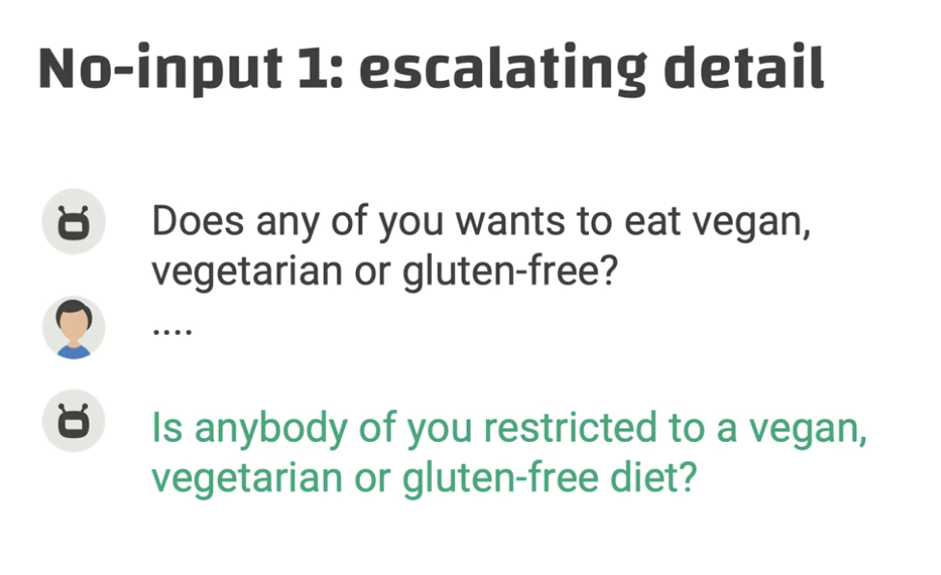

Keep asking for more details

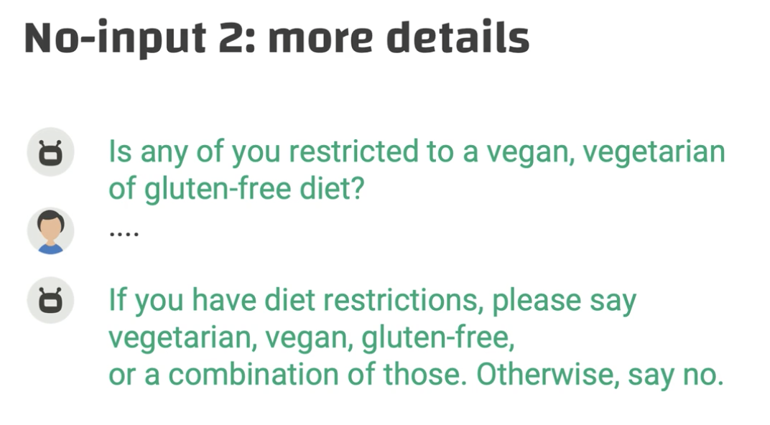

Finally give up

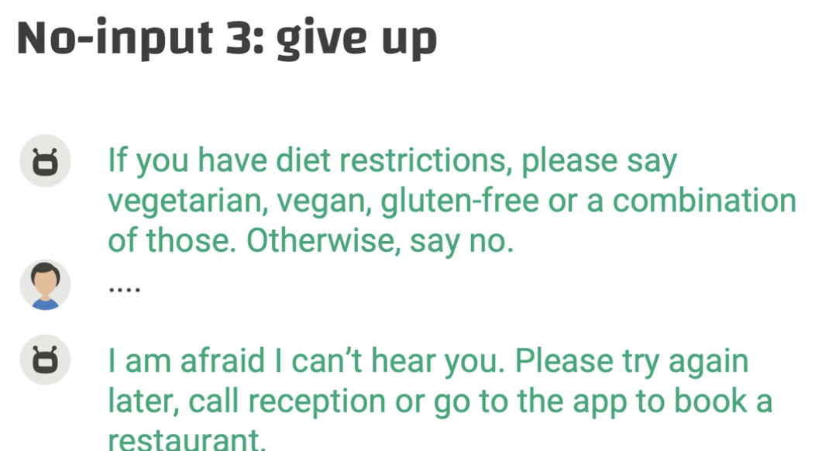

### No match

The user’s inputs do not match the trained model

Reason: user’s speech to other people; accent; out of vocab words

Use a prompt to quickly check what is going on

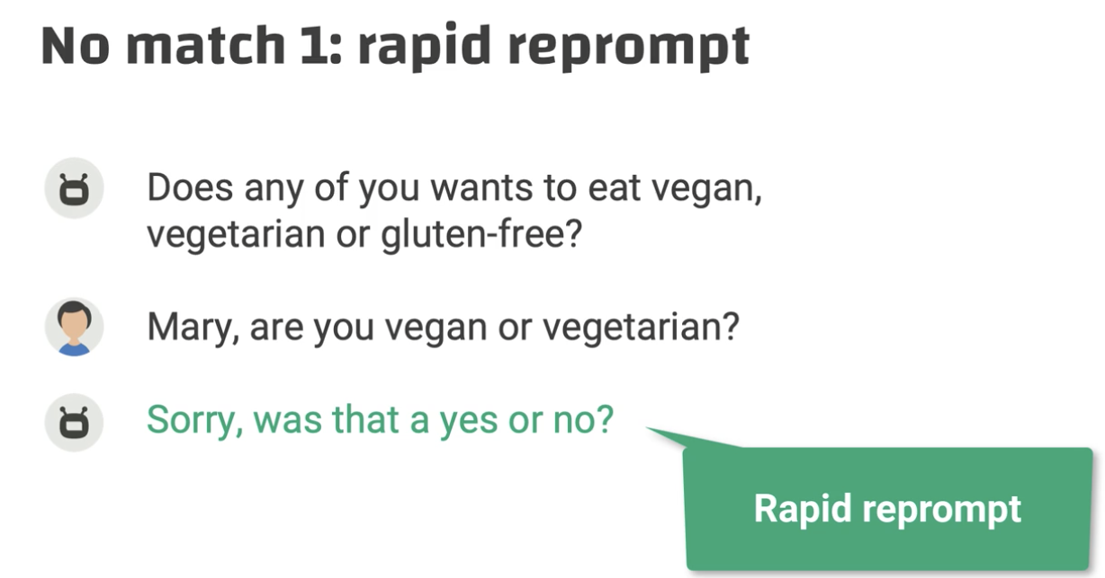

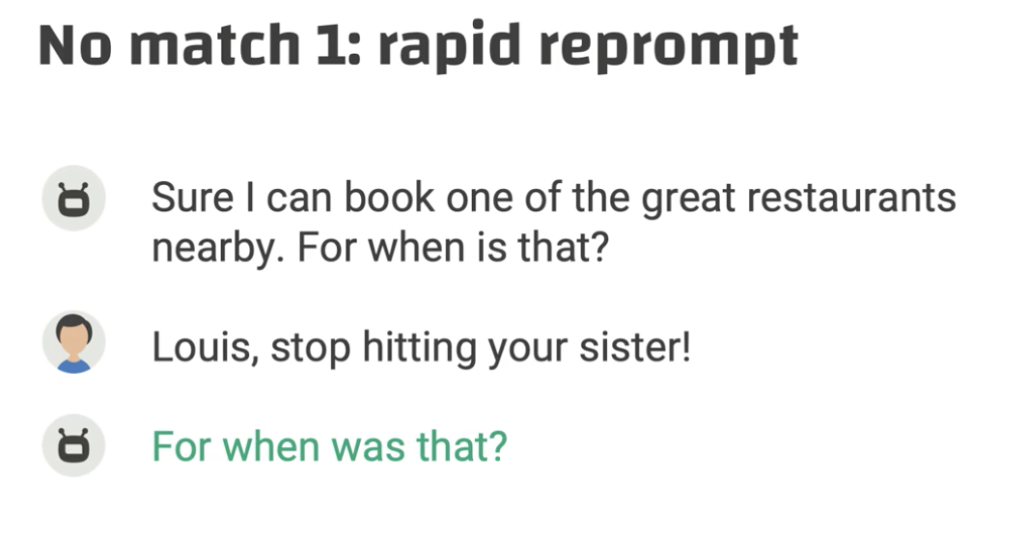

Reprompt + details

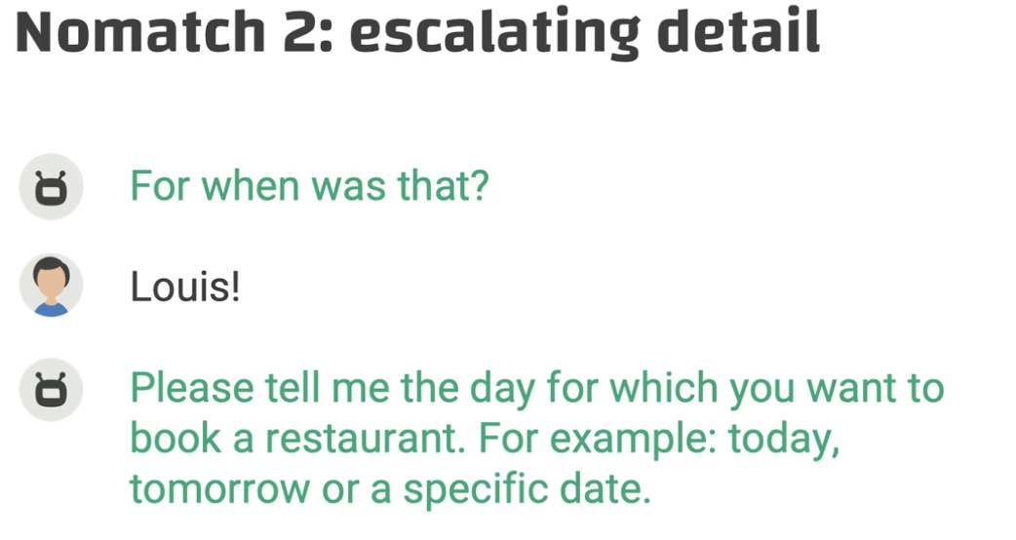

Note: No need to apologize

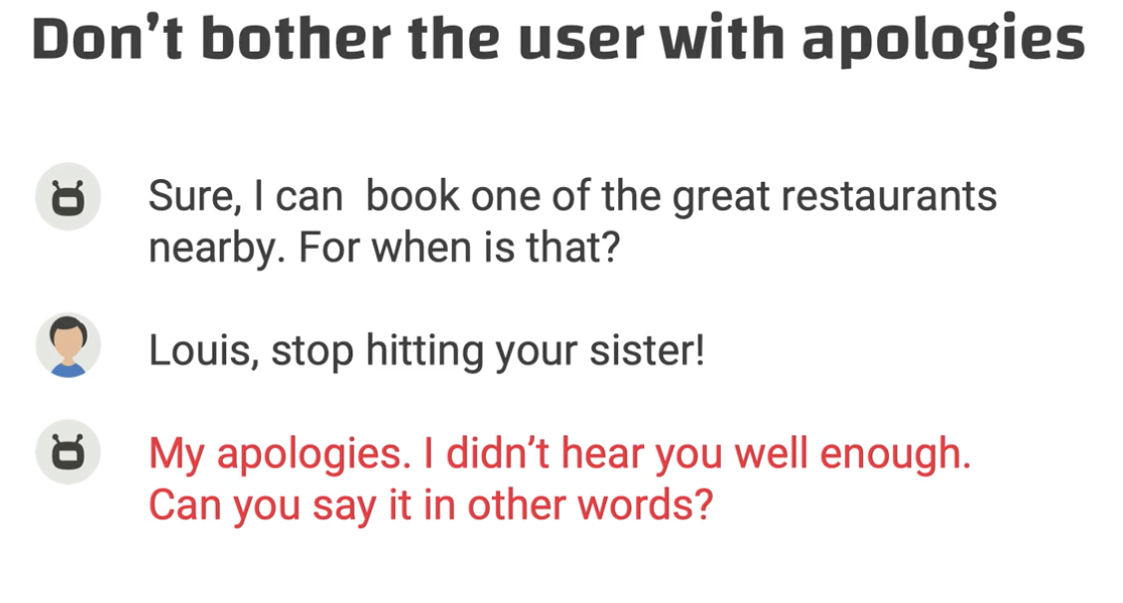

### Disambiguation

The bot needs to narrow the scope to make sure it gets the meaning

Asking a narrowing question

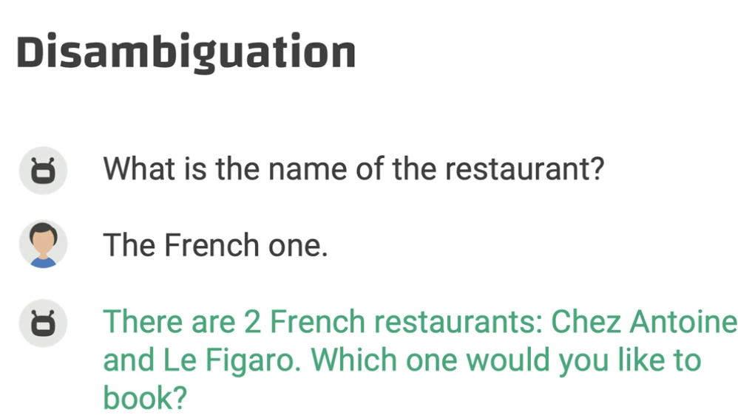

Or: Chez Antoine or Le Figaro?

### Misrecognition

The bot misinterprets the user

→ implicit or explicit confirmations

implicit

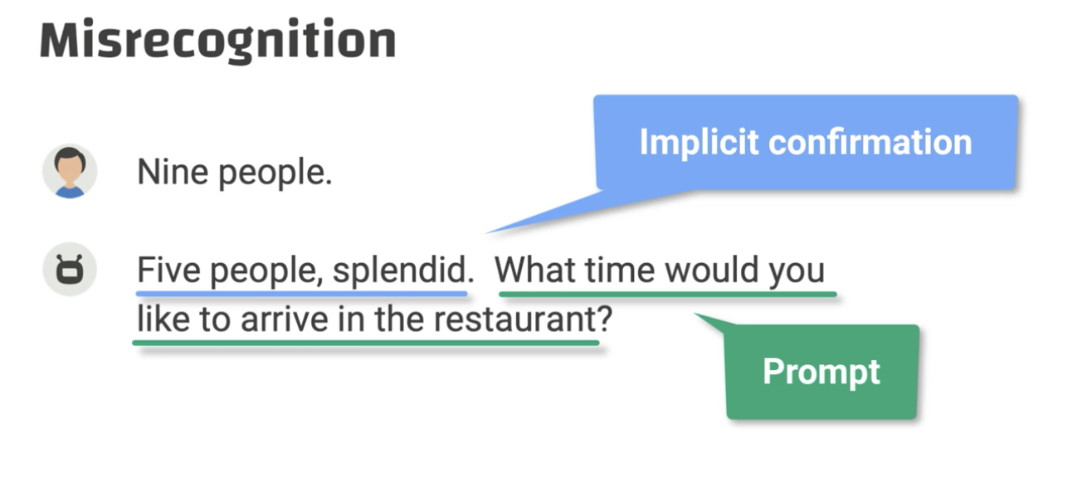

Implicit version requires an apology

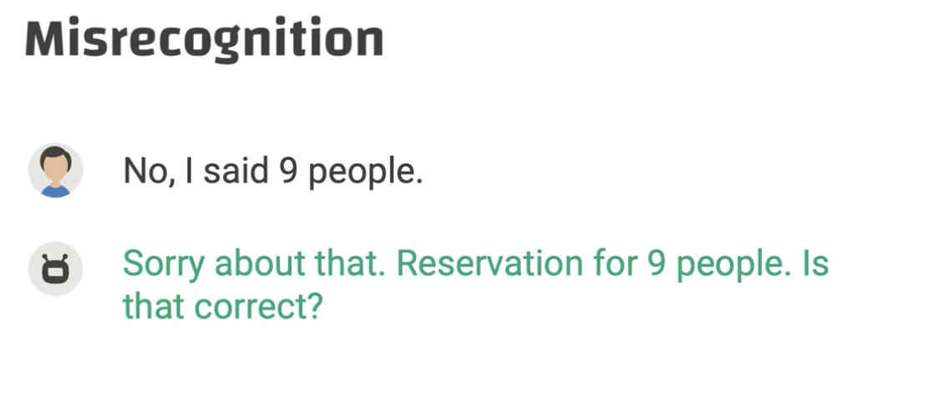

Explicit -> there is no apology

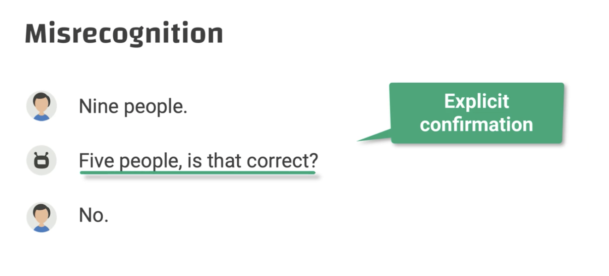

## Where to use bots

The best service is NO SERVICE (Bill Price)

Value-irritation model

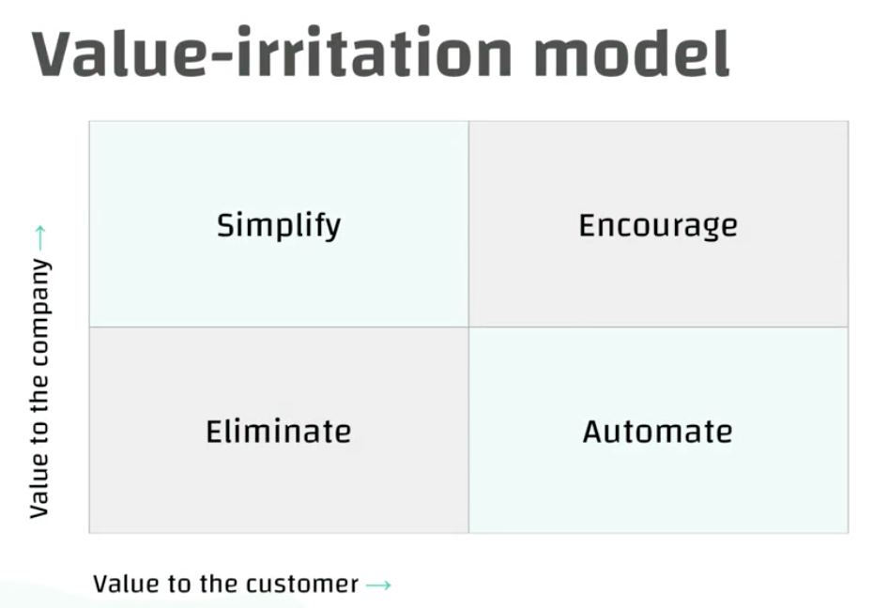

Important to customer → need to automate

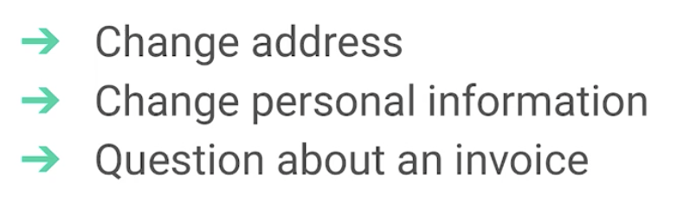

Important to the company → simplify

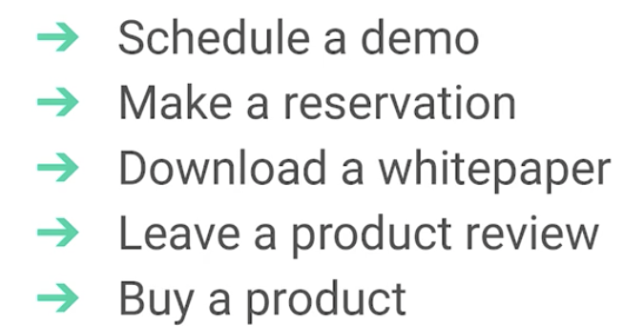

Value to both

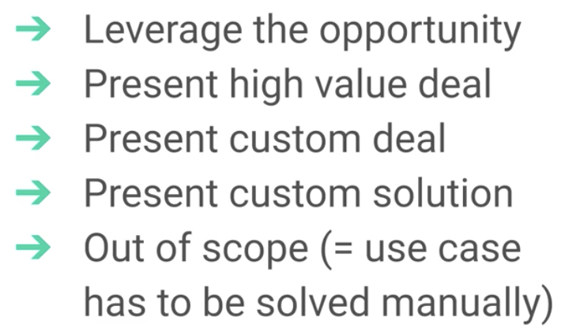

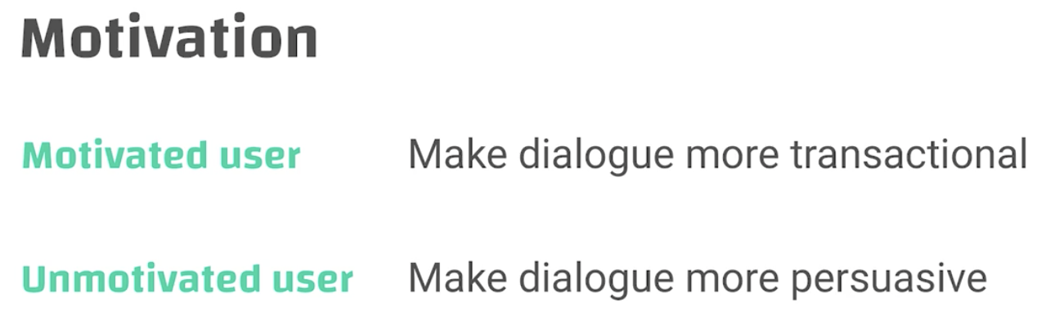

## Bot Scorecard

Use: evalue your own work; get feedback from coworkers; get comments from managers

**Five elements**

* Personality - does the character relate to the user and its tone consistent?
* Natural language - does the bot speak like a human or more robotic and transactional
* Empathy - Does the bot understand the objective, motivation, and emotional state of the user?
* Helpfulness - Does the bot serve the user’s needs, and does it help the user to get the job done?
* Persuasiveness - Does it influence the user’s behavior, and does it motivate the user to keep the conversation going?